


ENVIRONMENTAL AND SOCIAL MANAGEMENT PLAN

For

CONSTRUCTION OF THE AFRICA CENTRE OF EXCELLENCE FOR MYCOTOXIN AND FOOD SAFETY (ACEMFS)

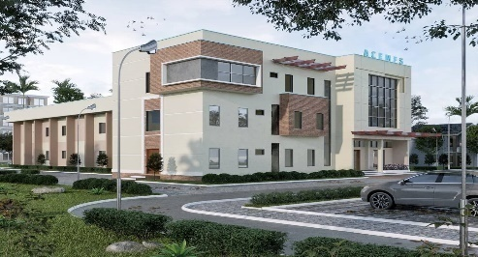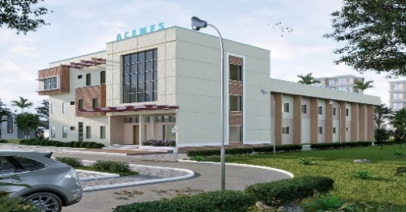

FEDERAL UNIVERSITY OF TECHNOLOGY MINNA MAIN CAMPUS
NIGERIA



January 2023

Prepared by: ACEMFS FUT Minna

TABLE OF CONTENTS
TABLE OF CONTENTS iii
LIST OF TABLES vii
LIST OF FIGURES viii
LIST OF ABBREVIATIONS AND ACRONYMS ix
EXECUTIVE SUMMARY xi
CHAPTER ONE: 1
INTRODUCTION 1
1.0 Overview 1
1.1 Project Background 1
1.2 Rationale for ESMP 2
1.3 Project Objectives 3
1.4 ESMP Objectives 3
1.5 Safeguard Policies 4
1.6 Nigeria Legal and Institutional Frameworks 4
1.6.1 Institutional Framework 4
1.6.2 Legal Framework 5
1.6.3 Comparing National Procedures and World Bank Policies 5
1.7 Analysis of Alternatives and Complementary Initiative 7
1.8 Envisaged Sustainability of the Project 7
CHAPTER TWO 9
PROJECT DESCRIPTION 9
2.0 Introduction 9
2.1 Description of Project Environment 9
2.1.1 Description of the Proposed Construction Activities 10
CHAPTER THREE 12
DESCRIPTION OF THE ENVIRONMENTAL AND SOCIAL BASELINE CONDITIONS 12
3.1 Introduction: 12
3.2 Project Location 12
3.2. Climate 14
3.3 Topography/Vegetation 18
3.4 Geology and Hydrology 18
3.4.1 Sample Collection, Preparation and Analysis Methods. 19
3.4.2 Results/Findings: 21
3.5 Land Use of the Project Site 22
3.6 Socio-Economic Environment 22
3.6.1 Population of Community 22
3.6.2 Social-economic Characteristics and Health Condition 22
Socioeconomic Baseline 24
CHAPTER FOUR 28
4.2 Impacts Identification 29
4.2.1 Identified Positive Impacts 30
4.2.2 Identified Negative Impacts 30
4.4 GBV Risks and Management Measures 31
4.4.1 Measures taken to Mitigate GBV/SEA/SH Risks 31
4.5 Environmental and Social Management and Monitoring Plan 32
4.3.3 Institutional Responsibilities 45
Table 4.5: Institutional Responsibilities 45
4.4 Environmental Monitoring Programme 46
4.5 Capacity Building 47
4.6 Contractual Measures 48
4.7 Measures for Non-Compliance (Regulatory Compliance Plan) 48
CHAPTER FIVE 49
ENVIRONMENTAL SOCIAL MANAGEMENT AND MONITORING PLAN 49
5.0 Introduction 49
5.1 Roles, Responsibilities and Accountability for ESMP Implementation 49
5.2 Complimentary Initiatives 51
5.2.1 Training and Awareness Plan 52
5.2.2 Public Participation/ Involvement Plan 52
5.2.3 Regulatory Compliance Plan 52
5.2.4 Project Design Guidelines 52
5.2.5 Project Execution Guidelines 53
5.3 Transmission of Communicable Diseases 54
5.4 Environmental and Social Monitoring System 54
5.5 Decommissioning and Abandonment 55
5.6 Disclosure of ESMP 55
5.6.1 In-Country Disclosure Process 55
5.6.2 Info-shop 55
CHAPTER SIX 56
GRIEVANCE REDRESS PROCESS 56
6.1 Introduction 56
6.1.1 Objective and Purpose of Grievance Redress Mechanism 56
6.1.2 Potential Grievances/Disputes 56
6.1.3 Redress Mechanism 56
6.2 Processing and Resolution of Grievances 58
6.3 Functions of the Grievance Redress Team/Committee 59
6.5 Estimated Costs to Implement the ESMP 61
CHAPTER SEVEN 62
STAKEHOLDERS CONSULTATION 62
7.0 Introduction 62
7.1 Stakeholders Consultation Program 62
7.2. Stakeholder Engagement Meetings 65
7.3 Conclusion 68
7.4 Recommendations 69
REFERENCES 70
ANNEXES 71
Annex 1: Terms of Reference for the ESMP 71
Annex 2: Sample of Questionnaire for socioeconomics 78
Annex 3: List of participants in consultations and summaries of meetings 81
Annex 4: General Environmental Management Conditions for Construction Contracts 82
Annex 5: Project Occupational Health and Safety (OHSP) 86
Annex 6: Company Code of Conduct 88
Annex 7: Manager’s Code of Conduct 89
Annex 8: Individual Code of Conduct 91
Annex 9: Waste Management Plan (WMP) 93
Annex 10: Traffic Management Plan 97
Annex 11: Chance Find Procedure 99
Annex 12: Land Allocation Paper 100
Annex 13: Building Plans 101
Annex 14: Soil and Water Sample Result 103
Annex 15: Safeguard Guidelines on Covid-19 in Construction/Civil Works Projects 106

LIST OF TABLES
Table 2.1 Construction Phase / Activities of the project 11
Table 3.1: Air quality and noise level measurement within the proposed site 17
Table 3.2 Sampling Points 20
Table 3.3: Gender Base Profile for Study Community 22
Table 3.4: Demographic characteristic of the respondents in the Community 24
Table 4.1: Risk Assessment Matrix 28
Table 4. 2: Risk Matrix Explanation 28
Table 4.3: Identified Potential Negative Impacts 30
Table 4.4: Potential Impact Mitigation and Monitoring 33
Table 6.1: Participants of the stakeholder Consultation / on-site visit 63
Table 7.2: Consultation with Stakeholders 64
Table 6.3: Stakeholders Consultation with Management Team 66

LIST OF FIGURES

Figure 3.1: Absolute Temperature in the proposed Area 1991 to 2021. (NIMET,2022) 15
Figure 3.2: Relative Humidity in the proposed Area, 1991-2021 (NIMET, 2022) 15
Figure 3.3: Average Monthly Rainfall distribution in the project Area (NIMET, 2022) 16

LIST OF ABBREVIATIONS AND ACRONYMS
ACE Africa Centre of Excellence
ACEMFS Africa Centre of Excellence for Mycotoxic and Food Safety
CO² Carbon Dioxide
EA Environmental Audit
EIA Environmental Impact Assessment
EAs Environmental Assessment
EPC Engineering Procurement and Construction
ERP Emergency Response Plan
ESA Environmental Safeguard Audit
ESIA Environmental and Social Impact Assessment
ESMF Environmental and Social Management Framework
ESMP Environmental and Social Management Plan
ESO Environmental Safeguard Officer
ESP Exchange Sodium Percentage
FEPA Federal Environmental Protection Agency
FGD Focus Group Discussion
FGN Federal Government of Nigeria
FMEnv Federal Ministry of Environment
FUTM Federal University of Technology, Minna
FPIU Federal Project Implementation Unit
HEMP Hazard and Effect Management Process
GPS Global Positioning System
HSE Health, Safety and Environment
H2S Hydrogen Sulfide
IIF Incident and Injury Free
ISO International Safety Organization
NSG Niger State Government
NSEPA Niger State Environmental Protection Agency
NSURP Niger State Urban and Regional Planning
LF Lymphatic Filariasis
LGA Local Government Area
M & E Monitoring and Evaluation
MOU Memorandum of Understanding
NESREA National Environmental Standards and Regulations Enforcement Agency
NH2 Hydrazine
NO2 Nitrogen Dioxide
NTD Neglected Tropical Diseases
NIMET Nigerian Meteorological Agency
OP/BP Operational Policies / Bank Policies
PM Project Manager
PG Post Graduate
PIU Project Implementation Unit
PPDU Physical Planning Development Unit
PPE Personal Protective Equipment
PPP Public-Private Partnership
PMT Project Management Team
PSP Private Sector Partner or Private Sector Participation
PV Photovoltaic
REA Rural Electrification Agency
SDW Sanitary and Domestic Waste
SO² Sulfur Dioxide
SPS School of Postgraduate Studies
SSI Semi Structured Interviewed
ToR Terms of Reference
WB World Bank
WHO World Health Organization

EXECUTIVE SUMMARY

ES1 Introduction
The Africa Higher Education Centres of Excellence (ACE) Project is a World Bank initiative in collaboration with governments of participating countries to support Higher Education institutions in specializing in Science, Technology, Engineering and Mathematics (STEM), Environment, Agriculture, applied Social Science / Education and Health. It is the first World Bank project aimed at the capacity building of higher education institutions in Africa.
Based on the initial successes, the World Bank and in collaboration with the African governments, launched the ACE Impact Project in 2018 to strengthen post-graduate training and applied research in existing fields and support new fields that are essential for Africa's economic growth. There are 53 ACEs (25 new ones and 18 from ACE I); 5 Emerging Centers;1 “top up” centre in Social Risk Management; and 5 Colleges and Schools of Engineering. The new areas include sustainable cities; sustainable power and energy; social sciences and education; transport; population health and policy; herbal medicine development and regulatory sciences; public health; applied informatics and communication; and pastoral production
The Africa Centre of Excellence for Mycotoxin and Food Safety (ACEMFS) in Federal University of Technology, Minna – Nigeria, is one of the ten ACE Centres in Nigeria. There are presently 17 African Centres of Excellence in Nigeria
Project Components and Objectives
Project Components
The Project has 3 components
Component 1: Establishing new Africa Centres of Excellence and scaling up well-performing existing Africa Centres of Excellence (ACE) for development impact.
Component 2: Regional Partnerships and Scholarships.
Component 3: Enhancing Regional Policymaking, Monitoring, and Facilitation.
The Project Development Objective (PDO) of the ACE II Project is to improve the quality, quantity and development impact of postgraduate education in selected universities through regional specialization and collaboration.
The overall goal of the proposed Upgrade is “to strengthen the dimensions and capacity of FUTM to train high quality researchers and scientist who will recognize, understand and readily exploit the immense potentials of emerging modern global technology movements” through specific initiatives.
The ACEMFS primary focus areas of research is on three of the postgraduate programs (MTech. and PhD) in;
- Food safety,
- Toxicology,
- Molecular biology and Bioinformatics
The main aim of the Centre is to train personnel in food safety, toxicology, molecular biology & bioinformatics that will impart better food and feed safety culture, and ensure safer foods for healthy living in Nigeria and across Africa.
As the proponent for the sub-projects, their central objectives are;
- To acquire knowledge required to create an interdisciplinary and experience based educational model that will prepare graduates on the rapidly emerging need for innovations at the nexus of food security, food safety, agricultural productivity and economics from local to global scales.
- To be able to foster impactful interdisciplinary research and implement solutions that will improve the quality of life of Africans through fit-for-purpose interventions fostering economic growth and access to sufficient safe food for all.
- To be able to address Africa’s shortage of expertise and applicable solutions to ensure a safe, controlled and sufficient food supply that will support economic growth and public health.
Need for ESMP
The proposed building project has been assessed to have potential adverse impacts that are site specific, limited in number, reversible and is thus a category B Project. The World Bank Safeguard Policies OP/BP 4.01 on Environmental Assessment and OP 4.11 on Physical and Cultural Resources have been triggered on this project
The overall objective of the ESMP is to ensure project compliance with applicable national environmental and social legal requirements and the World Bank’s environmental and social safeguards. Further, the ESMP aims to identify environmental and socio-economic benefits of the project as well as identifying potential adverse environmental and socio-economic impacts.
Applicable World Bank Operational Safeguards Policies
- Two of the World Bank Operational Safeguards Policies are triggered under this Project as described in table below
- Applicable ESS and Applicability to ACEMFS FUT Minna Project

Triggered Policy | Reason for Application of Standard to the Project | How it will be addressed by the project
OP/BP4.01 Environmental Assessment | Proposed construction works will result in environmental and social impacts attributed to generation of waste, noise/air pollution, movement of heavy-duty vehicles & traffic issues, occupational health & safety risks, risks associated with labour influx, community health & safety risks amongst others. However, these impacts are limited, site specific and can be mitigated. | This ESMP contains measures to address the identified risks and includes other MSIPs like waste management plan, OHS plan, community health & safety plan amongst others.
OP/BP4.11 Cultural Physical Resources | During the excavation and earthworks, contractors may encounter physical and cultural resources such as artefacts, tombstones, historical/cultural landmarks | A Physical and Cultural Resources Management Plan has been included in annex 9 of this ESMP

Nigeria Legal and Institutional Framework
Legal and Institutional framework guiding this document includes;
Federal Ministry of Environment (FMEnv) Act. 1999 repelled from the Environmental Protection Agency Act of 1988 (FEPA Act) which was later changed to National Environmental Standards and Regulations Enforcement Agency (NESREA), which was established in 2007 to replace FEPA;. The following Regulations were made pursuant to the FEPA Act:

Chapter One of this project report outlines several legislative issues that were considered during the exercise. This is to ensure that the proposed project complies with the relevant legislative and planning requirements of Nigeria. They generally comprise of legislations that encompass laws relating to environment, public health and land. The project generally conforms to the legal requirements outlined in Chapter One and subject to the proposed ESMP in Chapter five of this report.

Methodology
The consultant adopted a participatory methodology during the study. Several consultative meetings were conducted at the federal, state, agencies and the university Physical Planning Development Unit (PPDU) responsible for implementation of activities relating to development in the institution, the communities and other stakeholders. The consultant further reviewed various legal issues relevant to the exercise.

ES 2: Project Description

Project Activities
The proposed activities associated with the project will involve construction of a new building office accommodation, Laboratories, Class Rooms, Conferences Rooms and associated structures; works such as plumbing, electrical fittings, soak away, roofing etc.to accommodate staff and students of the Centre. The construction works will be implemented by the ACEMFS PIU within the University main campus, as such there will be no involuntary resettlement, acquisition of land, relocation, compensation, loss of physical and economic assets, and/or loss of livelihoods particularly as the project by design cannot finance such concerns.
Initial State of the Environment
The initial state of the environment is relatively flat, slope gently Eastward direction, hence can easily be drained and discharged into the natural stream eastward direction of the site. The existing master plan refers to the University vegetation as being dominated by stunted shrubs intercepted with trees of moderate height. The trees are said to be generally of eucalyptus extraction with fairly useful products. Human activities have greatly affected the vegetation pushing it towards derived dry Sahel- Savannah grass/shrub land. Vegetation of the site today can simply be referred to as shrub/grass land with scattered short trees; with danger of extinction of some common trees. The site is accessed through the following roads (a) From the University gate to the roundabout to school of Life Sciences and extended to the subject site. The site can easily be connected to the electricity from the electric line that terminated at the School of Life Sciences 170 metres away from the subject site.
ES3 Biophysical and Socio-Economic Characteristics
Baseline environmental assessments of the project area were conducted from 25th & 29th July 2022 to determine the existing environmental condition (both natural and human environments) prior to the commencement of the project. The information/data on the environmental condition of the study area were acquired through desktop research and field visit. Materials that were consulted included reports on feasibility study of the proposed project site, previous environmental surveys in the area, publications, textbooks, maps etc.
Information was gathered during the stakeholder consultation and socio-economic baseline study undertaken within the University community. Information relating to the biophysical aspects of the site was captured through these interactions and details are also presented. The additional information gathered from the campus relates to ecosystem services and livelihood aspects within the study area.
Potential Impact Identification
Positive/Beneficial Impacts
- The proposed project is expected to be largely beneficial to the adjoining communities, students and staff of the University, Niger State and Nation at large, as it is envisaged to increase enrolment of students for technology and IT courses such as cybersecurity, computer sciences and information technology, amongst others.
- Rehabilitation of the access route to the site will be beneficial to students and other road users in the project location
- Short term employment will also be created for locals within the school and around the project location especially as unskilled workers.
- Presence of contractor workers will lead to Increase in revenue for petty traders of food, water etc. due to patronage.
Negative/Adverse Impacts
The proposed construction is within the fenced FUT Minna Main campus Gidan Kwano. Some of the potential adverse impacts include:
- Risk of aquifer over-exploitation and pollution of ground water resources due to borehole drilling.
- Occupational health & safety risks from civil works and operation of machinery could lead to injuries, accidents for workers.
- Poor labour and working conditions could lead to ill-health, grievances, discrimination etc.
- Waste generated from construction activities such as cement, wood, iron rods etc. could lead to environmental pollution if poorly managed. This could also lead to public health concerns especially for the students
- Electrical and electronic wastes such as electrical wires, sockets etc. could lead to toxicity if poorly managed
- Risk of increased air and noise pollution, if Contractor harnesses water from the river for construction works, or discharges wastewater into the river.
- Risk of theft, security, gender-based violence (GBV) /sexual exploitation and abuse (SEA), and increase in sexually transmitted infections (STIs)/sexually transmitted diseases from influx of labour to site.
- Poor labour and working conditions could lead to ill-health, grievances, discrimination etc.
Environmental Impacts Mitigation Measures
The potential and associated impacts of the proposed project were identified and evaluated using standard procedures. Various source references including past project experience, professional judgment and knowledge of both the project environment and project activities were used in the assessment. The associated and potential impacts of the proposed project as well as the proffered mitigations are summarized in Chapter 4 in table 4.4..
ES 4: Environmental and Social Management and Monitoring Plan
As part of this ESMP, a project specific E&S management and monitoring plan has been designed. The environmental and social management and monitoring plan for matrix presents site-specific mitigation measures for potential negative impacts of the project. The matrix also presents the plan for monitoring compliance, defines the costs for mitigation and monitoring, frequency of monitoring, parameters to be monitored, and responsibilities for mitigation and monitoring. Additionally, training programmes to enhance capacity as well as budget estimates to ensure implementation. Most of the mitigation measures are the obligation of the Contractor. Consequently, the project team will provide the ESMP to the selected contractor to guide the preparation of their bids taking into account the mitigation measures and associated costs in this ESMP and other provisions and guidance as provided therein.
Institutional Arrangements and Responsibilities
ACEMFS will ensure implementation of the project ESMP with the support of its environmental staff. Contractor will be held to account for implementation of their responsibilities in the Project Management system. The institutional arrangement for implementation of the ESMP under the project include the following;
- ACEMFS
- Project Manager (PM)
- Environmental Safeguard Officer (ESO)
- Contractor
- Consultant
- Project Financier
Estimated costs for ESMP
The summary of the cost for the implementation of the ESMP is presented in the Table 1 below. The total costs of the ESMP including costs for mitigation and monitoring and capacity building is estimated as: Twelve Million, One Hundred and Forty-Eighty Thousand, Four Hundred Naira (₦12,148,400.00) only. Breakdown cost in Table 6.5, Pg. 60.
ES 5: Grievance Redress Mechanism (GRM)
The project is in an established institution which already has mechanisms in place for grievance redress and will be built on by the project, specifically, complaint form is provided on the ACEMFS website https://acemfs.futminna.edu.ng/, designated phone number will be provided by the project, Grievance Redress Committees at the project and management level. Ultimately, the project will ensure all grievances received are addressed timely and efficiently. A standalone procedure for responding to allegations of GBV/sexual exploitation and abuse (SEA)/ sexual harassment (SH) has been established which adopts the Survivor’s centered approach and confidentiality.
ES 6: Stakeholder Consultation
Stakeholder consultation process took place between 25th – 28th July, 2022 within the project area of influence. Continuous consultations should be held with project stakeholders throughout the lifecycle of the project to keep them informed and provide an avenue to receive suggestions and complaints.
Community Influence on Vulnerable Persons
The proposed project's implementation could have an impact on the economic conditions of nearby communities. Construction projects provide opportunities for local food vendors to sell to construction workers in a secure environment.
Artisans and other construction workers will also be employed on a temporary basis as a result of the project. Vulnerable groups are those who are at risk of being disadvantaged and require special consideration in project design. Vulnerable individuals include, but are not limited to:
- Disabled members of the community and Children.

Conclusion
ACEMFS recognizes that it has a role to play and a responsibility in protecting and enhancing the environment in which the project is to be deployed to meet the needs of the communities without compromising the integrity of the environment and the major disruption of the socioeconomic set up of the project affected areas. This Social and Environmental Management Plan has therefore described in details the processes ACEMFS will follow to maximize its compliance to statutory requirements as well as those of project sponsors and minimized the impacts of the project on the general environment.

CHAPTER ONE:

INTRODUCTION

Overview
The Africa Higher Education Centres of Excellence (ACE) Project is a World Bank Initiative in collaboration with governments of participating countries to support higher education institutions in specializing in science, technology, engineering and mathematics (stem), environment, agriculture, applied social science/ education and health. It is the first World Bank Project aimed at the capacity building of higher education institutions in Africa.
The first phase (ACE I) was launched in 2014 with 22 Centres of Excellence in nine (9) West and Central African countries; Benin, Burkina Faso, Cameroon, Côte d'Ivoire, Gambia, Ghana, Nigeria, Senegal and Togo. The Project aims to promote regional specialization among participating Universities in areas that address specific common regional development challenges. It also aims to strengthen the capacities of these Universities to deliver high quality training and applied research as well as meet the demand for skills required for Africa's development. The second phase (ACE II) was launched in East and Southern Africa with 24 centres across Ethiopia, Kenya, Malawi, Mozambique, Rwanda, Tanzania, Uganda and Zambia.
Based on the initial successes, the World Bank in collaboration with the African governments, launched the ACE Impact Project in 2018 to strengthen post-graduate training and applied research in existing fields and support new fields that are essential for Africa's economic growth. There are 53 ACEs (25 new ones and 18 from ACE I); 5 Emerging Centers;1 “top up” centre in Social Risk Management; and 5 Colleges and Schools of Engineering. The new areas include sustainable cities; sustainable power and energy; social sciences and education; transport; population health and policy; herbal medicine development and regulatory sciences; public health; applied informatics and communication; and pastoral production.

1.1 Project Background
In Nigeria, The Africa Centre of Excellence for Mycotoxin and Food Safety (ACEMFS) was selected at Federal University of Technology Minna to strengthen inter-disciplinary approaches to promote food safety in Africa through training and research for evidence-informed policy development in West and Central Africa. This approach utilizes non-traditional partnership among different sectors of the community, public health, Food industry, academia, Farmers, Government Food Regulatory Agencies and Agricultural Extension Workers to achieve positive food safety outcomes through policy development and implementation. The Centre has adopted a strategy of translating research outputs to policy through recommendations to policy makers for implementation purposes as a process of promoting or „Turning Research into Practice (TRIP)‟ for evidence proven interventions. The Centre’s thematic areas of research cover Food safety, Mycotoxin, Nutrition and Global Health. ACEMFS has Five (5) main collaborating departments which run its academic programmes. These departments are Department of Biochemistry, Department of Micro Biology, Department of Biological Sciences, Department of Chemical Engineering and Department of Crop Production. They are all housed within the two University campuses of Bosso and Gidan Kwano.
The ACEMFS focus areas of research are on three (3) of the following postgraduate studies (MTech and PhD) in;

- Food safety,
- Toxicology,
- Molecular biology, and Bioinformatics
The objectives of the ACEMFS are:
- To train postgraduate students to acquire knowledge, skills and competences towards achieving food safety
- To strengthen capacity and capability of translating research findings to policy and practice
- To promote and enable gender parity and participation in population health research and policy
- To increase the nursing human resources for health in West and Central Africa

1.2 Rationale for ESMP
The proposed ACEMFS project will involve construction activities that can cause negative/positive environmental and social impacts due to the nature of works. Some of the potential negative impacts that would arise during the construction works will include: generation of hazardous and non-hazardous wastes, noise/air pollution, accident from movement of equipment and materials to site, occupational health & safety risks, risks associated with labour influx (security threat, gender based violence (GBV) in particular Sexual Exploitation and abuse due to labour influx, increase in STIs/STDs), grievance and disturbance to physical resources among others. All these triggered the World Bank’s operational policy (OP) on Environmental Assessment (OP/BP 4.01) In addition, the Nigeria EIA Act CAP. E12L.F.N.2004 mandates that any construction that would have significant impact on the environment must be subjected to an environmental assessment prior to commencement of the civil works.
The Africa Centre of Excellence for Mycotoxin and Food Safety (ACEMFS) FUT Minna in collaboration with the World Bank has engaged the services of an Environmental Consultant to prepare an Environmental and Social Management Plan report for the proposed building construction of its centre.
Following successful project’s classification as a Category B project not requiring the preparation of an Environmental Impact Assessment (ESIA), but necessitating Environmental and Social Management Plan (ESMP) in line with FMEnv and World Bank standards. The consultant shall handle the assignment following best practices which include:
•Early screening for potential impacts and select appropriate instrument to assess, minimize and mitigate potentially adverse impacts, for a successful monitoring and implementation of the project.
This report evaluation is in accordance with the term of reference (ToR) prepared for the ACEMFS which formed the bases for the Environmental and Social Management Plan (ESMP). The ESMP report preparation shall cover a period of four weeks.

1.3 Project Objectives
As the proponent of this project, their central objectives are;
I. To avoid where practical, unacceptable adverse environmental, social and /or economic impacts. In the circumstance that an impact cannot be avoided, ACEMFS and the Project Management (who will be responsible for the management of the project) are committed to the implementation of appropriate mitigation measures. For clarity in the management structure however, Project Manager will consult ACEMFS on matters relating to environmental health and safety performance. Project Management will however have overall responsibility for planning, implementation, monitoring and enforcement of activities associated with this ESMP.

1.4 ESMP Objectives
The objectives of the environmental and social management plan are to:
- Identify, predict and evaluate the environmental and social consequences of the proposed building construction project.
- Conduct baseline study on the predicted environmental components that will be affected at the project location.
- Recommend appropriate mitigation measures for all significant adverse impacts.
- Describe the measures required to implement mitigation commitments made in the environmental assessment.
- Identify responsibilities and actors for the implementation of proposed mitigation measures
- Assess the capacity available to implement the proposed mitigation measures, and suggest recommendation in terms of training and capacity building, and estimate their costs.
- Develop an environmental and social management plan for effective management of all significant adverse impacts.
- Communicate environmental and social expectations and implementation throughout the project implementation team.
- Produce an ESMP in line with the World Bank OP 4.01 and OP 4.11, Federal Ministry of Environment and the Physical Planning and Development Unit FUT Minna.
The main thrust of the ESMP shall focus on findings, conclusions and recommended actions, supported by summaries of data collected and citations for any references used in interpreting those data. It shall provide a description of the specialist studies undertaken and the report shall include a bibliography, designs, photographs, diagrams and any other diagrammatic representation needed to facilitate understanding of the main text. Detailed data shall be presented in annexes or a separate volume. Unpublished documents used in the assessment shall also be included or referenced in an appendix and the location of the originals of such documents indicated.

1.5 Safeguard Policies
World Bank projects are guided by Environmental and Social Safeguards Guidelines and Operational Policies. This enables the integration of environmental and social considerations into the development, planning and execution of projects. These were used as a guide to support ACEMFS’s environmental and social (E&S) risk management. Among all the World Bank environmental and social safeguard policies, two Operational Policies and Bank Procedures (BPs) were triggered under the ACEMFS Project, namely:
- OP 4.01 Environmental Assessment which covers impacts on the environment (air, water and land), human health and safety, physical cultural resources, and global Tran’s boundary and environmental issues. This policy is triggered because the project is likely to have environmental risks and impacts on its area of influence. The policy requires that environmental and social consequences be identified early in the project cycle and considered in the selection, location, planning, and design of the project to minimize, prevent, reduce, or compensate for adverse impacts and thereby maximize positive impacts.
- OP 4.11 Cultural Physical Resources which provides cultural heritage guidelines to avoid or mitigate adverse impacts of development projects. This policy applies to the following projects: (I) any project involving major excavation, demolition, earthworks, flooding or other environmental modifications; (ii) any project located on or near a site recognized as cultural property; (iii) any project designed to support the management or conservation of physical cultural property. This will also concern buildings of historical value and which would be subject to rehabilitation works.

1.6 Nigeria Legal and Institutional Frameworks
In Nigeria, the power of regulation of all environmental matters is vested in the Federal Ministry of Environment (FMENV), hitherto, the now defunct Federal Environmental Protection Agency (FEPA) which was set up by Act 88, of 1988). The act establishing the Ministry places on it the responsibility of ensuring that all development and industry activity, operations and emissions are within the limits prescribed in the National Guidelines and Standards, and comply with relevant regulations for environmental pollution management in Nigeria as may be released by the Ministry. Largely, the federal legislation serves as the benchmark in the execution of standards in the states. Notably, the Federal Ministry of Environment provides EIA guideline and procedures. It has the overarching responsibility of approving EIA project proposals, report reviewing, public disclosure and certification. Highlights of the various legislations are presented below.

1.6.1 Institutional Framework
Construction of building projects are guided by the ministry of works and housing, through the various municipal assemblies and other state agencies that help in the protection of the environment by regulating project activities. The following are the main regulating institutions:
- Federal University of Technology Minna (FUT-Minna): The FUT is represented by the Physical Planning Development Unit and Works and Services Department which is the main regulatory body in charge of project developments in the university.
- The Ministry of Education: The Ministry of Education is responsible for all policies on education, including apprenticeships and wider skills acquisition in Nigeria.
- Federal Ministry of Environment Environmental Protection Agency (FMEnv): The EPA regulates Environmental Impact Assessment (EIA) and Environmental Management Plan (EMP) procedures. The objective of the Agency is to ensure the compliance of good practices and seek co-operation from entities whose activities could potentially cause harm to the environment.

1.6.2 Legal Framework
With respect to the legal framework, Nigeria Possess several policies aimed at protecting the environment. Whole or partial sections of these policies relate directly to construction works:
The basis of environmental policy in Nigeria is contained in the 1999 Constitution of the Federal Republic of Nigeria. Pursuant to section 20 of the Constitution, the State is empowered to protect and improve the environment and safeguard the water, air and land, forest and wildlife of Nigeria. In addition to this, section 2 of the Environmental Impact Assessment Act of 1992 (EIA Act) provides that the public or private sector of the economy shall not undertake or embark on or authorize projects or activities without prior consideration of the effect on the environment.
The Federal Government of Nigeria has promulgated various laws and Regulations to safeguard the Nigerian environment. These include:
• Federal Environmental Protection Agency Act of 1988 (FEPA Act) which was later changed to National Environmental Standards and Regulations Enforcement Agency (NESREA), which was established in 2007 to replace FEPA;. The following Regulations were made pursuant to the FEPA Act:
- National Environmental Protection (Effluent Limitation) Regulations:
- National Environmental Protection (Pollution Abatement in Industries and
Facilities Generating Wastes) Regulations; and
- National Environmental Protection (Management of Solid and Hazardous Wastes)
Regulations.
- Environmental Impact Assessment Act of 1992 (EIA Act).
- Harmful Wastes (Special Criminal Provisions etc.) Act of 1988 (Harmful Wastes
Act)
- National Adaptation Strategy and Plan of Action on Climate Change for Nigeria
(NASPA-CCN) 2011.
- National Biodiversity Strategy and Action Plan (NBSAP) 2016.
- National Policy on Environmental 2016.
- National Climate Change Policy and Respond Strategy (NCCPRS) 2012.
- National Water Policy (2012)
- National Agency for Food and Drug Control (NAFDAC Act Cap F.32 LFNL 2004);

1.6.3 Comparing National Procedures and World Bank Policies
Observing both policies, it can be identified that Ghana’s environmental and social management system and that of the World Bank share similar views. All laws, regulations and instruments governing investments and activities in the natural resources sector are generally consistent with the World Bank procedures. In terms of gaps and differences, recent WB assessments have pointed out the quality of the interactions existing between EPA and WB regulations, the EPA having demonstrated willingness and abilities to undertake in-depth, technically-sound reviews and provided authoritative guidance, and used conditionality effectively in administering the environmental permitting process. In the event of policy discrepancies, the World Bank Policies will override national policies and regulations.

Table 1.1: Summary of Regulatory/Policy Framework
Regulatory Framework | Description
Policies
National Policy on the Environment, 1989. Revised 2016 | The policy identifies key sectors requiring integration of environmental concerns and sustainability with development and presents their specific guidelines
National Policy on Occupational Safety and Health, revised 2020 | This policy was approved by the Federal Executive Council (FEC) in September 2020. It provides a guide for voluntary compliance and serves as a basis for occupational health and safety programs for workers even under such development projects
National Gender Policy (2006) | Provides a framework for ensuring gender inclusion and sensitivity in developmental plans and programs at the national and sub-national levels.
National Inclusive Education Policy (2001) | This national policy provides that education must be inclusive for all children including those with disabilities. Children with disabilities have the right to qualitative, functional and effective basic education. The policy ensures that systems and strategies are modified to provide a barrier free environment for all learners with disabilities.
Sexual Harassment (SH) Policy | The policy is dedicated to enlightening its public on the evils of sexual harassment and other associated anti - social conduct Sexual harassment has very grave effects on the overall productivity of staff and students in the university
Acts
Environmental Impact Assessment (EIA) Act CAP E12 LFN 2004 | The Environmental Impact Assessment (EIA) Act CAP E12 LFN 2004 provides guidelines for activities of development projects for which EIA is mandatory in Nigeria. According to the act, category II projects such as the ACEMFS requires only a partial EIA/EMP, which will focus on mitigation and Environmental planning measures,
Workers Compensation Act (2010) | The Workmen’s Compensation Act makes provisions for the payment of compensation to workmen for injuries suffered in the course of their employment
The Violence Against Persons Prohibition Act (VAPP) (2015) | This act prohibits all forms of violence against private and public life and provides maximum protection and effective remedies for victims and punishment of offenders. Nigeria’s national government has taken steps to penalize and address GBV and SEA.
Regulations
National Environmental (Sanitation and Wastes Control) Regulations (2009) | The purpose of the Regulation is the adoption of sustainable and environment friendly practices in environmental sanitation and waste management to minimize pollution. The Instrument amongst others makes provisions for the control of solid wastes and hazardous wastes.
National Environmental (Soil Erosion & Flood Control) Regulations (S.I. 12) 2011 | The purpose of these Regulations is to establish technically feasible and economically reasonable standards and procedures to achieve appropriate level of management and conservation practices to abate soil erosion, siltation and sedimentation of the waters of Nigeria, due to soil erosion and flood aggravated by non-agricultural earth-disturbing activities.

1.7 Analysis of Alternatives and Complementary Initiative
The various project alternatives were analysed objectively. The basis of selection of a preferred alternative were used with comparative analyses of alternatives based on costs, benefits and environmental risks. The “no project” scenario as well as differing degrees of development or technologies were adopted in these analyses.
For projects of this nature, there are usually a number of viable options that can be considered. These alternatives include: the no project option; delayed project, alternative location and project execution option. For this project, the execution option was adopted.
Execute Project Option
This option means going ahead with the construction. This also entails harkening to professional advice on the most practicable option. This will definitely upgrade the standard and statue of the institution and the centre, also to improve their research base. It will also aid in economic development and create employment generation.
The decision to embark on the project is to increase the accessibility and capacity of the people to research and development in Molecular Biology and Bioinformatics, Toxicology. This option is therefore considered the most viable and recommended for implementation.

1.8 Envisaged Sustainability of the Project

Economic Sustainability
Besides the stimulation of socio-economic growth and development of forensic technology, modern techniques that will be used are considered to be one of the most reliable. There will be an increase in jobs for forensic science technicians. The modern technologies that will be used in general are more economical than the conventional generation systems. Several of these technologies offer the least cost and in particular have the potential for significant capital cost GB reduction due to scaling up and technology improvements.
Environmental Sustainability
The proposed building is designed to provide some level of comfort for the staff, as in a tropical climate would essentially deal with variations in temperatures and ventilation. Most modern buildings in tropical climate resort to the use of mechanical means, such as air conditioning and heating for the promotion of comfort, with the result of building being too expensive to maintain and therefore unsustainable. Specifically, principles employed in the design include natural ventilation and selection of building materials that have low carbon footprint. Natural vegetation will be employed for shading to guard against direct sun penetration and glare, as the site constraints do not permit maximum utilization of proper building orientation. A combination of these and other sustainable principles would ensure buildings that are not only cost effective to manage and maintain but also motivating to the personnel.
Social Sustainability
Another important consideration in the design is the institutional image of the building, having an iconic image that would further intensify the feelings of belonging among the personnel as well as making a statement to the public. In this sense, the building would fit and harmonise with the neighbourhood and at the same time stand out. It shall convey the Nigerian culture against the background of modern international concepts in institutional building design.
1.8 ESMP Structures
The ESMP Report is presented in a concise format in line with the ToR and shall contain all studies, processes, analyses, tests and recommendations for the proposed intervention. The report shall focus on the findings, conclusions and any recommended actions, supported by summaries of the data collected and citations for any references used. See ToR in Annex 1.

The ESMP report will include the following Chapters and Sections:

Preliminary pages

- Cover page
- Table of contents
- List of acronyms and their definitions
- Executive Summary

Chapter 1: Introduction
Chapter 2: Project Description
Chapter 3: Baseline Description of Project Area
Chapter 4: Environmental and Social Management and Monitoring Plan
Chapter 5: Grievance Redress Mechanism
Chapter 6: Stakeholders’ Consultation
Chapter 7: Summary and Recommendations
References:
Annexes:

CHAPTER TWO

PROJECT DESCRIPTION

2.0 Introduction
The proposed project is the construction of the ACEMFS Centre and associated structures within the FUT Minna Main Campus. The philosophy of establishing ACEMFS/FUT Minna is to leverage on the affordance of technology to ensure and enhance equity of STEM education. ACEMFS visualizes recognition for excellence in research and deployment for learning with application to all sectors. Going by the research objectives of the Centre that include developing early warning systems, fit-for-purpose good agricultural and food processing codes of practice, drought, pest and mycotoxin resistant cultivars, phytofungicides, bio-competitively eliminating mycotoxin producing fungi at the farm, nanobased mycotoxin feed binder and detoxifiers, and portable detection systems. The Centre is to also conduct regional monitoring of heavy metals, veterinary drug and pesticide residues as dictated by the needs of national food control systems and CODEX Alimentarius Commission for development of Standards.
The Centre is also to run a full-fledged postgraduate programmed in Food Safety, Toxicology, Molecular Biology and Bioinformatics.
The major Task is to develop digital expertise to drive economic growth and transformation in the West African sub-region and beyond. Structurally, the centre will serve the purposes of office, laboratories, conference room, library, restrooms, among others. Chapter 2 of this ESMP describes in detail, the spatial design/schedule for the proposed construction.

2.1 Description of Project Environment
The ACEMFS is proposed to sit on a 300 x 200 sqm (6 hectare) land of the FUT Main Campus premises, at Gidan Kwano Bosso Minna.
Major environmental and social sensitivities identified include:
- The land is been cultivated by farmers who were temporary farming by the permission of the school authority. The proposed works and the operations of the Centre may lead to termination of the farming activities; hence the land is not meant for that purpose. contamination of the surface water.
- The proposed site is close to the school of Life Science
- The site is accessed through the following roads (a) From the University entrance/Exit gate to the roundabout to school of Life Sciences and extended to the subject site.
- The site can easily be connected to the electricity from the electric line that terminated at the School of Life Sciences 170 meters away from the subject site.
- The site lies within Long 9.54468763N and Lat. 6.45333875E within the main campus occupying about 6 hectare of land.
- Vegetation of the site today can simply be referred to as shrub/grass land with scattered short trees; with danger of extinction of some common trees.

The initial state of the environment is relatively flat, slope gently Eastward direction, hence can easily be drained and discharged into the natural stream eastward direction of the site. The existing master plan refers to the University vegetation as being dominated by stunted shrubs intercepted with trees of moderate height.
The proposed activities associated with the project will involve construction of a new building and associated structures and works such as plumbing, electrical fittings, soak away, roofing etc.to accommodate staff and students of the centre. The construction works will be implemented within the University main campus, as such there will be no involuntary resettlement, acquisition of land, relocation, compensation, loss of physical and economic assets, and/or loss of livelihoods particularly as the project by design cannot finance such concerns.

2.1.1 Description of the Proposed Construction Activities
The construction works for the ACEMFS Centre will be implemented within the land area approved (300x200m) equivalent to 6 hectares within FUT-Minna, Main campus and as such there will be no involuntary resettlement, acquisition of land, relocation, compensation, loss of physical and economic assets, and/or loss of livelihoods particularly as the project by design cannot finance concerns of involuntary resettlement or land acquisition or compensation. Land allocation letter is presented in annex 12.
Major activities of paramount importance in the project would include:
- Establishment of a research laboratory in the Centre Creation of a Computer Laboratory in the Centre Establishment of research laboratories in the Centre Establishment of wet and dry research reagents store in the Centre Establishment of research preparatory rooms in the Centre
- Establishment of Seminar rooms, conference rooms and classroom facilities in the Centre Upgrading of laboratories and lecture rooms of collaborating departments
- Establishment of active learning classroom in the Centre Acquisition of a generator as an alternate source of electricity. Acquisition of solar system as an alternate source of electricity
- Establishment of ramp for vulnerable, disabled and persons with reduced mobility
- Clearing and landscaping, construction of drainage and boreholes, Temporary electrical fittings and connections (in case of working hour extending beyond day light period.)
- Temporary structures such as cabins (possibly to serve as storage facility) and mini canteen,

- Vulnerability Consideration: The design proposes ramps into and within the building, leading to all levels from the ground level . Generally, the layout is designed to reduce point-to-point movement time, which is favourable to persons with disability (PLWDs) who may experience physical stress and exhaustion from longer travel time between operation points. Furthermore, the floors are designed in levels, which reduces the point-to-point movement time compared to conventional floor designs (see Figure 1 above). Additionally, the design provides special toilets for PLWDs with larger toilet spaces, lower wash-hand basin, marked floor tiles for visually impaired, adequate lightening on stairs, bigger doors, supporting rails, and other supporting accessories for ease of use for PLWDs.

The ACEMFS, along with its collaborating departments is designed to accommodate the following features;
O Centre Leaders‟ office with secretary and waiting area (en-suite)
- Deputy Centre Leaders‟ office
- En-suite office spaces for principal officers in the organogram attached, excluding the VC, Accountant office, Five offices for research groups, A Central e-Library facility Restrooms (Male, female and exclusive users) Two classrooms with minimum of 50 sitting capacity at first floor. Two Seminar rooms with minimum of 50 sitting capacity at first floor. A conference hall for conference and events with video conferencing facilities, minimum of 100 sitting capacity at second floor.
- Server room, Generator room
The activities shall be divided into three phases: (i) pre-construction activities; (ii) construction phase activities; and (iii) post construction activities as indicated in table 2.1
S/N | Phase | Project Activities | Proposed Duration(Week)
1 | Pre-Construction | Mobilization to Site /Site Clearing (Site Establishment) | 4
 |  | Transportation of materials and equipment to site
 |  | Construction of temporary site office
2 | Construction | Ground works (Setting out, excavation and substructure i.e. building of foundation trench) | 24
 |  | Interiors, Internal walls Structure
 |  | Floorings
 |  | Water system, electricity Installations, Fit Out & Finishes
 |  | External Works including any landscaping work, growing of decorative and other plants, enhancement of the aesthetic, visual impact of the building and provision for fencing or boundary wall.
3 | post construction activities | Assemblage and installation of equipment’s | 5
 |  | Commissioning
 |  | Operation/maintenance

Table 2.1 Construction Phase / Activities of the project

Design for Fire management and response: The design proposes installation of fire extinguishers at specific and easily accessible positions of the building, installation of smoke detectors, and sprinkler system.
Drilling of Borehole: The source of water for the Centre is proposed to be primarily from a borehole which will be drilled for the Centre within the proposed site. The geophysical survey for drilling the boreholes for the nearby postgraduate hostels and Biochemistry Department reported that the depth is approximately 100 m depth Hence, the depth of drill for the proposed borehole for the ACEMFS Centre may be about 150 m as recommended by DAFDAC for a standard quality borehole. For a good and sustainable result a geophysical survey is recommended before and drilling. Additionally, the design proposes accessories for water supply into the Centre including an overhead water storage tank and reticulation.
Source of Electricity: The Centre proposed primary source of electricity is to link to the National grid (PHCN) and diesel-powered generator. The Centre is envisaged to have significantly high energy demand and consumption rate due to the functionalities of the proposed Centre with Laboratory Services. This necessitates the need for a stable and hybrid energy source for the Centre. However, a mini solar power arrangement is proposed for the Centre as to achieve its aims and objectives.

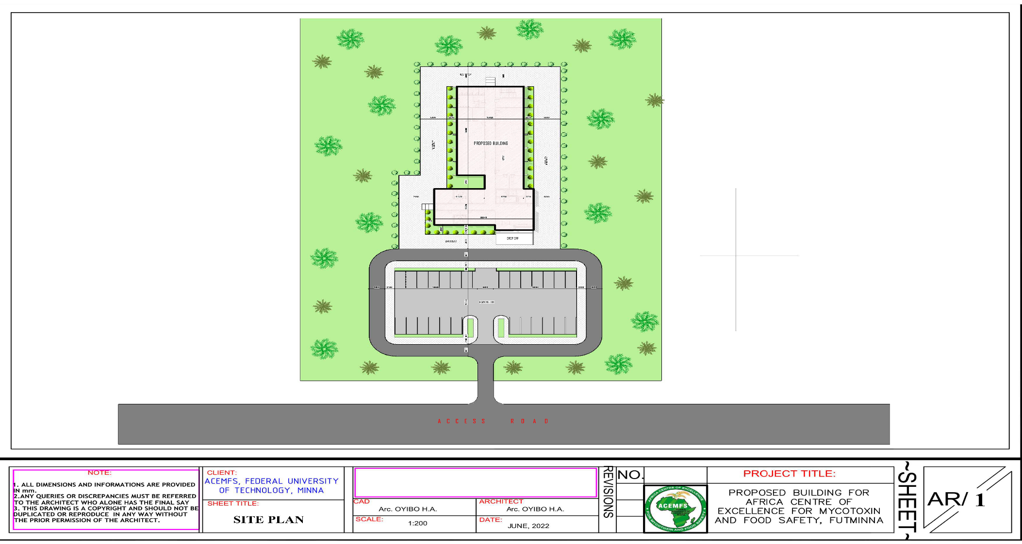
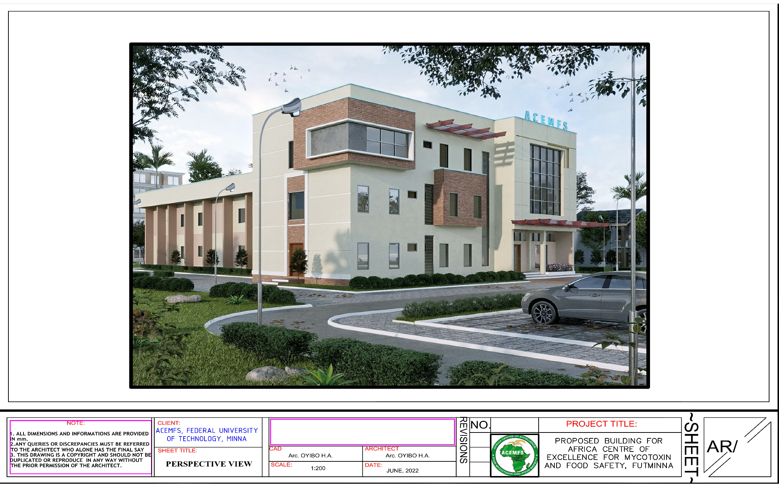
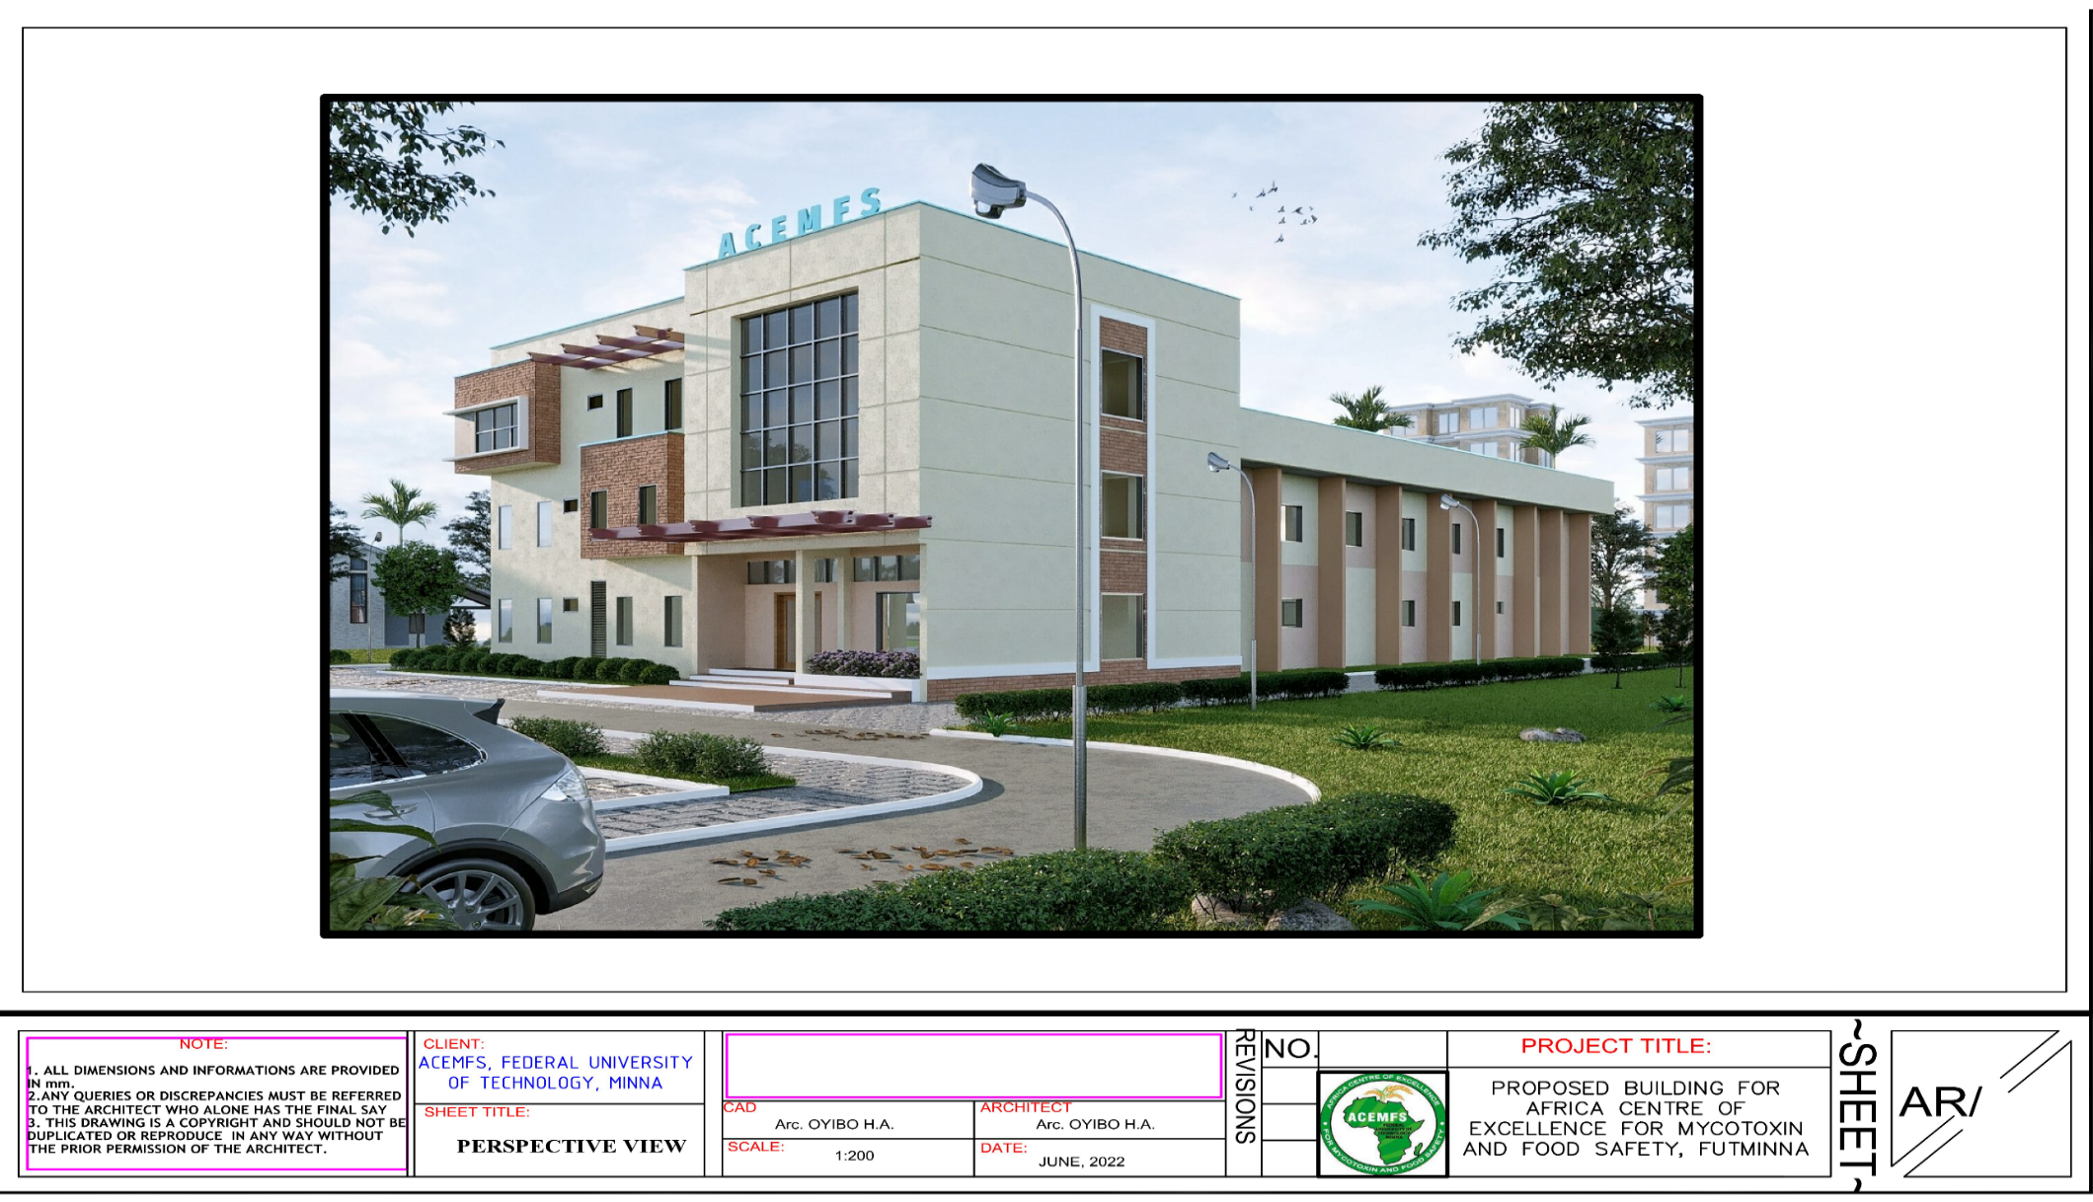

CHAPTER THREE

DESCRIPTION OF THE ENVIRONMENTAL AND SOCIAL BASELINE CONDITIONS

3.1 Introduction:
This chapter presents the baseline status of the propose construction site with respect to water, soil, air quality and noise level
The physic-chemical and biological components of an environment would normally receive impact impose through environmental activities and respond appropriately. As such these element & microorganism presents in the environment (soil, water & air) can be used to assess spatial-temporal changes which occurs in the environment as result of developmental impact.
In order to establish the baseline status of these parameters: site visitation/observation and environment media sample collection and in- situ air quality and noise level measurement of the proposed site were conducted.
Brief review of relevant literature relating to the host state, community and site was also done in order to establish the climate, topography, vegetation, Geology and hydrology within the proposed project site.

3.2 Project Location
Niger State was created in 1976 from the defunct North-west state and has on the GPS position is 9⁰25’00”N-9⁰40’00” and longitude 6⁰24’20”E-6⁰36’40” with its capital located in Minna having GPS position 9⁰25’00”N- 9⁰40’00’’N and 6⁰24’20’’E- and Lat. 8.5504° E, Ref: fig. 1.1. The project site is located at Federal University of Technology, Main Campus, Gidan Kwano, Minna.

The Federal University of Technology, Minna, Nigeria that house the Centre was established on the 1st February, 1983 and was later backed by Decree No. 13 of 1986. It is a specialized University of Technology established with a view to give effect to the Nation’s drive for the much-needed self-reliance in Science, Engineering and Technology. The State Government granted permission for the acquisition of 10 650 hectares of land along the Minna – Kateregi - Bida road as its permanent site, to carter for the inevitable expansion of the University. This acquisition was conveyed via a letter Ref NGSG/981/18 of 23rd February, 1983.
The site is relatively flat, slope gently eastward direction, hence can easily be drained and discharged into the natural stream eastward direction of the site. The site is accessed through the following roads (a) From the University gate to the roundabout to school of Life Sciences and extended to the subject site. The site can easily be connected to the electricity from the electric line that terminated at the School of Life Sciences 170 meters away from the subject site.

The site allocation was made known to the University community through the campus newsletter as expected. The University has information unit that publish major events within the University. The publication of the site in the University newsletter is to arouse the university community interest and to sensitize them on the Centre’s activities for possible observations and critic contributions as at when due. But the act establishing all federal universities in Nigeria made them semi-autonomous within their jurisdiction. Hence, the establishment of such a centre like this may not necessarily be subjected to the approval of neither agencies like NESREA nor the state environmental protection agencies.

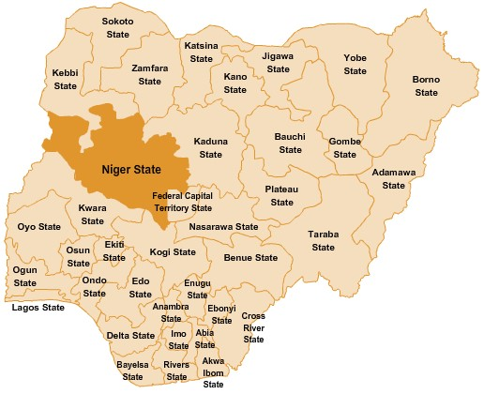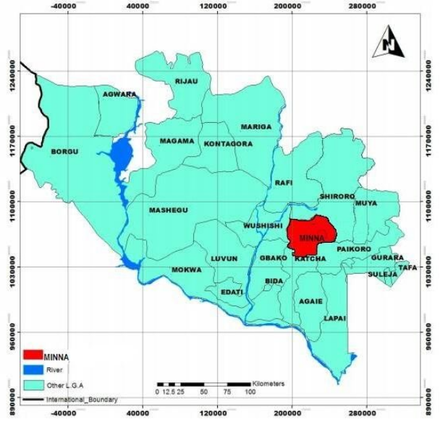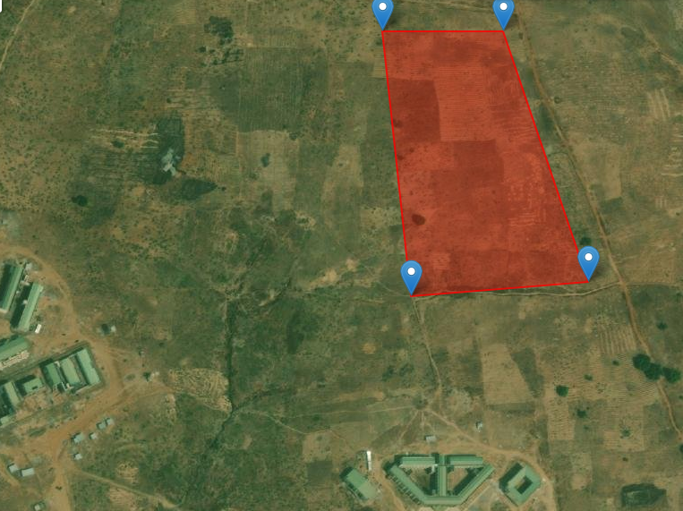Figure 3.0 Map of Nigeria showing Niger State and Project Location FUT Minna.

Map of Nigeria showing Niger State

Map of Niger showing Minna

Aerial map showing proposed study location,

ACEMFS FUT Minna, July 2022

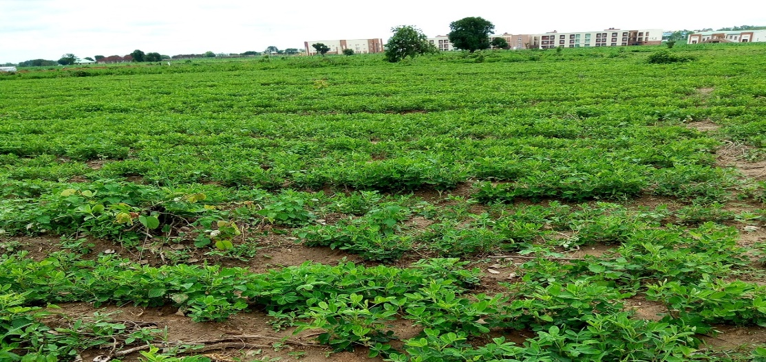
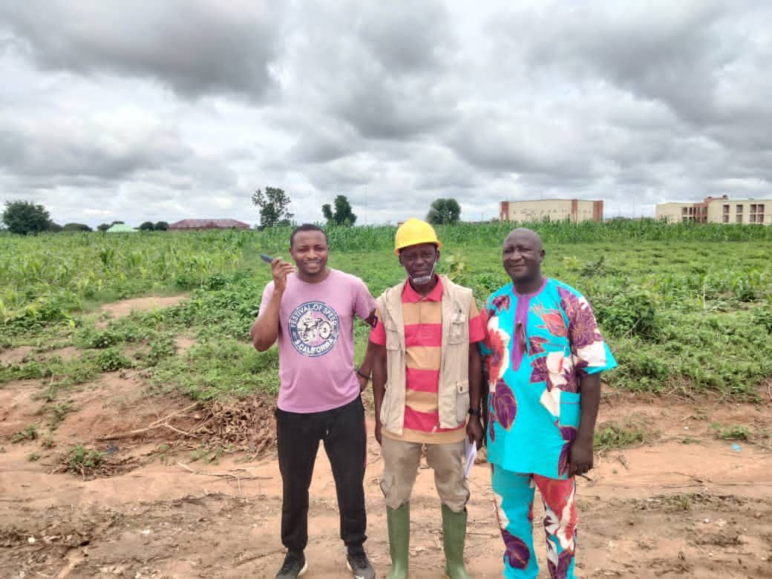
Proposed Project Site. Field study, July2022.

Consultant at Project Site with the Project Officials

3.2. Climate
The area is hot, humid and topical. The State lies within the north-central geopolitical zone of Nigeria and the climatic zone is a transitional climate type between the rainforest climate the south and Guinea Savannah climate of Northern Nigeria. The area has two distinct climatic regimes: rain season which begins from April and ends in October and dry season which begins from November and ends in March. Mean annual temperature is 35⁰C with the month of Mach recording the highest annual temperature of about 40⁰C. However, Minna the capital of the state where the proposed project is domicile lies in the Guinea Savannah climatic zone of the state.
3.2.1.1 Ambient Air Temperature
Over the year, in the project site, the wet season is oppressive and overcast, the dry season is partly cloudy, and it is hot year-round. Over the course of the year, the temperature typically varies from 15°C to 35°C and is rarely below 13.5°C or above 38.2°C. The project site is relatively warm and enjoys moderate amounts and duration of rainfall, thus, given the area a typical tropical ecological setting. Minna is characterized by two distinct seasons namely, rainy (from May through October) and dry (December – March); with the two seasons often separated by somewhat transitional periods in April and November. While, the months of February and March typify the peak of the dry season, with very high temperatures, the rains climax usually in August. The months of November through January are marked by cold and dry weather conditions (i.e., the harmattan) under the influence of the northeast trade wind. The vegetation of the study area is characteristically grass-dominated, forming a mixture of the southern and northern Guinea Savanna ecological biomes. Recent trends of climatic elements in the project site are presented thus.
Over the 30 years of examination, the absolute temperature of the project area depicts an increase with positive trend line equation of y=0.0985x+42.069 and regression equation of R² = 0.2746. The highest value of temperature (47.6⁰C) was observed in 2005 while the lowest temperature (41.2⁰C) was recorded in 1997 but will decline scenario of temperature values in the last four years. The monthly mean temperature of the project area depicts a decrease with negative trend line equation of y=-0.3111x+45.9 and regression equation of R²=0.2371. The general rise in the trend of temperature is similar to the global temperature rise (See Figure 3.1 and 3.2) which is an indication of climate change. Rising temperature could exacerbate Mycotoxin food contaminants in field, storage & processing conditions and postharvest could be influenced by changing rainfall scenarios.

Figure 3.1: Absolute Temperature in the proposed Area 1991 to 2021. (NIMET,2022)
3.2.1.2 Relative Humidity
Monthly average relative humidity from 1991 to 2021 for the project area is presented in Figure 3.2. The relative humidity of the project area depicts decrease with a negative trend line equation of y = -0.2506x + 74.251 and regression equation of R² = 0.218. This is clear indication of climate change (declining relative humidity) in the project area which could be an exacerbating factor to the occurrences of the Mycotoxin food contaminants in field, storage & processing conditions and postharvest could be influenced by changing rainfall scenarios.

Figure 3.2: Relative Humidity in the proposed Area, 1991-2021 (NIMET, 2022)

3.2.1.3 Rainfall Pattern
The annual trend of rainfall in the project area depicts depreciation from 1991 to 2021 with trend line equation of y=-14.897x+1476.1with regression of R² = 0.1341. This rainfall change is an indication of climate change as also observed in Figure 3.1. The monthly depicts a monthly increase trend in the value of rainfall from January to December with y = 7.2666x +55.909 and R² = 0.0697 (See Figure 3.3). It should be noted that rainfall is very important in contamination studies because of its ability to cause wet deposition. Monitoring Mycotoxin food contaminants in field, storage & processing conditions and postharvest could be influenced by changing rainfall scenarios. s

Figure 3.3: Average Monthly Rainfall distribution in the project Area (NIMET, 2022)

3.2.1.4 Cloud Cover
Cloud cover maximums were found to occur in both day and night time during the raining season most, with the mean cloud cover in the area being 57.9%. High amounts of cloud were observed in July (82%) and August (85%) which are the months of high rainfall in the project area. The lowest cloud cover was observed in December 19% and January 25%. The trend line depicts positive trend cloud with an equation of y = 0.2679x + 53.639 and R² = 0.5279. Despite’s this increase in in cloud; this does not translate into increase in rainfall in the project area.
3.2.1.5 Atmospheric Pressure
The average surface pressure of the project area from 1991 to 2021 is 99.01kpa. There is no significant variation in atmospheric pressure in the project site with y=-8E-05x + 99.021 and R² = 0.0003 (See Figure 3.7). Though the complex interplay between pressure and other meteorological parameters does not easily yield to straightforward analysis but this trend in Figure 3.7 does not depicts any relationship with other climatic elements in Figure 3.1; 3.2; 3.5
3.2.1.6 Solar Radiation
The average surface pressure of the project area from 1991 to 2021 is 42.6 kW-hr/m^2/day. There is slight decrease in solar radiation in the project site with y=-0.0524x+43.164 and R R² = 0.0713 (See Figure 3.8). Figure 8 do not depict link with key climatic elements like rainfall, temperature and relative humidity in the study are over the study period.

3.2.1.7 Wind Speed and Direction
The long term (1991-2021) wind distribution data retrieved and analysed for FUT Gidan Kwano Campus, Minna Niger State (Figure 3.9) shows that the wind blows generally from the South-South-East 48%, South-East 37% and South-South 12% of Nigeria at a speed of 1.00-3.40m/s for both wet and dry seasons, calm periods are frequently observed in the middle of the raining season (May, June July and August) when the atmosphere is saturated with atmospheric moisture.
The destinations of this wind are North-North-West 45%, North-West 35% and North of Nigeria 12% at a speed of 1.00-3.40m/s for both wet and dry seasons; calm periods are frequently observed in the middle of the raining season (May, June July and August) when the atmosphere is saturated with atmospheric moisture (See Figure 3.9). Information on frequency distribution of wind speed and direction is important since it provides the basis for accurate estimation of the dispersion patterns of pollutants in the atmosphere which plays significant role is spread of the several mycotoxins in agricultural products cause health hazards to people and animals and economical problem. Because mycotoxins are naturally present in foods, feeds and our environment and some of which are potentially carcinogenic and mutagenic, the contamination of mycotoxins could be exacerbated by prevailing wind in the area.
3.2.2 Air quality and noise level within the proposed site
Generally, the air quality parameters and noise level in the area were observed to be very low indicating that the proposed site is environmentally safe for the project. This is likely due to the absence of the students in school as a result of the ASUU, NASUU and SSANUU strike during this in-situ environmental parameters measurement. FUT Minna main Campus has established greenbelt within and around the campus, these established networks of trees are capable of cleaning the air with respect to suspended particulate matter and carbon IV oxide removal. Also, the recorded low values for most of the parameters might be connected to the Greenbelt environment that is in place around the propose project site.

Table 3.1: Air quality and noise level measurement within the proposed site
Sampling  point | Spm mg⁻³ | H₂S  PPM | So₂  PPM | CO  PPM | NO₂  PPM | TVOC  PPM | NOISE  Db | Coordinates
FLA1 | 0.08 | ND | 0.03 | 1.92 | ND | 0.21 | 31.2 | 11.152619N  7.64747E
FLA2 | 0.03 | ND | 0.01 | 2.05 | ND | 0.18 | 30.6 | 11.152619N  7.647240E
FLA3 | 0.12 | <0.02 | 0.10 | 2.64 | ND | 0.22 | 36.3 | 11.152409N  7.646968E
MEAN | 0.08 | <0.01 | 0.05 | 2.20 | ND | 0.20 | 32.7
FMENV L | 0.25 | 0.05 | 0.26 | 10 | <0.06 | 0.51 | 90
Source: Field Survey, July 20th , 2022.

3.3 Topography/Vegetation
Bosso LGA is within North-central basement complex terrain of Nigeria and the rock types are predominantly schist that are mostly exposed along River Chanchaga. The area is undulating comprising high hills and valley which slopes gently southward.
As a guinea Savannah climatic zone, the vegetation is characterized by grassland inter-phased with shrubs and trees. However, urbanization and agricultural land use has seriously altered the primary vegetation of the propose site area and majority of the plants as can be seen in the area are agricultural crops like maize, groundnut, yam etc. Below are pictures of yam and maize farm in portions of the proposed project site within the campus. (30/07/2022)
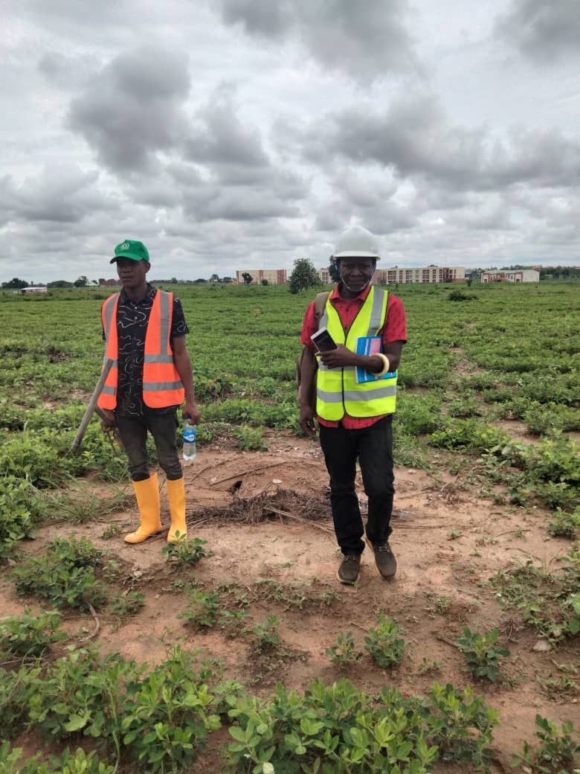  Consultant Taking Air/Sound Quality | 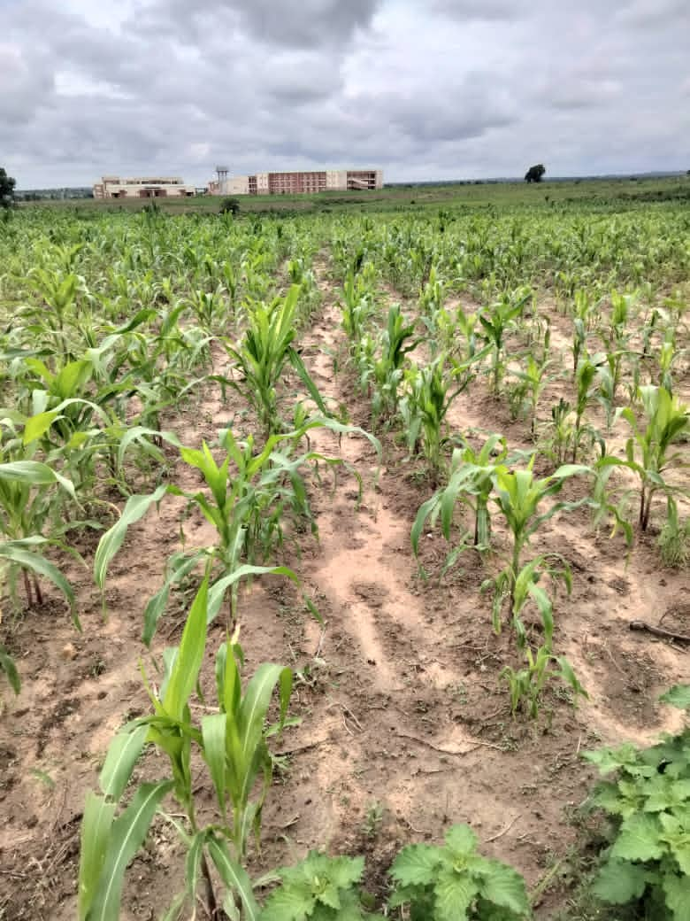  Corn planted within the Area

3.4 Geology and Hydrology
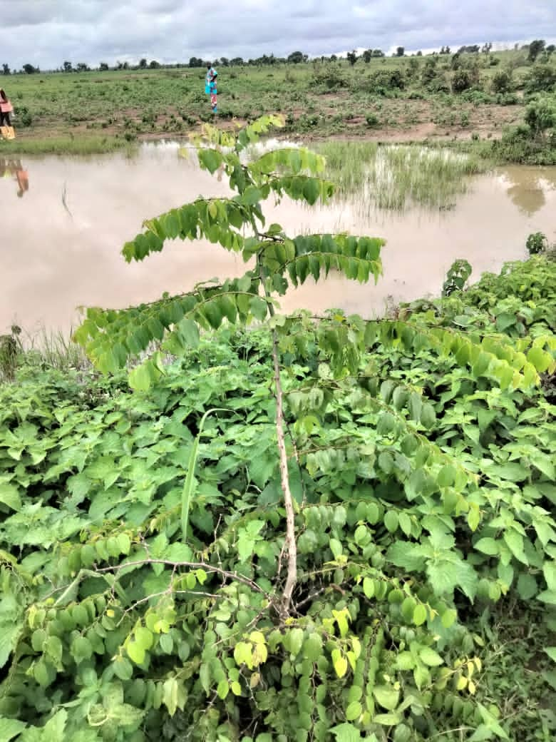  Sauropusandrogynus plants | 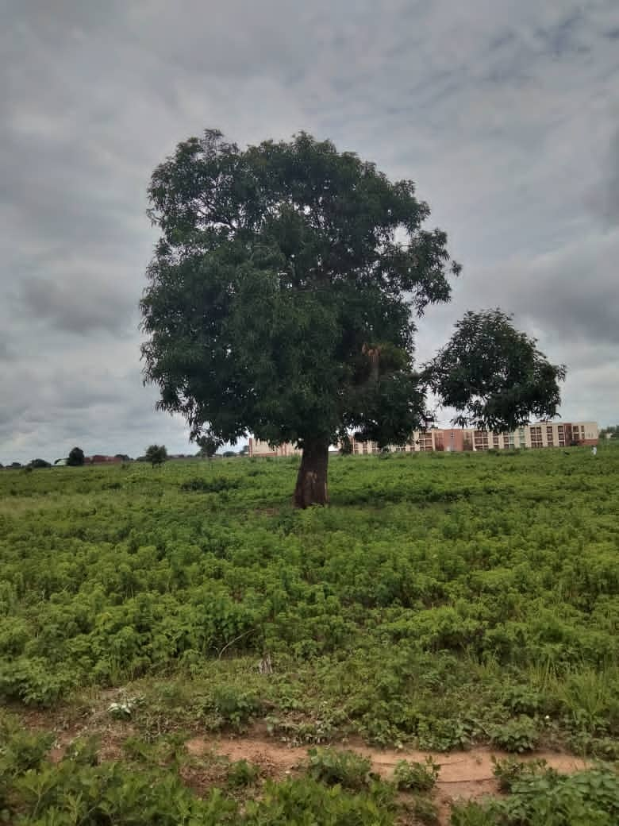  Enriching perspective of trees protecting biodiversity

As a basement terrain, the area is underline by crystalline and sedimentary rock. The crystaline rocks are made up of granite, gneisses, migmatite and schist while the sedimentary rocks are made of sand stone, clay and a shale.
River Chanchaga is the major river that drains the area and it flows from east to west. Most of the stream around the area takes their sources from the river.
In the BirninGwari formation within which the area falls, the fracture zone is within 30-50m at shallow level and 80-140m at deeper level. Shallow hand dug well depth is about 15m, hand pump borehole has depth of about 35m while motorize borehole have an average depth of about 80-140.
The site as it is now, has no stream cries-crossing around the area but a pond of seasonal surface water is within the perimeter boundary and the closest ground water was collected some few meters away
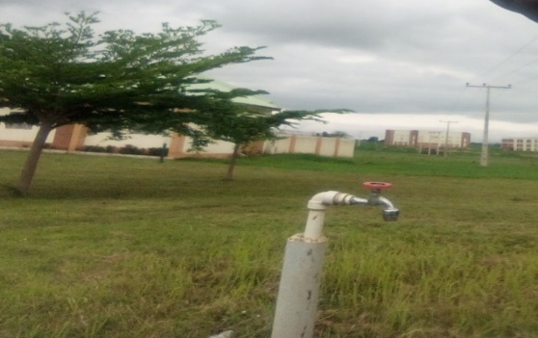
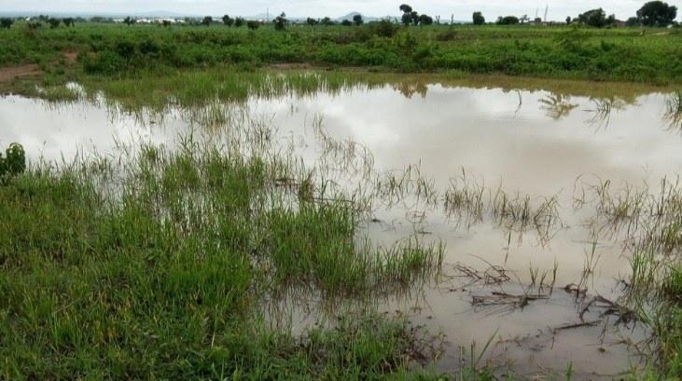
from the site. Precisely in the premises of doctoral research program in climate change and human habitat premise within the area as seen in the picture bellow.

Surface Water found within project site. Tape Water within the project

3.4.1 Sample Collection, Preparation and Analysis Methods.
The environmental media collected as samples within the project site were:
A: Water;
Surface and ground water within the proposed project site using prepared pvc 500ml sample bottles. Surface water were fetched directly by immersing completely the pvc plastic bottle into the water with hand to avoid air being trapped in the bottle.
Collection of ground water was done by fetching directly from outlet tap of the borehole into the prepared bottle.
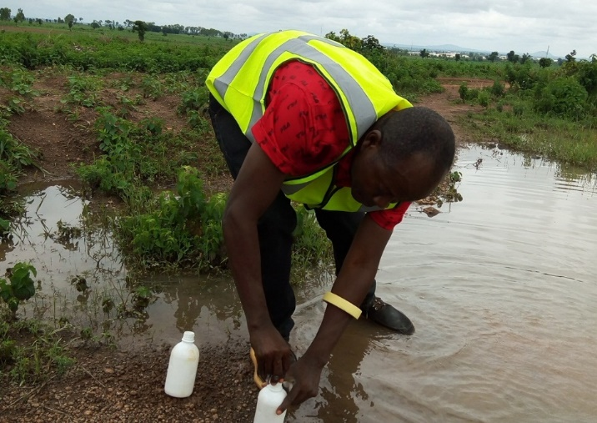
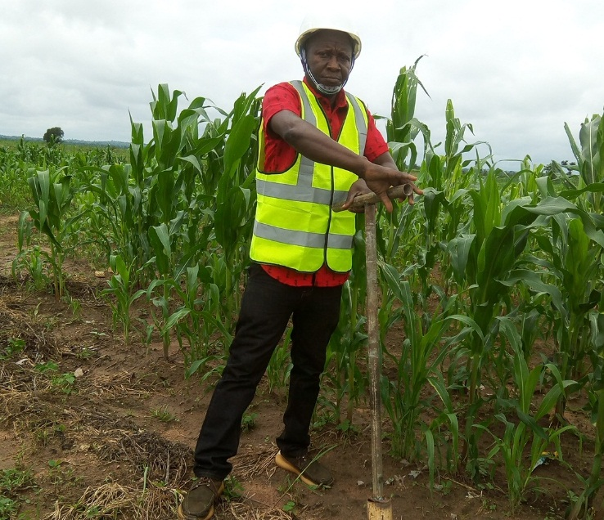
Water and Soil sample collection at the project site, July, 2022
Water samples went through wet digestion as a preparation step for elemental determination. Surface water has turbidity >1NTU, hence were digested with HNO₃ 67%: H₂SO₄ 98%:Hcl 37% : HF 40% RATIO 2:1:1:1. While water has turbidity <1NTU, were digested with HNO₃ 67%: Hcl 37% in ratio 3:1
Determination of trace elements and heavy metals were done on the digest using Flame Atomic Absorption Spectrophotometer (FAAS) with Air/ Acetylene flame.
For the non-metals and anions analysis, water was filtered through 0.45 microns filter, appropriate reagent added to specify measured volume of water. Analysis for anions were done using LAMBDAXL/XLS model UV-VS Spectrophotometer.

B: Soil;
Top soil 0-15cm and sub soil 15-30cm were collected each separately using local fabricated soil Auger. The grabbed sample of soil for each stratum were mixed and a reasonable quantity (100-120g) taken from the mixed soil to form a representative composite soil sample of the site as describe in the representative diagram of the propose site bellow.

Table 3.2 Sampling Points
A  9.5431780N, 6.45467632E | B  9.5430286N, 6.45257557E
C  9.5448568N, 6.45417360E | D  9.54468763N, 6.45333875E

Each stratum of soil sample was grabbed from position A, B, C and D respectively, as defined by the coordinates respectively, then mixed and a reasonable quantity (100-120g) taken from the mixed soil to form a representative composite top/ sub soil sample of the site as the case may be.
Soil sample Collection.
Labelled samples of soil from the field were entered into laboratory log book. Then they were air dried at room temperature for Two weeks. Stones and other extraneous constituents were picked out with hand and the soil samples were then crushed with mortar and pestle.
Crushed soil samples were wrapped in foil paper, labelled and stored in desiccator while the analysis began immediately.
Soil extract were obtained through leaching of measured quantity required for determining specific soil parameter.
Extractable cations were determined using Flame Atomic Absorption Spectrophotometer (FAAS). Dispersion and Hydrometer test methods for particle size analysis.

C: Air Quality and Noise Level.
Air Quality and noise level of the area within the propose project site were assessed and the result reviews against regulatory limit of federal ministry of environment (FMEnv) to establish the site air quality parameter baseline status. In-situ air sampling was carried out using PCE – mpc10 multi-parameters gas detector with range 0.01-15.00mg/m^{3.} Ambient air was drawn by the calibrated instrument at the sampling points and the subsequent digital reading for the various parameter were read off the instrument.
The result of the measured air quality parameters /Noise level is presented below in the Annex.7.

3.4.2 Results/Findings:
Air:
The average concentration of these measured parameters compares favorably with maximum allowable limits as established by regulatory body; Federal ministry of environment (FMEnv).and the WB standards.
As such the atmosphere within the site is safe with respect to the measured parameters and noise level.
Flora and Fauna:
A number of diverse assemblages of organisms exist within the study area. Organisms observed in the area include, birds, reptiles etc. Vegetation types include guinea savannah suitable for the cultivation of crops. The project activities would have an impact on the flora and fauna population of the area.
The project would require the removal/clearing of vegetation for the commencement of the project. The resulting effect would be the loss of flora species in the site as well as migration of fauna species that make use of the vegetation for food and shelter further away into the forest. There would also be loss of trees products (fuel wood, medicinal, shade etc.) due to site clearing and preparation.
Apart from clearing activities, noise from vehicle and heavy-duty machinery use would cause noise and vibration which would scare fauna species away and further into the forest as was earlier mentioned. Generally, the impacts on flora and fauna species are termed minor significant.
During the construction, permissible /acceptable human noise levels can be temporarily exceeded due to the operation of vehicles and equipment in the working zone. Noise abatement measures will be taken in the area crossing the residential/educational areas, including adequate work scheduling.

Soil:
Land and soil constitute the foundation for sustainable engineering infrastructural development of any society and it is a key in proper ecosystem function and life sustenance. Hence, it is important that baseline status of soil in areas to be used for physical development be established so that mitigation against future impact of such projects can be measured and compare.
The result of physiochemical/biological characteristics of soil within the proposed site is presented in Annex 14. The textural composition of soil within the site is sandy loam and sandy clay which is a reflection of the characteristics of the North-Central basement.
Soil C is a control sample and the result compare well with the known values of its previous result. The result compares well with maximum limit established by Fen. and indicate that the soil is safe with respect to the measured parameters.

Water:
The result of physiochemical biological characteristics of water (ground and surface) is presented in Annex 14. It shows that ground water is slightly acidic while the surface water is slightly basic.ME limit, indicating that the surface water is unsafe for any portable use.

3.5 Land Use of the Project Site
The project area is an academic institution (FUT Minna, Main Campus, Gidan Kwano Campus). Outside the campus/project site fallow land was observed and agricultural is one of the major land use categories outside the campus. Apart the land being put into urbanization due to the presence of institution FUT, farming is also a major utilize land around the project site. Common crops cultivated include sugar cane, maize, millet, guinea corn and vegetables. Subsistence fruit crops like mango, cashew, and pawpaw were spotted around existing and farmlands.

3.6 Socio-Economic Environment
As a new university campus that is located at the periphery of Minna metropolitan area is relatively free from major socio-economic activities. The current metro-area population of mina in 2022 is 473,000, a 3.46% increase from 2021. The Metro-area population of Minna in 2021 was 463, 000 a 3.35% increase from 2020. Minna is the capital city of Niger State; it consists of two ethnic groups: Gbagyi and the Lupe. The languages spoken in the state include; the Gbagyi, Nupe,Kamuku, Kambar, Gungawa, Hunsaare, Hausa, Yoruba and Koro form the numerous indiginious tribes of Niger state including some foreign nationals from Asia and Arab. It is rank first of the 36 state with a population of 3,954, 772 and land area of 29,484 sqm. Minna been a railway town, and also commercial centre of differenttribes, raceand culture. Minna is a town dominated by Gbagis.

3.6.1 Population of Community
The study population is inhabited mostly by students and Staffs of Federal University of Technology, GidanKwano Campus, Minna, Niger State. The total student enrolment in the university's degree and postgaduate programme is about 15,000 (Male about 6000 and Female about 9000), drawn from every part of the country and outside. There are about 1,000 academic and research staff and 2,500 support staff.

3.6.2 Social-economic Characteristics and Health Condition
The project area is an academic community with a common socio-cultural characteristic. The community is universal in nature, most practise Islam, some Christianity and some Traditional believes and some Atheists. The major socio-economic activities are academic related with business centres to service the academic institution. Details of findings on socio-economic characteristics of respondents are presented in Table 3.2.

Table 3.3: Gender Base Profile for Study Community
FUT MINNA COMMUNITY
GENDER BASE PROFILE FOR SELECTED HOUSEHOLD | HOUSEHOLD SIZE |  | EDUCATION PER HOUSEHOLD |  | EMPLOYMENT PER HOUSEHOLD
HOUSEHOLD / | M | F | M | F | M | F
SALISU IBRAHIM | 4 | 4 | 3 | 2 | 1 | 3
MOHAMMED IBN | 3 | 7 | 3 | 2 | 3 | 2
YUSUF MICHAEL | 3 | 2 | 2 | 2 | 3 | 2
RAHILA DANIEL | 2 | 3 | 1 | 3 | 2 | 3
JUMAL YUSUF | 3 | 2 | 3 | 2 | 3 | 2
DANLADI IBRAHIM | 5 | 3 | 3 | 4 | 4 | 4
HABIBA MAITALA | 2 | 4 | 2 | 3 | 2 | 2
JOHNSON CHUKWU | 1 | 1 | 0 | 0 | 2 | 1
ADEMOLA MUBARAK | 3 | 2 | 3 | 2 | 3 | 2
DANJUMA KHALID | 3 | 5 | 2 | 3 | 2 | 1
MAIMUNA GRIBA | 2 | 3 | 1 | 3 | 2 | 3
YAKUBU ISMAIL | 4 | 3 | 3 | 3 | 2 | 3
NASIRU IBRAHIM | 2 | 1 | 2 | 1 | 2 | 1
HALIRU DOGO | 3 | 2 | 2 | 2 | 3 | 2
DANIEL SAMBO | 1 | 1 | 1 | 0 | 2 | 1
SARKI TANKO | 3 | 1 | 3 | 1 | 2 | 1
MAIMAIKO HARUNA | 2 | 3 | 1 | 3 | 2 | 3
TOTAL | 46 | 41 | 35 | 36 | 43 | 36
Source: Field Survey, Nov, 2022.

Sources of Water | Responses | It was observed that 31.305 of the respondents sourced their domestic water from public pipe, 12.50% of the respondent sourced theirs from private boreholes, and 43.75% got their water from well while 12.50% of the respondents get their domestic water from water vendors within the project area.
Public Pipe | 5
Private Borehole | 2
Well | 7
Water vendors | 2
Total | 16
Primary Sources of Electricity | Responses | Within the project area, all (100%) of the respondent’s primary source of power is from the PHCN.  None of the respondents assert that their primary source of power is from Hurricane lamp, generator, and state energy.
Hurricane Lamp | 0
Generator | 0
State Energy | 0
PHCN | 16
Total | 16
Secondary Sources of Electricity | Responses | The alternative source of power by the respondents in the project area is 100% from generator.  Power is not alternatively sourced by the respondents from Hurricane lamp, PHCN, and state energy.
Hurricane Lamp | 0
Generator | 16
State | 0
PHCN | 0
Total | 16
Method of waste Disposal | Responses | The most prominent method of waste disposal in the project area is open dumping as asserted by 50% of the respondents.  Organised collection is a source of waste disposal as observed by 31.30% of the respondents while 18.80% opined that burning of waste is common around the offices.  None of the respondents bury their generated waste or dump the waste in the bush.
Burying and Bush | 0
Burning | 3
Open dumping | 8
Organized collections | 5
Total | 16
Source: Consultant fieldwork, July, 2022.

Socioeconomic Baseline
The methodology for collecting socioeconomic data is primary source during consultations with community leaders, members, and other stakeholders. Socioeconomic baseline of the subject community was collected through administration of electronic socioeconomic questionnaire using Kobo toolbox/ODK Collect. The summary of socioeconomic condition of the project area is presented in the Table 11 below.

Table 3.4: Demographic characteristic of the respondents in the Community
No. | Parameters | Percent | Remark
 | Respondents |  | This is indicative of more household Heads and senior Departmental Heads than the students as a result of the on going ASSU and NASSU strike in the country. However, when school resumes, there will be more students than the heads of the groups.
 | Heads of Departments  Household Heads  Students  Others | 34.5% 34.5% 25% 1%
 | Gender Distribution  Male:  Female: | 62%  38% | This is indicative of a more male presence within the community and a lower women labour force within the communities. Contractors may be constrained in establishing gender balance for local labour. However, more considerations should be given to female applicants.
 | Age Distribution  Less than 18 Years  18 - 30  31 - 45  46 – 55 and above | 10%  35%  45%  12% | The respondents were mostly adults above 18 years. Similarly, the constitution of respondents from widespread age groups implies that varying views from younger to older respondents concerning the project activities were incorporated. The age distribution indicates the presence of local workforce for unskilled labour.
 | Marital Status  Married  Single  Divorced | 56%  42%  2% | This indicates that the communities are mainly family-based communities, with fewer percentages of singles. This shows opportunity for direct and indirect benefits from integrating community members into the project for such opportunities create corporation and understanding. Local skilled/unskilled labour shall benefit from the project.
 | Residency Duration  Less than 5yrs  6- 10yrs  11-15yrs  16 and above | 37.5%  25%  25% 12.5% | The study reveals that majority of the respondents lived for less than 5yrs. This shows that the communities are primarily characterized by small family sizes. This indicates a smaller size of dependents, and a higher number of income earners in families
 | Literacy level  FSLS/Islamiya School  WASC/SSCE  OND/NCE  HND/BSC  MSc/PhD | 0%  0%  7%  10%  83% | Most of the respondents had postgraduate education few of the respondents have NCE and BSc. with a higher fraction with tertiary learning. This indicates presence of higher skilled worker force from the community, and a lower availability of unskilled labour. Unskilled labour will be expected from a far neighbouring communities.
 | Ethnicity (Languages)  Nupe  Gbagyi  kamuku  Hausa  Igbo  Yoruba  Gbagyi  Koro | 28%  10%  8%  44%  4%  3%  2%  2% | Hausa is the major ethnic group in the Gidan Kwano within the project community. Other minority groups were identified. The selection process for workforce should take into consideration these minority groups and should not be neglected to avoid ethnic discrimination. The studies revealed that Niger State in general is dominated by the Nupe people in the south, Gwarri in the east, the Busa in the west, and Kamberi Hausa, Fulani, Kamuku, and dakarki in the north. Islam is the most predominant religion.
 | Occupation  Civil Servant  Farmer  Trader  Teacher  Others | 2%  16%  48%  6%  28% | Most of the respondents are traders, who are involved in mini to petty trading within and around the community. Others are involved in artisanal activities, due to the nature of a predominant activities of the city (infrastructural development).
 | Income Earners  1  2  3 and above  None | 48%  42%  8%  2% | Although most of the families are large, the number of income earners are not commensurate in the families. This is indicative of financial strain, which may lead to increase in out-of-school children if the cost of accessing education is high, including transportation to schools.
 | Average Monthly Income  More than N30,000  N0 - N10,000  N10,000 - N20,000  N20,000 - N30,000 | 58%  4%  6%  32% | Most of the respondents earn above the minimum wage (N30,000). Opportunities for employment for locals on the construction work may contribute significantly to the income of community members who may be involved in providing labour for contractors.
 | Sanitation Facilities  Water Closet  Water Closet & Pit Latrine  Pit Latrine | 52%  2%  46% | Contractors should ensure to provide sanitary facilities during construction phase, so as not to exacerbate any existing sanitary conditions within the communities.
 | Waste Management  Open Burning  Open Dumping | 4%  96% | Construction works may increase generated solid waste. The contractors will have to liaise with the NOUN FMU and AEPB to manage construction wastes.

Discussion of Socio-economic Environment
The project area seems to be a self-sufficient community with the availability of Nursery school, primary schools, tertiary school, shops/minimarts, worship centres and business centres. Generally, the road to the community, roads within the community, the community schools, community health facilities, portable water, electricity ICT facilities and available recreational facilities are relatively in good conditions as depicted in table 3.7.
Social problems experienced in the community are drug addiction among youths, indiscriminate sex, thugery activities and child labour among others.
Twenty five percent (25%) of the respondents were student of the postgraduate school, 37.5% of the respondents were Heads of departments within the campus. Deputy director of procurements, Head of Estate management and Deputy director of Centre for Leadership was also consulted for this study. Also 37.5% of the respondents were Heads of household within the Gidan Kwano Campus of FUT Minn.
Majority of the respondents (62.5%) in this study were males while 37.50% of the respondents in this study were females male. This not farfetched from the reality that the male gender dominates the institution of learning Nigeria particularly in the Northern States of Nigeria where culture and religion is critical in women attendant in the educational sector.
The respondents were all adults from 17 years and above. Significantly, the workforce age constitutes of 54% of the population (26-64 years old), while the older age (65 years and above) is 13% and represent the age bracket that may be vulnerable.
Similarly, the constitution of respondents from widespread age groups implies that varying views from younger to older respondents concerning the project activities were incorporated
Among the respondents, 56.20% of them were married while 43.80% of the respondents were not married. None of the respondents is divorced or widowed.
Observations depicts that 37.50% of the Respondent have lived for less than five years in the project site, 25% lived between 6 to 10 years in the project site area so also 25% have lived for 11 to 15 years. Only 12.50% of the respondents lived for over 16 years in the project area.
Findings depicts that up to 37.50% of the respondents earned less N50,000, 25% of the respondents earned N101,000 to N200,000. Also 37.50% of the respondents earned over N201,000. It was observed that None of the respondents earned between N51,000 to N100,000. The least earned among the respondents were students.
Incidences of insecurity are not a common event in the Project area as expressed by all the respondents (100%). It obvious that the area is safe for any form of constructional activities.
It was revealed 32.65% of the respondents that Malaria Fever and Typhoid Fever are the common types of diseases in the project area. Cholera is also prominent as declared by 25.50% of the respondents. Hepatitis, diarrhoea, cough is among other diseases common in the project area.
The dominant diseases outbreaks in the project area in recent years is cholera as opined by (87.50%) of the respondents.12.5% of the respondents asserted that lesser fever outbreak was registered in the area.
It was observed that 68.80% of the respondents have no contact with patients during such outbreaks in the hospital.Only 31.30% of the respondent having contacts with the patients in the hospital during the outbreaks.
Vulnerable Groups
Vulnerable groups identified during the field assessment are presented below. The criteria for selection included: (i) easy predisposition to SH and SEA, contracting STIs and STDs or unwanted pregnancies (social vulnerability); (ii) occupation; and (iii) socioeconomic status.
- Female workers and onsite vendors: They stand the risk of suffering SH, SEA, contracting STIs, STDs or unwanted and/or early pregnancies caused by workers, especially at the pre-construction and construction phases. Stringent conditions for engagement may discourage female participation, and constraint them to succumb to advances for sexual favours in return for an opportunity by their male counterparts or contractors.
- Occupation (Petty traders): who reside or offer petty trading services within project communities where contractor’s personnel may go to buy commodities. They may also stand the risk of being cheated by Contractor’s personnel who may buy “on-credit” with a promise to pay, and never do so.
- Socioeconomic status: those earning below the government minimum wage (N30,000) who may depend on the payments for services to sustain themselves and their dependents. Delay in payments on the part of contractors may cause ripple effect for the workers and their dependents.
Associated negative impacts associated with vulnerable groups have been identified in Chapter 4 below and mitigation measures are included on the ESMP matrix table.

CHAPTER FOUR

ASSESSMENT OF ADVERSE ENVIRONMENTAL AND SOCIAL IMPACTS

4.0 Introduction
Methods and Techniques used in assessing and analyzing the environmental and social impacts of the proposed construction. A risk assessment matrix (Table 4.1) was used to determine the risk of each individual environmental aspect relevant to the Construction of design studio complex and installation of ancillary equipment’s. The level of risk determined from the matrix identifies the level of control measures required for that environmental aspect. These risks are to be mitigated through the application of measures identified in this EMP.

Table 4.1: Risk Assessment Matrix

 | Probability
Consequences |  | A | B | C | D | E
 | 1 | H | H | H | H | M
 | 2 | H | H | H | M | M
 | 3 | H | H | M | M | L
 | 4 | M | M | M | L | L
 | 5 | M | L | L | L | L

Explanatory notes on the selection of the consequence and probability for each issue are presented in Below – Risk Matrix Explanation.

Table 4. 2: Risk Matrix Explanation
Probability |  |  | Consequence
A | Almost Certain. | Expected to occur, quite common. | 1 | Major | Major environmental harm. e.g., major pollution incident causing significant damage or potential to health or the environment, loss on vegetation cover.  Fines and prosecution likely
B | Likely | Will probably occur, has happened | 2 | Significant | Long term or serious environmental damage.  Numerous complaints received.  Potential for prosecution.  Loss of reputation
C | Possible | Might occur at some time | 3 | Moderate | Moderate environmental impact.  Will cause complaints.  Possible fine
D | Unlikely | Could occur at some time although unlikely | 4 | Minor | Minimal environmental harm.  Potential for complaints.  Fine unlikely.
E | Rare | Might occur at some time in exceptional circumstances. | 5 | Insignificant | Little or no environmental harm.  Little potential for fines or complaints.

4.1 Potential Social and Environmental Impacts
The project is expected to have high positive environmental and social impacts for impacted communities in the project area and the west African coast at large as it provides incentives for establishing innovation platform for knowledge flow and collective dialogue between farmers, researchers, industries, Agricultural business and educational institutions in the region and increase in food production, improved environmental management and livelihoods. The negative environmental and social impacts will largely be localized in spatial extent, short in duration, occurring within less sensitive environmental areas and are manageable through the implementation of appropriate mitigation measures. Based on the assessment, the potential environmental and social impacts are outlined in Table 4.3.
Project Area of Influence
The area of influence of the proposed building complex will be described with respect to the following:
- Physical Environmental Media Influence.
- Geographical Area of influence.
- Community influence and vulnerable persons in the institutions and
- Institutional Influence

Physical Environmental Media Influence
The proposed project's activities may have an impact on air quality, land (landscape), and surface and ground water. The proposed project site's landscape features include soil, flora, and fauna, and runoff water will be channelled to drains along the proposed site.
Community Influence and Vulnerable Persons
The proposed project's implementation could have an impact on the economic conditions of nearby communities. Construction projects provide opportunities for local food vendors to sell to construction workers in a secure environment.
Artisans and other construction workers will also be employed on a temporary basis as a result of the project. Vulnerable groups are those who are at risk of being disadvantaged and require special consideration in project design. Vulnerable individuals include, but are not limited to:
- Disabled members of the community and Children.
Institutional Influence
The major institutions to be influenced or involved in the proposed project include:
- FUT Minna
- National Environmental Standards Regulatory Agency NESREA
- Federal Ministry of Environment
- Physical Planning/ Works and Services Department, FUT Minna.

4.2 Impacts Identification
The proposed project is expected to be largely beneficial to the adjoining communities, students and staff of the University, the MINNA and Nation at large. The proposed construction activities will take place within the premises of the FUT Minna, however, the nature of civil work activities entailing the use of heavy equipment, earthworks and labour influx will inevitably predispose the bio-physical and social components of the environment to varying degrees of negative impacts. The following sections highlights the potential environmental and social impacts, positive and negative, of the proposed construction works.

4.2.1 Identified Positive Impacts
- The positive impacts of the proposed works are highlighted below. Increased enrolment of students for postgraduate studies in food safety, toxicology, Molecular biology and Bioinformatics technology and IT courses such as cybersecurity, computer sciences and information technology, etc.
- New infrastructures including IT laboratories will enable enhanced learning for physical and virtual students.
- The project will promote human capital development which will support economic growth and poverty reduction.
- It is envisaged that the project will create short term employment for skilled and unskilled workers during the construction phase.
- The project supports achievement of some of the Sustainable Development Goals (SDGs) including SDG 1: No Poverty, SDG 4: Quality Education, SDG 6: Clean Water & Sanitation, and SDG 9: Industry, Innovation & Infrastructure
- The project GBV activities, including Code of Conducts etc. will support the overall drive for the FUT MINNA in prevention of GBV related issues and provision of a response mechanism for survivors.
- Promote synergy amongst MDAs at the state level including FUT Minna and the Federal Ministries of Women Affairs, Environment, Health amongst others.
- Improved landscape and aesthetics of the FUT Minna.
- Improve quality of education and education delivery in Nigeria.

4.2.2 Identified Negative Impacts
Table 4.3: below highlights some of the potential negative impacts of the project.

Table 4.3: Identified Potential Negative Impacts
Potential Negative Impacts
Environmental & OHS Impacts | Social Impacts
- Land clearing activities could lead to loss of vegetation cover and soil erosion.  - Noise pollution from movement/operation of vehicles and machineries/equipment operations  - Sourcing of construction materials such as sand, clay, gravels will lead to impacts related to sand mining and extraction of gravel from unlicensed quarries.  - Grievance from recruitment process, especially for women who may be impacted by any stringent requirement, and where special considerations and wavers are not provided for women.  - Risk of aquifer over-exploitation and pollution of ground water resources due to borehole drilling.  - Occupational health & safety risks from civil works and operation of machinery could lead to injuries, accidents for workers.  - Poor labour and working conditions could lead to ill-health, grievances, discrimination etc.  - Waste generated from construction activities such as cement, wood, iron rods etc. could lead to environmental pollution if poorly managed. This could also lead to public health concerns especially for the students  - Electrical and electronic wastes such as electrical wires, sockets etc. could lead to toxicity if poorly managed  - Risk of increased air and noise pollution.  - Occupational health & safety risks from civil works and operation of machinery could lead to injuries, accidents, electrical shocks for workers  - Poor labour and working conditions could lead to ill-health, grievances, discrimination etc.  - Risk of underground water pollution if borehole is situated too close to septic tanks for the toilet facilities  - Waste generated from construction activities such as cement, wood, iron rods etc. could lead to environmental pollution if poorly managed. This could also lead to public health concerns especially for the students  - Electrical and electronic wastes such as electrical wires, sockets etc. could lead to toxicity if poorly managed  - Poor maintenance of toilet and WASH facilities could lead to damage of facilities and environmental pollution especially from poor sewage management. This could lead to air, land and underground water pollution  - Burning of e-waste and debris as a disposal/management procedure may increase the risk of global warming and climate change  - Increased e-waste generation from spoilt computers, waste inverter batteries, broken solar panels, wires, etc.  - Risk of electrical fire which may lead to fire outbreak.  - Poor management of healthcare waste from the clinic and exposure to humans could lead to environmental pollution from injection of harmful substances into soil and water and affect soil and water organisms | - Risk of minor traffic build up and delay in travel time at the FUT Minna Main Campus junction and the entrance gate, EFCC during mobilization of equipment and materials to and from the proposed site.  - Disturbance of the FUT Minna community due to construction activities such as movement of vehicles/materials/equipment to site and civil works/operation of machinery on-site.  - Risk of pedestrian and vehicular accidents between contractor’s vehicle and staff of FUT Minna using the road, and other road users.  - Conflict may arise between Contractor’s workers and the staff of FUT Minna who are responsible for waste management for the University.  - Labour influx may induce SEA/SH/GBV risks, risk of STIs/STDs for community members, students and staff of the FUT Minna.  - Vulnerable groups could be further disadvantaged by not benefitting directly from the project either as engaged labor or school facilities if there are no provisions for inclusion  - Sourcing for unskilled labour may lead to risks of child labour during construction activities. This could further predispose children to health & safety risks, Violence Against Children (VAC) etc.  - Poor labour and working conditions especially wages for community workers could lead to grievances  - Grievances could arise from non-payment of rental fees and poor usage of facilities by the contractors such as staging areas, campsites etc.  - Persons with Disability (PWD) may further be disenfranchised during operations if considerations such as ramps are not provided in the project design for classes / WASH facilities.  - Burning of e-waste and debris as a disposal/management procedure poses risks to human health of staff/persons around the ACEMFS in the form of Respiratory tract infections (RTIs)  - Poor management of healthcare waste from the clinic and exposure to humans could lead to public health concerns such as infections, injuries etc.

4.4 GBV Risks and Management Measures
The continuous social interaction between contractor’s personnel and community members, onsite food and petty items vendors, and staff of the FUT MINNA may trigger GBV/SEA/SH issues.
Gender-based violence (GBV) – including sexual harassment, exploitation and abuse – is a prevalent feature in settings across countries where the World Bank operates. In order to understand and address more effectively key drivers that contribute to incidence of GBV, the recently released report by the Global GBV Task Force emphasizes the need to improve social risk assessment and specifically assessment and identification of key risks of Sexual Exploitation and abuse (SEA) and GBV. In particular, the report highlights the extent to which existing World Bank-supported projects may compound broader contextual risks of GBV in a society, community or relationship that already contribute to prevalence of gender-based violence.

4.4.1 Measures taken to Mitigate GBV/SEA/SH Risks
Key actions to be implemented by the ACEMFS/FUT Minna project include the following:
- Include information on SEA/SH prevention and mitigation considerations in all relevant documents such as ESMPs, C-ESMPs ToRs, bidding documents
- Ensure the inclusion of qualified GBV officer on the PIU
- Strengthen the Counselling Unit for ethical handling of GBV/SEA through training and capacity building. Designate a GBV focal person who will be trained by the project on handling cases in line with the section 5.4 of this ESMP on GBV GRM protocol to ensure confidentiality, survivor-centered approach and referral of cases.
- Produce GBV Code of Conducts (CoCs) for all staff/workers and conduct training on CoC.
- Establish collaboration with the Federal Ministry of Women Affairs.
- Identify local NGOs with capacity as first respondents to provider psychosocial support services to survivors in an ethical and survivor-centered approach.
- Produce posters and billboards to discourage any form of GBV, including SH and other workplace related GBV risks.
The ACEMFS Project team, particularly the gender/GBV officer and the Environmental & Safeguard Officer will conduct periodic monitoring to ensure the project is implemented in accordance with the relevant SEA/SH preventive contractual provisions.

4.5 Environmental and Social Management and Monitoring Plan
The environmental and social management and monitoring plan for matrix presents site-specific mitigation measures for potential negative impacts of the project. The matrix also presents the plan for monitoring compliance, defines the costs for mitigation and monitoring, frequency of monitoring, parameters to be monitored, and responsibilities for mitigation and monitoring. This is presented in the Table 13

Table 4.4: Potential Impact Mitigation and Monitoring
Preconstruction Phase
S/No | Activities | Potential Impact | Mitigation Measures | Responsibility for Mitigation | Mitigation Cost (NGN) | Parameters to be measured | Method of measurement | Performance indicator | Sampling Location | Monitoring Frequency | Institutional Responsibility (Monitoring) | Costs (NGN)
A. Environmental & OHS Impacts
1A | Movement of materials, vehicles, and equipment to site | Air pollution from exhaust fumes of vehicles, equipment can lead to health risks such as Respiratory Tract Infections (RTIs)  Worsen road condition  Destruction existing landscape and structures of FUTM | Ensure that all vehicles are serviced; undergo vehicle emission testing (VET) and vehicle exhaust screening (VES). Use fuel efficiency techniques, catalytic converters etc. on machinery  Use road worthy vehicles/ maintain regularly  Limit area of movement and use closest access route (ARi-1 and AR-1) from the school gate. See Figure 5 | Contractor | 200,000 | SO2, NO_{X}, CO, VOC, PM_{2.5}, PM₁₀  Type of vehicles/sites  Access route marked out | In-situ measurement  Site inspection | Air Quality Parameters are within permissible limits as documented by NESREA  Evidence of VET and VES  Evidence of compliance | Project area and within 1km  Project area | Bi-monthly  Weekly  Before movement of vehicles | ACEMFS E&S Team  Dept of Planning Development, Works & Services (PPDU)  FRSC  AEPB | 200,000
2A | Land and site clearing, staging area | Minimal vegetation cover removal  Vegetative waste | Limit land clearing to specific zone needed for the construction work.  Collaborate with FMU/AEPB for onsite waste removal | Contractor | 30,000 | Cleared area  Vegetative waste onsite | Site inspection | Contractor compliance | Project site & area | Before and during land clearing | ACEMFS E&S Team  AEPB | Covered in 1A above
3A | Creation of Staging area for equipment | Temporary removal of topsoil, Oil leakages from stacked equipment and dis-coloration of topsoil | Segment a safe and specific area for equipment parking  Service equipment and install a non-permeable membrane/ drip pan | Contractor | 80,000 | Soil Quality | Visual observation | Soil Quality parameters are within FMEnv permissible limits | Equipment Staging Area | Bi-monthly | ACEMFS E&S Team  PPDU  AEPB | Covered in 1A
 |  | Minimal noise impacts | Retrofit vehicle exhausts with sound-control or sound -proofing devices  Maximize off-work hours, especially for activities with potentially high noise generation | Contractor | 50,000 | No. of complaints from nearby offices | Noise measurement | Evidence of Compliance | Project Area | Weekly | ACEMFS E&S Team  AEPB | Covered in 1A
4A | Sourcing and mobilization of construction materials to site | Debris may fall off from trucks or other lighter materials like sand may be blown into the environment causing dust and disturbance on roads and to other road users.  Protruded metals, rods, woods, roofing sheets may constitute hazard and nuisance to other road users who may not notice the protrusion. Also, these materials may fall off from the vehicle and may lead to road accidents. | Use tarpaulin material to properly cover conveying truck.  Ensure that materials are tightly packed and belted firmly to avoid rolling off the truck.  Convey materials using most suitable trucks.  Ensure caution tapes are attached to the ends of protruded rods /woods in transit to notify oncoming vehicles and road users. | Contractor | 30,000 | Use of tarpaulin to cover truck conveying materials to site  Use of belts to secure materials in position  Use of caution tapes attached to protruded rods/woods. | Inspection | Contractor’s compliance | Along access road to site | During mobilization | ACEMFS E&S Team  PPDU | 50,000
4A | Mobilization to site and clearing activities | Risk of accidents and injuries to contractor workers  Respiratory diseases to Workers due to inhalation of exhaust fumes and dusts  Noise Pollution | Submit and implement company HSE Manual/ Implement site specific Occupational Health and Safety Management Plan (OHSMP) see annex 5 for sample  The OHSMP will entail: - Provision of Hazard Communication Procedures (HAZCOM); Job Hazard Analysis (JHA); OHS Training program  Provision of adequate first aid, first aiders, PPE, safety signages  Ensure qualified HSE officer on every team  Workers should get a daily induction/toolbox before work commences  Use reflective tapes and signage integrated in all worksites for safety at night | Contractor | 100,000 | Compliance with OHSMP  No of workers Trained on HSE/OHS  No of accidents, incidents or injuries  Noise level  Availability and use of appropriate PPEs  First Aid Kits  Security Management Plan | Site inspection  Consultation | HSE/OHS Training reports and list of attendees  Evidence of Compliance to OHSMP  Evidence of use of PPEs, caution signs onsite, well-stocked first aid kits  Compliance with Security Management Plan | Project area | Weekly | ACEMFS E&S Team,  PPDU | Covered in 1A
 | Sub-Total (Environmental & OHS) |  |  |  | 485,000 |  |  |  |  |  |  | 250,000
 | B. Social Impacts
1B | Movement of materials and equipment to staging area | Obstruction to access route for staff of FUTM, EFCC HQ, FMC, and students of FUTM  Disturbances from increased noise levels  Grievance from poor recruitment of local labour for semi- & unskilled labour by contractor  Grievance for women who may not be able to satisfy stringent recruitment requirements | Limit movement to off-peak hours (peak hours are: 7:30AM – 10:00AM; and 4:00PM – 5:30PM; Mondays – Fridays) Liaise with the personnel at the security checkpoint for traffic management.  Ensure collaboration with community leadership for recruitment of local labour.  Establish effective GRM for receiving and resolution of complaints  Special consideration and less stringent recruitment requirement for women and PWD to encourage women participation  Ensure adequate sensitization of the GRM process and the Complaint form | Contractor  Project level GRC | 150,000 for  GRM | No of locals recruited  GRCs established, compliant boxes on site  No. of sensitizations held and No. of community members sensitized | Site inspection  Recruitment records | No of complaints received  Contractor’s compliance  Documentation from consultations  Implementation of GRM and sensitization attendance sheet | Project vicinity | Weekly  Monthly | ACEMFS E&S team  GRC | 100,000
2B | Land and site clearing, staging area | Delay in removal of vegetative wastes from site, which may lead to pollution | Collaborate with FMU and AEPB for timely removal of waste materials from site | Contractor  FMU | Same as 2A above | MoU with FMU /AEPB | Site inspection | Signed MoU  Timely removal of vegetative waste from site | Cleared area and surrounding | Staging | ACEMFS E&S Team | covered in 2A above
3B | Labor Influx | Potential for SEA/SH/GBV  Potential for spread of STDs, sexual relations with community members, onsite vendors, female students and staff | Sourcing of local workforce from project community (Gidan Kwano)  All contractors’ workers to be trained/sensitized and sign Code of Conduct (CoC) (see annex 7 for sample CoC) and zero tolerance for sexual integration with students, staff, community  ACEMFS to establish a GRM equipped to handle GBV cases with reporting channels that are easily accessible and community members feels safe reporting to  ACEMFS to establish collaboration with Federal Ministry of Women Affairs and local NGOs for responding to and managing GBV related grievances  ACEMFS to sensitise school staff, Community leaders, women group, youth group on SEA/SH preventive measures and response plan  Signages against tolerance for SEA/SH/GBV to be installed along the project communities/corridor  Use of minors (below 18) will be prohibited and stated in the CoC  Ensure separate toilets for male and females’ workers with locks | Contractor  Contractor, ACEMFS GBV Officer, GBV Experts/ Service Providers  ACEMFS GRM/GBV Officer  ACEMFS  ACEMFS GBV Officer, GBV Experts/ Service Providers  Contractor / ACEMFS E&S Team  Contractor  Contractor | Same as 1B above  100,000  Captured as part of 1B above  20,000  150,000 | No. of local labour  Number of trained/sensitized Personnel  Signed Code of Conducts  Established GBV-GRM  MoU  Attendance List/ sensitization reports  Signages onsite  Designated toilets | Attendance list / training report  Observation/ review of CoCs  List of GBV focal persons  List of identified NGOs  Review sensitization report/ attendance list  Observation  Observation | Compliance to SEA/SH measures  Signed Code of Conducts  Available GBV-GRM  MOU Signed  Sensitization conducted  Evidence of signages onsite/ project communities  Separate toilets available for male and female | Project vicinity | Bi-weekly | ACEMFS Gender/GBV Officer  ACEMFS GBV Officer | 80,000
4B | Labor Influx | Risk of social conflicts between the local community and the construction workers, which may be related to religious, cultural or ethnic differences, or based on competition for local resources | Provision of information regarding Worker Code of Conduct in English and local language(s),  Provision of cultural sensitization training for workers regarding engagement with local community.  Consultations with and involvement of local communities.  Contractors to provide resources for workers including water, health, toilet (WASH) | Contractor  GRCs | 50,000 | Reports/ Complaints  Worker’s welfare | Review grievance logbook, interviews/ consultations  Observation, workers GRM/ Complaints | Absence of complaints | Project vicinity | Weekly | ACEMFS E&S Team | Covered in 3B above
5B | Movement of vehicles and operationalization of equipment | Health & safety risks such as accidents | Ensure contractor drivers adhere strictly to traffic management plan (TMP) and road safety rules. see annex 5 for sample:  Avoid night hours for fleet movement, use trained drivers, ensure drivers do not use substances, comply with fleet management standards, vehicles should not be overloaded with materials, use of flagmen and safety cautions in built up areas, limit movement during religious activities such as Fridays etc. | Contractor  FRSC | 150,000  (Driver’s training) | Training Records  No of Complaints | Review of training records  Accident/ incident reports  Grievance records | Drivers trained by FRSC on road safety and fleet management  Installed caution and safety signs in strategic places  Absence of traffic incidents | Project site/ Communities | Weekly | ACEMFS E&S Team  FRSC | 50,000
7B | Onsite storage / staging area | Theft of construction materials and equipment from staging area | Engage onsite security personnel  Liaise with FUTM chief security officer (CSO) | Contractor  ACEMFS | 150,000 | Engaged security personnel  Incidents of theft | Security/ incident reports | Letter of engagement for security personnel  Absence of incidents | Staging area | During staging area | ACEMFS E&S Team  FUTM CSO | 30,000
 | Sub-Total (Social) |  |  |  | 770,000 |  |  |  |  |  |  | 260,000
 | Total Preconstruction Phase ( Environmental & OHS and Social) |  |  |  | 1,255,000 |  |  |  |  |  |  | 510,000

Construction Phase
S/No | Activities | Potential Impact | Mitigation Measures | Responsibility for Mitigation | Mitigation Cost (NGN) | Parameters to be measured | Method of measurement | Performance indicator | Sampling Location | Monitoring Frequency | Institutional Responsibility (Monitoring) | Costs (NGN)
 | C. Environmental & OHS Impacts
1C | Movement of vehicles | Increase in particulate matter, vehicular emissions which could cause air pollution & eye / respiratory diseases for contractor workers | Use road worthy vehicles and conduct routine maintenance  Provide PPEs including eye protectors, nose masks to be worn by workers | Contractor | 300,000 for PPEs | Air Quality  Vehicle quality  PPEs availability and usage by contractors’ personnel | Site inspection / observation  Vehicle inspection and maintenance reports  Use of PPEs | Compliance with air quality standards (see 1A)  Vehicle Maintenance records  Compliance to use of PPEs | Project vicinity | Bi-weekly  Monthly  Daily | ACEMFS E&S Team,  PPDU  FMU/AEPB | 200,000
2C | Civil Works | Indiscriminate defecation or open defecation by construction workers | Provision of WASH & toilet facilities for workers | Contractor | Same as 3B | Evidence of useable toilets | Site Inspection | Contractor’s compliance  Absence of open defecation by workers | Project site  Around project site | Weekly | ACEMFS E&S Team,  Supervising Consultant  FMU/AEPB | Covered in 3B
3C | Civil works, use of materials and machinery | Land degradation and increased susceptibility from sourcing of materials | Ensure sourcing of earth materials from registered quarries and licensed construction vendors/ building materials market nearby with appropriate quarry lease to prevent illegal sand mining. | Contractor | Part of contract cost | Primary supplier E&S checklist  List of licensed vendors | Site inspection  Completed E&S checklists and periodic compliance monitoring | Compliance to E&S requirements | Project site | Monthly | ACEMFS E&S Team | Covered in 1c above
5C | Civil works, Roofing, fixing of doors, Wall finishing and painting | Accidental spillage of lubricants and paints chemical | Buy only required quantity  Collect slurry into labelled container  Ensure workers use protective PPEs | Contractor | 50,000 (labelled waste collection containers)  Same as 1C | Number of waste collection containers  PPEs available | Site inspection  Observation  Incident reports | Contractor’s Compliance  Use of appropriate PPEs  Absence of incidents | Project Site | Weekly | ACEMFS E&S Team  Supervision Consultant | Covered in 1C
 |  | Accumulation of solid wastes including construction waste and debris  Generation of human waste (fecal waste)  Burning of e-waste and debris as poses risks of air pollution leading to health diseases such as RTIs | Ensure proper sorting; storage and final disposal of waste, liaise with FMU/AEPB to collaborate with a licensed waste operator.  Implement Waste Management Plan (see annex 4).  Ensure recycling of removed materials from site through approved recycling facilities to conserve resources.  Ensure no waste is left behind at project site after construction | Contractor  FMU/AEPB/ Licensed waste operator | 250,000 | Waste Management on site  Waste Manifest  Manifest for waste reuse | Site inspection  Verification of documents | Good waste management practices  Evidence of waste disposal records | Project site | Weekly | ACEMFS E&S Team,  FMU  PPDU | Covered in 1C
6C | Civil works, material handling, machinery usage | Worker’s accidents such as Injuries, explosions, electrical fires, leakages, falls from height, slips, release of hazardous energy, deaths etc. | OHS training and education, implementation of OHSMP:  Provision of Hazard Communication Procedures (HAZCOM); Job Hazard Analysis (JHA); OHS Training program  Provision of adequate first aid, first aiders, PPE, safety signages (Hausa and English languages).  Ensure qualified HSE officer on every team  Workers should get a daily induction/toolbox before work commences, use of hazard signs | Contractor | 200,000 | Compliance with OHSMP  No of workers Trained on HSE/OHS/ Training reports  No of accidents, incidents or injuries  Availability and use of appropriate PPEs  First Aid Kits | Consultation with workers  Site Observation  Incident Reports | HSE/OHS Training reports and list of attendees  Evidence of Compliance to OHSMP  Evidence of use of PPEs, caution signs onsite, well-stocked first aid kits  Absence of incidents/ accidents | Project site | Weekly | ACEMFS E&S Team,  Supervision  Consultant  PPDU | Covered in 1C
 | Sub-Total ( Environmental & OHS) |  |  |  | 800,000 |  |  |  |  |  |  | 200,000
 | D. Social Impacts
1D | Civil works, material handling, machinery usage | Health & safety risks such as accidents | Limit movement to off-peak hours (peak hours are: 7:30AM – 10:00AM; and 4:00PM – 5:30PM; Mondays – Fridays)  Ensure contractor drivers adhere strictly to road safety rules. Liaise with the personnel at the security along the route and in the school for traffic management. Avoid night hours for fleet movement, use trained drivers, ensure drivers do not use substances, comply with fleet management standards, vehicles should not be overloaded with materials, use of flagmen and safety cautions in built up areas, limit movement during religious activities such as Fridays etc. | Contractor | Same as 1 and 5B | Training Records  No of Complaints  Grievance records | Review of training records  Review of compliance to TMP  Accident/ incident reports  Review of Grievance records | Drivers trained by FRSC on road safety and fleet management  Installed caution and safety signs in strategic places  Absence of traffic incidents  Absence of complaints | Project site | Monthly | ACEMFS E&S Team, | Covered in 1c
2D | Civil works, material handling, machinery usage  Movement of vehicles, materials, and equipment | Fugitive Dust may likely affect the FUTM immediate community health & safety especially during digging, excavation and drilling  Noise: disturbance in a serene environment may affect their daily work schedule, psychology and peace of mind | Construction should be maximised during off peak periods/ weekends/holiday  Vehicles conveying materials should be covered with tarpaulin  Ensure all vehicles and machines undergo service before being brought to site with continuous regular maintenance.  Retrofit vehicles/ equipment with sound mufflers  Ensure vehicles/ equipment not in use are turned off  Ensure the GRM is effective to allow for associated complaints | Contractor  ACEMFS/ GRCs | -  300,000 for GRM operations: complaint boxes, GRCs, toll free lines, sensitization on GRM | Air quality  Vehicles with tarpaulin  Noise level  Complaints/ Grievances | In-situ measurement  Vehicle inspection  Consultation with FUTM staff and workers at the recreational centre | Air quality is within permissible limits  Contractor’s Compliance  Absence of grievances/ resolved grievances | Project vicinity and its corridor | Weekly | ACEMFS E&S Team, | -
3D | Recruitment of workers | Unfair and discriminatory recruitment practices which may be exploitative, cause conflicts, potential litigation.  Poor terms and conditions of employment which could lead to poor wages, unsafe work conditions, suboptimal welfare etc. | Comply with and implement the Labour Management Plan in the ESMP including: inclusive recruitment especially for women and PWD, safe work conditions, provision of basic amenities etc.  Workers will have freedom of association and should be sensitised on the available grievance redress channels | Contractor | - | Consultations with workers  Recruitment records  Complaints/ grievances  Workers strike action  Dismissal records | Review: Minutes of meetings, Grievance records, recruitment records  Consultations/ interviews | Compliance to LMP  Minimal complaints  Resolved strike actions  Workers are not victimized for association/ unions | Project site | Monthly | ACEMFS E&S Team | 50,000
4D | Staging Area, equipment and material parking | Obstruction to free movement within the FUTM premises | Limit parking to selected zones | Contractor | - | Area selected  In-school access route  Grievance records | Site inspection  Review of grievance logs | Contractor Compliance  Absence of complaints/ resolved complaints | Project site | Monthly | ACEMFS E&S Team  PPDU | -
6D | Continuous civil works | Risk of Child Labour which can lead to Violence Against Children and litigation against existing child protection laws | Ensure that children and minors are not employed directly or indirectly on the project by requesting legal proof of age during recruitment process  Implement sensitization campaign against child labour  Regular stakeholders’ meetings  All employees and contractor must sign the code of conduct | Contractor  ACEMFS Gender Officer | - | Categories of employees  Number and reports of campaigns and meetings  Signed Code of Conduct  Prepared & approved CESMP | Documentation  Consultations | Contractor Compliance  Absence of underaged children  Number of complaints | Project vicinity | Bi-monthly | ACTEL E&S Team  Federal Ministry of Women Affairs  Partnering NGO | Covered in 1C
7D | Civil works, movement of vehicles conveying materials and equipment | Labour Influx; which may lead to conflicts amongst locals and employees; competition for limited resources such as water, materials etc. | Engage local workforce especially as unskilled workers  Provide basic amenities for workers like water, health, toilets etc. implement labour influx plan | Contractor | 650,000 (supplementary costs) | Number of local work-force  Availability of basic amenities | Contract Verification  Site inspection  Document verification | Contractor compliance to E&S LMP  Number of local employees | Project site | Monthly | ACEMFS E&S Team  PPDU | Covered in 1C
8D | Labor Influx and presence of Followers | Occurrence of onsite/off-site, social vices (Fights, harassments, theft, vandalization, drug use etc.)  Threat to health and safety of locals  Increase in SH/SEA  use of minors  use of cultural norms  Potential for spread of STDs, sexual relations with community members, female students and staff  Use of illicit drugs | Sourcing of local workforce from project communities  All contractors’ workers to be sensitized and sign Code of Conduct (CoC) (see annex 7 for sample CoC) and zero tolerance for sexual integration with students, staff, community  Prohibition of drug and alcohol use by workers while on the job through awareness & sensitization on side effects of drug use  Provide cultural sensitization training to improve awareness of and sensitivity of workers to local cultures, traditions, and lifestyles.  Ensure implementation of the GBV-GRM protocol and appoint GBV focal persons in the project sites  Ensure effective services from GBV service providers in the project area to enable survivors access to quality care  Sensitise staff, Community leaders, women group, youth group on SEA/SH preventive measures and response plan  Signages against tolerance for SEA/SH/GBV to be installed along the project communities/corridor | Contractor  Contractor in liaison with GBV Experts  Contractor  SPIU Gender Officer/ GBV Focal persons | Same as 3B  200,000  (Training cost) | Number of trained Personnel  Code of Conducts  GBV-GRM  Attendance List/ Training reports  Monitoring Reports  Signages onsite  Reports/ complaints | Attendance list / training report  Observation/ review of CoCs  Consultations with PAPs/ List of GBV focal persons  Review List of Service Providers  Review training report/ attendance list  Observation | Compliance to SEA/SH Action Plan  Signed Code of Conducts  Available GBV-GRM  MOU Signed between the SPIU and the Service Providers  Sensitization conducted  Evidence of signages onsite/ project communities  Absence of minors as workforce | Project site | Monthly | ACEMFS E&S Team  ACEMFS Gender/GBV Officer  Ministry of Women Affairs  Partnering NGO | 100,000
9D | Onsite storage / staging area | Theft of construction materials and equipment from staging area | Engage onsite security personnel  Liaise with FUTM chief security officer (CSO) | Contractor  ACEMFS | 250,000 | Engaged security personnel  Incidents of theft | Security/ incident reports | Letter of engagement for security personnel  Absence of incidents | Staging area | During staging area | ACEMFS E&S Team  FUTM CSO | 50,000
 | Sub-Total(Social) |  |  |  | 1,400,000 |  |  |  |  |  |  | 400,000
 | Total Construction Phase ( Environmental & OHS and Social) |  |  |  | 2,200,000 |  |  |  |  |  |  | 910,000

Operation Phase
S/No | Activities | Potential Impact | Mitigation Measures | Responsibility for Mitigation | Mitigation Cost (NGN) | Parameters to be measured | Method of measurement | Performance indicator | Sampling Location | Monitoring Frequency | Institutional Responsibility (Monitoring) | Costs (NGN)
 | E. Environmental & OHS Impacts
1E | Continuous usage of WASH and other facilities | Generation of different types of wastes – solid waste, e-waste, sewage. | Provide colour coded waste bins that are immovable but can be easily tipped off from down or up  FMU in collaboration with AEPB to ensure routine removal of waste  E-waste to be sent to recycling centres  Sewage evacuation as may be needed periodically | ACEMFS  FMU/AEPB | Part of operation cost | Waste management practices  Waste Manifest | Document inspection  Site inspection/ Observation | Good housekeeping | ACEMFS Centre | Monthly | ACEMFS E&S Team  PPDU | Part of annual budget
 |  | Poor maintenance of WASH Facilities may lead to damage of facilities & public health issues  Water unavailability may impact cleaning & usage  Sanitary pads may clog the sewage | Prepare a maintenance schedule  Reticulate water to WASH Facilities.  Provide covered waste bins for disposable of sanitary pads  Liaise with SURWASH, UNICEF or similar programs for maintenance of WASH facilities | ACEMFS Project  FMU | Part of operational cost | Design  Maintenance schedule  Water points  Waste disposal system | Physical inspection | Good waste management practices  Good housekeeping  Routine maintenance | WASH Facilities | Quarterly | ACEMFS E&S Team  PPDU | Part of annual budget
2E | Use of Overhead Tanks | The tank could fall and cause accidents.  The tank could also rust and pollute the water produced over time | The stand should be adequate and well installed. The tank should be galvanized to prevent rust and should be periodically washed out to remove sludge. | Contractor  ACEMFS/FMU | Part of project installation costs  FMU Budget | Reports of incidents  Water quality | Review of reports  In-situ/ laboratory water analysis | Tanks are well mounted and accidents avoided  Absence of rust in tanks/ periodically maintained | ACEMFS Building` | Quarterly | Supervision Consultant  PPDU | Part of annual budget
3E | Continuous use of mini clinic  Routine rehabilitation | Discharge of wastewater into drainage which may lead to downstream contamination  Generation of maintenance wastes such as cement, paint etc. | Provide treatment of wastewater before discharge  Wastewater from clinic to be discharged into sewage tank  Liaise with FMU for maintenance works and continuous waste removal; Ensure proper handling of hazardous wastes. | Contractor  Engineering Design Consultant | Part of design cost  ACEMFS/FMU routine maintenance budget | Termination of handwash and floor drain of mini clinic to sewage  Removed waste | Site inspection | Discharge points are terminated into sewage  Timely removal of wastes | ACEMFS Centre | Monthly | PPDU | Part of annual budget
4E | Lawn maintenance | Overgrown lawn may pose hazards as it may become hideouts for reptiles such as snakes  Vegetative waste generation from lawn maintenance activities | Routine lawn maintenance by FMU  Ensure full removal of wastes | FMU | FMU routine maintenance budget | Lawn maintenance schedule  Mowed lawn | Site inspection | Mowed lawns | ACEMFS environs | Monthly, especially during rainy seasons | PPDU  ACEMFS | Covered in 3E
5E | Operation of the clinic | Poor management of healthcare waste could end up in the environment/ stream and cause pollution | Implement WMP | ACEMFS | ACEMFS/FMU routine maintenance budget | Compliance with WMP | Site inspection | Presence of designated waste bins | ACEMFS Centre | Monthly | ACEMFS  FMU | Covered in 3E
6E | Operations of facilities | OHS risks such as electrical shocks, slips, and falls from stairs | Ensure proper termination of electrical points, and efficient insulation of cables.  Ensure all electrical appliances are properly earthed.  Installation of breakers  Routine inspections and maintenance of electrical appliances | FMU / PPDU | FMU maintenance budget | Installations and cabling | Inspection  QA/QC | Use of only approved electrical materials | ACEMFS Centre | Routine (FMU routine maintenance schedule) | PPDU  ACEMFS Centre
 | Sub-Total |  |  |  | - |  |  |  |  |  |  | -
 | F. Social Impacts
 |  |  |  |  |  |  |  |  |  |  |  | -
1F | Operations of Facility | Theft of equipment and devices | Install surveillance (CCTV) with manned monitoring and record room  Provide security for the ACEMFS Centre  Login and Logout book for staff and visitors into the ACEMFS Centre and prior to entrance into the Lab  Restrict access to Labs | ACEMFS  PPDU | 2,400,000.00 | CCTV and Security | Site inspection | Presence of CCTV and security personnel on site | ACEMFS Centre | Routine monitoring | ACEMFS Centre
 | Sub-Total
 | Grand Total |  |  |  | 3  5,460,000.0033 |  |  |  |  |  |  | 910,00.00

b

4.3.3 Institutional Responsibilities
The Roles and Responsibilities of the Stakeholders in the Implementation, Monitoring and Review of the ESMP

Table 4.5: Institutional Responsibilities
S/N | Stakeholder | Roles and Responsibilities
1 | ACEMFS PIU | - Liaise closely with Niger State Ministry of Environment in preparing a coordinated response on the environmental and social aspects of project development respectively as required;  - Safeguards due diligence  - In case of any violations on arising works, PIU will request contractors to amend and correct the violation.  - Disclosure of the ESMP  - Receive and supervise the environmental report from the Independent Environmental Consultant (IEC),  - PIU’s Safeguard Specialist will be in charge of review environmental report and recommend further actions.  - Cooperate with WB to periodically supervise contractors’ activities.  - Weekly meetings will be held between Contractors, PIU, and consultants. In addition, PIU is to have assigned personnel for regular inspection.
2 | Niger state Ministry of Environment | - Environmental compliance Coordinator at the State level  - Lead role - provision of advice on screening, scoping, review of draft ESMP report (in liaison with Federal Ministry of Environment)  - Site assessment and monitoring of ESMP implementation
3 | Federal Ministry of Environment | - Lead role - provision of advice on screening, scoping, review of draft ESMP report (in liaison with State Ministry of Environment),  - Receiving comments from stakeholders, public hearing/ review of the project proposals, and convening a technical decision-making panel arising from the public disclosures,  - Project categorization for EA, Applicable standards, Environmental and social liability investigations, Monitoring and evaluation process and criteria  - The Ministry in conjunction with its parastatal NESREA shall enforce the compliance of the Waste Management up to the disposal level by giving approval to each step of the waste’s segregation.
4 | Other MDAs | - Other MDAs come in as at when relevant areas or resources under their jurisdiction or management are likely to be affected by or implicated by projects.  - They participate in the EA processes and in project decision-making that helps prevent or minimize environmental and social impacts and to mitigate them. These institutions may also be required, to issue a consent or approval for an aspect of a project; allow an area to be included in a project; or allow impact to a certain extent or impose restrictions or conditions, monitoring responsibility or supervisory oversight
5 | World Bank (WB) | - Overall supervision and provision of technical support and guidance.  - Recommend additional measures for strengthening the management framework and implementation performance  - The Bank shall review the step-by-step progress report of the management plan on the implementation of this ESMP that from Project beginning to commissioning.  - Supervising the application and recommendations of sub- project ESMPs.
6 | Safeguards Unit | Environmental Aspects  - Analyze potential community/individual sub-projects and their environmental impacts;  - Lead the process of disclosure of the ESMP  - Develop, coordinate and ensures the implementation of the environmental aspects of the ESMP;  - Ensure that project activities are implemented in accordance to best practices and guidelines set out in the site specifics;  - Identify and liaise with all stakeholders involved in environment related issues in the project; and  - Be responsible for the overall monitoring of mitigation measures and the impacts of the project during implementation.  - Ensure that the project design and specifications adequately reflect the recommendations of the ESMP  Social Aspects  - Develop, coordinate and ensures the implementation of the social aspects of the ESMP;  - Implement the grievance mechanism on the project  - Identify and liaise with all stakeholders involved in social related issues in the project;  - Conduct impact evaluation and beneficiaries’ assessment; and  - Establish partnerships and liaise with organizations, Community Based Organizations (CBOs) and Civil Society Organizations (CSOs).  - Ensure the operationalization of Grievance Redress Mechanism (GRM)
7 | Works Contractor | - After receiving and committing to the environmental procedures and Management Plans,  - Contractors must fully carry out the measures of the environmental protection, health and safety procedure as indicated;  - Any changes related to Environment, health and safety procedure must be informed to PIU for approval  - In case of any violations on arising works either detected by Environmental consultant, Safeguard Specialists, or new arising works proposed by contractors, they must be reported to PIU for further actions.  - If contractors decided to not follow instruction from PIU, construction activities will be halted until necessary actions are taken.  - Contractors must assign at site, personnel in charge of Environment, health and safety procedure.  - Compliance to BOQ specification in procurement of material and construction  - Provide oversight function during construction and decommissioning
8 | Community | - Members of host communities are expected to embrace the project and see it as theirs and grievances or misconduct should be reported to PPDU.

4.4 Environmental Monitoring Programme
All contractors shall be required to monitor their performance with respect to environmental and social performance. The ACEMFS HSE Officer shall also undertake monthly, quarterly and yearly environmental assessment and spot checks throughout the building construction project lifecycle. Assessment findings shall be reviewed by the Project Management Team (PMT) and where corrective actions are necessary, specific plans (with designated responsibility and timing) shall be developed to ensure continuous performance improvement.
In addition to assessing operational aspects and monitoring, assessments shall also consider compliance with agreed objectives and targets, and the effectiveness of the ESMP and its implementation programs. The ESMP shall, therefore, be subject to ongoing review and development to ensure that it remains appropriate for all aspects of the project. As is typical with all FMEnv approved projects, the ministry will carry out an assessment before the end of the project to confirm compliance of project activities to the terms and conditions of the ESMP approval.
The objectives of the monitoring programme are to:
- Ensure compliance with regulatory emission and discharge limits;
- Monitor changes in existing physiochemical, biological and social characteristics of the environment, compared both to the environmental baseline and predicted conditions;
- Ensure continual interactions and flow of information between ACEMFS and the stakeholders;
- Determine whether any detected changes in socio-economic and environmental components are caused by the project or by other forces;
- Determine the effectiveness of the control and mitigation/ enhancement measures and provide a basis for recommending additional measures; and Ensure sustenance of accountability and a sense of local ownership throughout the project lifecycle
In order to comply with regulatory requirements and to maintain a clean and health environment throughout the project implementation, key components of the environment and other monitoring items have been identified. These items include: Noise and Vibration, Air Pollution, Soil /Vegetation, Sanitary and Domestic Wastes, Migration and Disease

4.5 Capacity Building
During discussions with the officials at the Centre, PPDU and the technical staff from other departments, it was realized that there will be need to empower the relevant officials with technical skills in environmental assessments and management.
Based on the assessment of the institutional capacities of the different agencies that will be involved in the implementation of the ESMP, the following broad areas of capacity building have been identified and recommended for the PIU and other relevant agencies for effective implementation of the ESMP.
It is important to ensure that all site personnel have a basic level of environmental awareness training. Topics covered should include among others:
- What Is Meant By “Environment”?
- World Bank Safeguards Policies
- Why the Environment Needs to Be Protected and Conserved.
- How Construction Activities Can Impact on The Environment.
- What Can Be Done to Mitigate Against Such Impacts?
- Awareness of Emergency and Spills Response Provisions.
- Social Responsibility during Construction e.g., being Considerate to Local Residents.
- The Environmental and Social Management Plan (ESMP);
- Environmental and Social Monitoring and Audit;
- Solid Waste and waste water Management;
- Environmental Reporting.

4.6 Contractual Measures
The Contractor should follow standard construction practices and comply with contractual requirements which will be monitored and supervised by the Project Implementation Unit (PIU).
The selected Contractor as the main contractor will be responsible for the compliance of all Sub-contractors with the Contract and Environmental Licenses by implementing the Environmental and Social Management Plan.
The Contractor will assist the Project Manager and shall monitor compliance of the ESMP implementation. With the assistance of the Site Engineer, the Project Implementation Unit/PM will monitor compliance of the ESMP implementation by the Contractor.
The Contractor will be required to confirm that they have carefully considered the requirements for environmental management contained in the updated Construction ESMP when preparing the bid and pricing the items of work. The Contractor should accept that the prescribed mitigation measures and clauses detailed in the ESMP are an integral part of the specifications for relevant items of work. Unless separate items are included in the Bill of Quantities (BoQ), the Contractor will accept that separate payments will not be made in respect to compliance with the Environmental and Social Management Plan. In case the Contractor or Sub-contractors fail to implement the ESMP recommendations, the Proponent shall take necessary action(s) to ensure that the ESMP is properly implemented and/or to rectify the damages caused by such negligence.

The Contractor will be required to provide the human and financial resources necessary to progress and achieve statutory compliance and implementation of the Contract. The Contractor will work in conformity with contract procedures and specifications and implementation of the EMP during construction and maintenance while the PIU will monitor them carefully. The Contractor shall assist the PIU/PM to carry out his/her duties as required in the ESMP implementation which shall include but not necessarily be limited to the following:
- • Maintaining up to date records on actions taken by the Contractor regarding the implementation of ESMP requirements;
- • Timely submission of reports, information, and data;
- • Participation in the meetings convened by the PIU, and
- • Any other assistance requested by the PIU.
The Contractor will provide Monthly Monitoring Report within 10 days of the following month to the PIU/PM, relative to the implementation of the requirements contained in the ESMP and the results of the environmental performance monitoring.

4.7 Measures for Non-Compliance (Regulatory Compliance Plan)
ACEMFS HSE Officer shall identify and develop a comprehensive checklist of every HSE- related regulation applicable to the proposed project. The specific requirements of each of the regulations, standards, or codes shall also be clearly defined in a checklist. Project-specific compliance requirements shall be interpreted and documented into a Regulatory Compliance Plan (RCP), which will be approved by ACEMFS and then incorporated into the detailed project design.

CHAPTER FIVE

ENVIRONMENTAL SOCIAL MANAGEMENT AND MONITORING PLAN

5.0 Introduction
This chapter presents the Environmental and Social Management Plan (ESMP), developed for the proposed building construction of ACEMFS Centre. The ESMP is essentially a management tool that provides assurance to contractors and regulators that mitigation measures developed for the significant impacts of the proposed project will be implemented throughout the project’s life span. It also outlines management strategies for complying with health, safety and environmental issues from the project.
This chapter presents the Environmental and Social Management Plan (ESMP), developed for the proposed building construction of forensic laboratories and administrative offices for Centre. The ESMP is essentially a management tool that provides assurance to contractors and regulators that mitigation measures developed for the significant impacts of the proposed project (as documented in chapter five), will be implemented throughout the project’s life span. It also outlines management strategies for complying with health, safety and environmental issues from the project.
The management of the centre has documented goals and policies as part of this ESMP in order to achieve a conserved, safe and healthy environment. The ESMP provides assurance that a reliable scheme has been put in place to monitor the interaction between the planned operations and the environment throughout the duration of the project. This ESMP was developed in accordance with the general requirements of World Bank and International Finance Corporation Performance Standards, ISO 14001 Environmental Management System (EM

S), OHSAS 18001 Health and Safety Management System, Equator Principles as well as other national and international regulatory requirements.
The Environmental and Social Management Plan (ESMP) was developed, which would be an environmental management tool to ensure that all mitigation measures are implemented and adhered to during the construction operation. The ESMP also enables a rapid rescue/ response if an unforeseen environmental impact occurs.

5.1 Roles, Responsibilities and Accountability for ESMP Implementation
The Centre / PIU shall be responsible for ensuring that all environmental standards and guidelines throughout the project life cycle are followed and implemented. The safeguard officer is also responsible for environmental operation, including environmental supervision of contractors through the Site Project Manager and HSE Officer. He/She shall ensure implementation of the Environmental and Social Management Plan during the project phases. PIU shall also be responsible for liaising with the relevant stakeholders as well as the local community members through a Community Liaison Officer to be appointed.
Site Project Manager
The overall management of the proposed construction project from site preparation through construction, to operation and decommissioning is the sole responsibility of the Site Project Manager (SPM). The SPM should have a site supervisor/foreman who supervises all activities directed by the project manager. The SPM then reports directly to the Centre Safeguard Officer.

Monitoring and Evaluation
Monitoring, evaluation and reporting on environmental issues will be part of project implementation processes and reporting systems. Contractors as well as the implementing agency will be required to keep records of all activities that will be undertaken under the project site, which will be compiled and used in enhancing environmental sustainability of the project site. The Project Implementing Unit will be responsible for environmental and social monitoring at levels at each implementation phase. Compliance with the environmental and social screening requirements will be generated based on monthly works reports, quarterly reports, annual reports, evaluation reports, feedback meetings and implementation supervision missions. The responsible entities will regularly generate environmental reports to be shared with the PPDU and the World Bank Safeguard systems.
Capacity building and training needs identified
During discussions with the officials at the Centre, PPDU and the technical staff from other departments, it was realized that there will be need to empower the relevant officials with technical skills in environmental assessments and management.
Site Health, Safety Environmental Officer
The Site Health, Safety and Environmental (HSE) Officer is to report directly to the SPM. He/ she shall ensure that all safety, health and environmental policies and standards are kept and adhered to during the project execution. As a minimum, the Site HSE officer shall ensure all requirements of the ESMP are met. The designated HSE Officer may, at his/ her discretion, stop any work, activity or process not in accordance with directives of PMT.
Federal Ministry of Environment
The Federal Ministry of Environment (FMEnv) in conjunction with its parastatal NESREA shall enforce compliance of Waste Management at disposal level when needed as part of this project, the FMEnv has limited or no responsibilities as the institution has a Physical Planning Department saddled with the responsibility of implementation of the University Master Plan:
Require ACEMFS to show evidences of carrying out monitoring requirements, etc.
This study revealed that, the University Physical Planning Department is saddled with the responsibility of physical Development in the community, it is charged with the implementation of the university Master Plan. Neither the FMEnv nor the Kaduna State Urban and Regional Planning Board activities has extended its activities to the University community.
ACEMFS shall work closely with the Physical Planning Department to ensure that all environmental standards are upheld as to specification. ACEMFS shall conduct her business according to the Design standards stipulated. The Centre organogram defining the general line of authority is shown in fig: 1.1
Soil /Vegetation
The indiscriminate disposal of waste materials can lead to soil contamination and the risk of contaminants entering into human food chain. Clearing of vegetation cover including trees can lead to soil erosion and deterioration of soil quality. ACEMFS shall:

- Prevent soil contamination through proper handling of hazardous materials.
- Adopt a suitable installation design to prevent cutting down of trees and vegetation.

5.2 Complimentary Initiatives

Gender Assessment
This activity will mitigate and respond to the potential impacts of the project on especially women, children and the vulnerable. It will review the current status and the approach and methodology for addressing gender issues on projects of this sort and monitor the effectiveness of the proposed mitigation measures. The gender monitoring activity will take place during construction and operation, and will recommend new mitigation measures where those proposed are not effective. Emphasis on collaboration with the Millennium Development Goal (MDG) and local communities will ensure success of the proposed measures.
Gender Gaps:
Mostly, women are involved in transport of produce to market places, conveying of produce from farms, taking children to school and the hospital in the project affected community. Mostly women are involved in petty trading and their own individual farming, couples usually have the male counterparts controlling income realised from economic activities. Women therefore have to walk long distances in terms of conveying produce home. Sometime children are unable to make it to school due to infrequent transportation to location of schools, especially higher levels of education above the primary school level. Women have to also endure patiently to take sick wards to hospitals due to lack of frequent vehicular traffic.
Gender Differentiated Opportunities and Constraints:
Opportunities:
Several opportunities come with construction activities for the community in the project area. Key among them, especially for women and children are;
- Women will be engaged in petty trading of selling food, soft drink and other items to the construction workers to improve their income opportunities.
- Women are more engaged and reliable in providing services in construction industries, they assist in supplying material to workers. They should be more considered.
- Under Child Right Act/Child Labour 2003, a child under the age of 18 is not allowed to work in a construction site.
- Improvement upon the healthcare access by all genders, especially women and children. It will allow rapid access to health centers and thus reduce incidences of both maternal and infant mortalities.
Constraints:
A number of issues that may confront women and children upon implementation of the project include;
- The tendency that temporary construction jobs are usually reserved for men is usually high on such projects.
- Male construction workers who come from differentiate areas usually may leave behind cases of single mothers and teenage pregnancies in the wake of such project, in some cases STDs

Implementation of Gender Mainstreaming:
As part of the project Human Resource Management Plan, it is important that equitable opportunities are granted in terms of temporary jobs that may be availed by the project. The Waste Management Plan must include education that involves women and children as well as other vulnerable groups. STD and other Safety and other plans developed for the project must be mainstreamed for gender and inclusive.

5.2.1 Training and Awareness Plan
At the construction phase of the project, the following environmental awareness and trainings programs shall be conducted:
Induction Training
An induction training program shall be a requirement for every construction worker to be engaged in the project and shall be provided by the contractors. The training shall include:
- The proposed tasks for new worker;
- Safe work procedures;
- Use of personal protective equipment;
- Emergency responses and warning notices;
- Personal hygiene and site sanitation;
- Environmental protection; and
- Hazard recognition and incident reporting.
Weekly Safety and Environmental Forum
There shall be a weekly environmental and safety awareness forum for construction workers during the construction activities at the project site. ACEMFS Safeguards officer / Site Project Manager shall be responsible for coordinating these meetings. At the operation phase of the project, Safeguards Officer / SPM/Contractors shall educate all its workers on environment, health, and safety issues.

5.2.2 Public Participation/ Involvement Plan
ACEMFS shall welcome suggestions and information from relevant stakeholders, contractors, visitors and the general public, which shall help improve its operations in order to minimize impact on the environment and workers health and safety. The office of the Safeguard Officer /Site Project Manager/ shall be open to the general public for complaints and suggestions.

5.2.3 Regulatory Compliance Plan
ACEMFS HSE Officer shall identify and develop a comprehensive checklist of every HSE- related regulation applicable to the proposed project. The specific requirements of each of the regulations, standards, or codes shall also be clearly defined in a checklist. Project-specific compliance requirements shall be interpreted and documented into a Regulatory Compliance Plan (RCP), which will be approved by ACEMFS and then incorporated into the detailed project design.

5.2.4 Project Design Guidelines
The specifications to be used for the design, construction, and operations of the proposed construction of the laboratories and admin offices are based on applicable regulations, standards and codes that are in agreement with development control standards and construction / civil works practice. Applicable requirements to be incorporated into the project design would be clearly approved with national and international project specifications and standards.

5.2.5 Project Execution Guidelines
Vegetation Clearance
All clearance works at the construction site shall be carried out within defined perimeters and only when necessary. Clearing of vegetation shall be kept to the minimum necessary to permit safe operations. Trees felled from site shall be re-utilized for the benefit of the neighboring communities or as otherwise desired by ACEMFS in consultation with the communities. Areas cleared in excess of operational requirements shall be reinstated with indigenous topsoil and vegetation. A buffer zone or green belt shall be achieved to incorporate environmental conservation practices and improved aesthetic quality at the site.
Foundation Works, Sand Filling and Surfacing
Work within the construction site shall be carried out in such a manner that there is no interference with existing water courses especially the water/streams within the project community. Work shall be limited to defined operational perimeter.
If existing watercourse require to be temporarily diverted to enable the works to be carried out, approval for such diversions shall first be obtained from the relevant authorities. The diversion shall be maintained while the work is being carried out and shall be re-instated, including the removal of any obstruction to flow, as soon as practicable after the work is completed. No excavated material or debris shall be discharged into existing watercourses.
Use of Public Access Roads
All transportation, construction works shall be executed in such a manner that will ensure that interference with the use of public access roads is minimal. However, if operational safety demands the blockade of public roads, then the Site HSE and Community Security Officers after due consultation from relevant authorities, may approve such operation only when temporary traffic control and diversion arrangements have been provided. Dumping or storage of litter/debris, tools and equipment in public or private roads shall be prohibited. Contractors shall develop road-clearing strategies to ensure that public roads are kept clear, safe, passable and free of traffic.
Hydrological Properties and Drainage Protection
ACEMFS shall ensure that all hydrological characteristics and qualities of the area is maintained at its present status or improved on. See Annex 10. During excavation, construction work, the contractors shall where necessarily ensure that surface water flows on land area are controlled and if necessary channeled into temporary discharge Pits. Such Pits shall be located, designed and constructed in a manner that will minimize the potential threat of erosion. Muddy water and surface runoff from work site shall be drained into suitable silt traps, bagged and disposed-off with local waste contractors for discharge. But this is unlikely as the land are not waterlogged or given to water course, moderate sand filling and surfacing of base will sufficient general, ACEMFS intends to carry out the following activities during the project execution phases:
- Schedule project activities to avoid heavy rainfall periods to the extent that is practical;
- Mulching and re-vegetation to stabilize exposed areas;
- Design channels and ditches for post-construction flows;
- Provide adequate drainage systems to minimize and control infiltration;
- Minimize dust from material handling sources by using covers and/or control equipment (i.e., water suppression and bag house)
- Minimize dust from open area sources, including storage piles, by using control measures such as installing enclosures and covers, and increasing moisture content;
- Totally avoid open burning of solid wastes;
- Provide portable spill containment and cleanup equipment on site and training in the equipment deployment.

5.3 Transmission of Communicable Diseases
The prevalence of HIV/AIDS and other diseases in the area could increase due to the free-flow and high influx of people particularly during the construction phase of the project. The influx of people into the project area may result in increased infections of diseases, particularly HIV/AIDS, Hepatitis and other related transmitted diseases. During project implementation activities such as trade and employment are also likely to increase hence increased interaction consequently leading to increase infections.
Migration and Disease
The population of this community is likely to increase due to influx of migrants who will seek to settle as a result of the project activities. The increase in population though minimal and insignificant, but can impact on land, accommodation and existing social amenities such as; healthcare, water supply etc. The projects team shall consult with the community regularly to encourage peaceful coexistence.
HIV/AIDS Component
It is proposed that the activities carried out involve implementation of an HIV/AIDS Awareness/Prevention Campaign. There should be a review of mid-term likely effectiveness of the approach and methods adopted in case new approaches and strategies are deemed appropriate. The activity will thus be re-oriented as necessary to achieve its full potential in lasting benefits to project affected communities by the end of the construction period. The project contractor shall work with the ACEMFS Centre.
Additional guidelines developed by the ESMP to meet both national (FMEnv) and international requirement) includes;

5.4 Environmental and Social Monitoring System
ACEMFS has adopted a structured framework recommended by the regulatory bodies for monitoring the environmental and social consequences of its construction projects. The Environmental and social monitoring system (ESMS) is designed to guarantee compliance with regulatory requirements, encourage improved organizational environmental performance and integrate environmental and social considerations into the day-to-day activities of ACEMFS. This monitoring activity will be carried out in accordance with OP/BP Monitoring guidelines. The monitoring plan shall be tailored to the nature and scale of the project and the relative level of environmental and social risk and impacts of the project. The ESMS contains the following:
- Potential Impact (against IFC performance standard);
- Proposed Mitigation Measures;
- Parameter to be monitored (How mitigation measure is to be monitored);
- Number of jobs generated desegregated by gender, stage (construction/operation) and level (low skilled / high skilled).
- Measurement unit;
- Measurement range/ target level;
- Source of data;
- Timing (construction / operation);
- Frequency of monitoring (continuous/ daily/ weekly/ monthly);
- Reporting frequency (weekly/ monthly/ annually);
- Location where recorded (document name and location);
- Corrective action, where parameter over/ under indicated range;
- Quality assurance and /or supporting document;
- Responsible person.

5.5 Decommissioning and Abandonment
The design of the facilities shall take due recognition of the need to decommission the ancillary facilities at the end of their operational life. The abandonment plan shall take due note of the current national and international legislative requirements for decommissioning and abandonment.
Decommissioning after Construction Phase
Temporary structures (camp, storage yard, offices, etc.) would be installed at the construction phase to support site operations/ activities. Upon actualization of construction phase, all areas temporarily used will be cleared, cleaned and re-instated.
Decommissioning after Operation Phase
The fate of the Emptied and cleaned structures and equipment are then decided by a feasibility study as part of an “Abandonment Assessment” to determine the best environmental and economic solution consistent with Nigerian requirements for decommissioning construction utility-based facility.

5.6 Disclosure of ESMP
The World Bank (WB) requires that the ESMP is submitted for public disclosure purposes. The disclosure will take the form of in-country as well as disclosure at the info-shop of the World Bank.

5.6.1 In-Country Disclosure Process
The ACEMFS study team spearheaded by the Safeguards Officer will submit copies of the ESMP to the World Bank for clearance. After clearance from the world bank, the ESMP will be made available to the University Library website, other public places and the Physical Planning/Works and Services Department of the Federal University of Technology Minna as part of the tender documents for contractors to bid in tendering process which will be published in a national newspaper.

5.6.2 Info-shop
Copies of the final ESMP will be submitted in electronic form to the World Bank and the document will be disclosed at the Infoshop of the Bank.
Consultations, field inspections and studies helped in the identification of the project’s adverse environmental and social impacts. A monitoring programme to help detect changes arising from the predicted adverse impacts has also been presented in this ESMP. The recommendations outlined in the ESMP for the project will ensure a high level of health, safety, and environmental management for the proposed project

CHAPTER SIX

GRIEVANCE REDRESS PROCESS

6.1 Introduction
To establish a channel to resolve grievances, it is necessary to put together a Grievance redress mechanism (GRM). A GRM is basically the institutions, instruments, methods, and processes by which a resolution to a grievance is established and provided. The consultations of project affected persons and other key stakeholders will ensure that their concerns during project implementation and would help reduce the rate of conflicts. Avenues have been created for project affected persons to express a grievance related to the proposed construction activities.

6.1.1 Objective and Purpose of Grievance Redress Mechanism
The objective of the GRM is to provide a procedure which will be used to address and resolve grievance or complaints from affected persons promptly, and fairly in a manner that is acceptable to all parties. It is intended to provide an alternative form of dispute resolution to avoid or minimize litigation.

6.1.2 Potential Grievances/Disputes
Potential issues of grievances and disputes envisaged during the project implementation are expected to be related to the following:
- Disruption of traffic flow along the East West Road
- Noise generation
- Dust dispersal
- Poor housekeeping at project site
- Improper behavior by artisans towards members within the university environment.

6.1.3 Redress Mechanism
The general steps of grievance process comprise:
- Registration of complaints.
- Screening/sorting of the grievance
- Determining and implementing the redress action.
- Verifying the redress action.
- Monitoring and Evaluation.
- Achieving of Grievance Resolution Documents

Grievance Dedicated Phone Lines
- Dedicated GRM phone numbers will be provided by the SPIU to stakeholders (The ACEMFS dedicated lines for grievances are: 080337001988; 07068798264. These lines are not tollfree: it is recommended that the project upgrades them to toll-free lines).
- This number will be provided on the project signpost and the complaint box for easy access of stakeholders
- All complaints received on the phone will be recorded in the grievance logbook
- ACEMFS to sensitize student, staff and community members on the phone numbers
- The cost of maintaining the phone lines will be borne by the ACEMFS Project

Meetings/consultations/Focus Group Discussions (FGDs)/Oral reports
- Complaints and suggestions could be received during on-site project progress meetings, focal group discussions, community meetings or other forms of oral receipt etc.
- This complaints from such meetings will be channeled to the GRC and documented
- This will also follow the complaints resolution process
Grievance Redress Committees
- Complaints/suggestions can be received through Grievance Redress Committees (GRCs)
- GRCs will be set up at the project level, the Management level and the governing council
- Members of the communities would be sensitized on the GRM use, process and procedure.
- Stakeholders can channel their concerns through any member of the GRC, who will in-turn inform the committee for proper recording and subsequent action

Table 6.1: Grievance Redress Committee Members
Committee Level | Members | Function
1st Level – Project Level GRC | - ACEMFS Centre Coordinator - Chairperson  - ACEMFS E&S Officer  - Director, DPPW&S  - Director, DLSS (Counsellor & Gender Officer, ACEMFS)  - ACEMFS M&E Officer  Adhoc members may be called in to serve on the committee depending on the case:  - Risk Mitigation Officer (RMO)  - Student Representative – ACEMFS | - Receive, investigate and resolve complaints related to the project. (With the exception of GBV related complaints which will follow a different path as stated in section 5.3 below, due to the sensitive nature of such cases)  - Unresolved complaints at this level will be channeled to the Management level GRC
2nd Level–Management Level GRC | - Vice Chancellor, FUT Minna (Chairperson)  - Deputy Vice Chancellors  - Centre Coordinator, ACEMFS  - Management Team Directors  - Technical Professionals (DPPW&S) | - Receive, investigate and resolve outstanding complaints from the project level GRC  - Directly receive, investigate and resolve complaints related to the project  - Unresolved complaints at this level will be channeled to the Governing Council
3rd Level – Governing Council | In line with existing protocol | - The highest level of grievance redress related to the project, within FUT Minna  - Where grievances remain unresolved, the complainant is advised of their right to seek judicial redress.  - In this instance, the Centre coordinator will inform the World Bank officially including all steps taken to resolve the issue
Judiciary | State Judiciary | Act on the case

6.2 Processing and Resolution of Grievances
The grievances from the stakeholders or their representatives may be communicated through the designated channels (complaints boxes, designated phone numbers, online complaint forms, direct complaints lodged with any member, complaints raised at progress review meetings/FGDs/public consultations etc., anonymous complaints amongst others). All grievances communicated in any of these mediums will be recognized and recorded by the GRCs as and when it is expressed.
Grievance Logbook/Database
All project related grievances will be logged in the grievance logbook/database.
- The grievance logbook will be maintained by the GRCs at the project level
- This will be used to record grievances and how they are resolved
- The project will provide the logbook for the project GRC
- The logbook will be kept by the GRC secretary/GRM officer at each level
- A separate GRM log would be available for recording GBV related issues. The log will contain minimum information and be manned by the Guidance Counsellor at the project level and kept in a confidential manner.

Table 6.2: Logbook Format
N | Date & Time | Grievance No. | Name of Complainant | Department/  Designation | Name of Recording Officer | Medium of  Communication | Details of Grievance | Action Taken and Date | Status* | Remarks**
1.
2.
3.
* Status – Open/Closed/Referred
**Remarks – provide a summary feedback and any strategy the project has put in place to prevent re-occurrence of such complaint

The principal steps in grievance processing and resolution are stated in table 21 below

Table 6.3: Steps in Handling Grievances
N | Steps | Responsibility | Timeline
1 | Receipt of the grievance and acknowledgement to the complainant | Environmental and Safeguard Officer (ESO) | 1 day
2 | Entry of the complaint into the grievance database/ logbook | ESO | 1 day
3 | Preliminary assessment of grievance to ascertain whether it is project related. Where it is not project-related, the complainant should be duly informed and advised on the appropriate authority to report to. This is updated in the logbook and closed | ESO | 2 days
4 | Convene project level committee meeting to investigate the grievance | Centre Coordinator/ ESO | 2 days
5 | Agree on a resolution strategy, timeline, costs in conjunction with all parties involved | Complainant/ GRC/Accused | 2 – 5 days
6 | Response letter and register in the database/logbook if the solution is accepted, resolution (including any payments) and close the case. Monitor implementation of resolution | ESO | 1 - 2 weeks
7 | If the resolution is not accepted by any/both parties, it is referred to the Higher-Level Committee for resolution | Centre Coordinator/ Vice Chancellor/ Governing Council | 2-4 weeks after registration of grievance
8 | Resort to judicial measures | State Judiciary | At any stage in the process though complainant would be persuaded to exercise patience until thorough utilization of this mediation path

- Where grievances remain unresolved, the complainant is advised of their right to seek judicial redress.
- In this instance, the Centre coordinator will inform the World Bank officially including all steps taken to resolve the issue

Registration of Complaints
Complaints can be logged verbally or in writing or phone call to the ACEMFS project coordinator at the FUT Main Campus. The elected consultant for the project i.e., Physical Planning Development Unit can also receive complaints. The ACEMFS Project Manager will inform the team leader for the grievance redress committee within 24 hours on any complaint lodged.

Determining and Implementing the Redress Action
When a grievance/dispute is recorded as per above-mentioned registration procedures, the dedicated redress team will be called into action, and mediation meetings will be organized with the interested parties. Minutes of meetings will be recorded. The grievance issue will be resolved within 5 working days of receipt of complaints.

Verifying the Redress Action
The grievance redress team will visit the affected property or get in touch with the complainant to confirm that the redress action is carried out. If the complaint is not satisfied with the outcome of the redress action, additional steps will be taken to reach an amicable agreement.
Verification will be completed within 5 days of the execution of the redress action.
Monitoring and Evaluation
The monitoring and evaluation team will monitor the activities of the Grievance Redress Team to ensure that complaints and grievances lodged are followed-up and resolved amicably as much as possible.

6.3 Functions of the Grievance Redress Team/Committee
- Resolving of grievances, disputes, complaints, and conflicts from project affected persons.
- Aid the Safeguards Officer in the smooth implementation of the ESMP.
- Ensure that concerns of affected stakeholders and suggestions are incorporated and implemented during the construction phase.

Capacity Building Plan
For effective implementation of the ESMP, however, the Project team/PIU will undergo specific trainings on ESMP implementation, GRM, GBV in order to enhance its capacity in Environmental Assessment (EA), Implementation and Monitoring. Training is essential for ensuring that the ESMP provisions are implemented efficiently and effectively. The ACEMFS Project shall therefore ensure that all persons who have assigned roles in the implementation of the ESMP are competent with appropriate education, skills, training or experience.

Based on the assessment of the institutional capacities of the different agencies that will be involved in the implementation of the ESMP, the following areas of capacity building have been identified and recommended. The proposed training program, course content and estimated costs for the proposed project are shown in Table 5.2 below.

Table 6.4: Capacity Building Content
No | Training Modules | Participants | Duration | When | Training Responsibility | Cost (N)
1. | ESHS Guidelines, ESMP mitigation measures and procedures for implementation and monitoring Management  GRM Implementation | CC – ACEMFS, E&S Team of ACEMFS, and Procurement | 1 days | During project preparatory stage | Technical Consultant | 200,000
2 | GBV Action Plan, Referral pathways, Mitigating GBV risks in line with the WB-GPN | CC – ACEMFS, E&S Team of ACEMFS, | ½ day | During project preparatory stage | GBV Experts/ World Bank | 200,000
3. | Construction HSE  Overview of Health and Safety Hazards in Construction  Incidents: Causation, Investigation & Reporting  Site Specific OHS  Construction Site Inspection  Personal Protective Equipment | Contractors and their personnel | ½ day | During project preparatory stage | Certified OHS Consultant | Part of OHS costs in the ESMP Matrix table
4. | Training on Code of Conduct, Labour influx, OHS, C-ESMP, GRM, GBV-GRM, stakeholder engagement | Contractors and their workers | ½ day | During project preparatory stage | Technical Consultant  Contractor | Part of OHS cost in the ESMP Matrix table
5. | Training of Contractor Drivers, provision of required FRSC standards, Use of substance prohibition etc. | Contractor drivers, HSE officers | 1 day | 1 day during pre-construction.  1 day during construction phase | FRSC | 200,000
Total |  |  |  |  |  | 600,000
* In addition to the trainings, it is recommended that the ACEMFS Project E&S officers be supported by time-based technical assistant for 6 months.

6.4 Disclosure of ESMP
After the ESMP review and clearance by the World Bank, the ESMP shall be disclosed in line with the Nigerian EIA laws. This will include a formal registration of the ESMP with the FMEnv and receipt of guidelines for the disclosure from them. The Environmental Officer at the Project level is required to coordinate the disclosure process. Upon disclosure in the national dailies, the ESMP will be made available to the University Library website, other public places and the Physical Planning and Development Unit (PPDU) of the University as part of the tender documents for contractors to bid in tendering process which will be published in a national newspaper.

6.5 Estimated Costs to Implement the ESMP
The summary of the cost for the implementation of the ESMP is presented in the Table 5.3 below. The total costs of the ESMP including costs for mitigation and monitoring and capacity building is estimated as: Twelve Million, One Hundred and Forty-Eight Thousand, Four Hundred Naira (₦12,148,400.00.00) only.

Table 6.5 Summary of ESMP Implementation Budget
The estimated cost of implementing the ESMP shown below
Item | Responsibility | Cost Estimate  In  (N)
Mitigation | Contractor | 3,460,000.00
Mitigation | PIU | 2,400,000.00
Monitoring | PIU, PPDU, MDA’s | 910,000.00
Capacity Building | PIU, PPDU, Contractor | 600,000.00
Disclosure costs | PIU | 3,674,000
Sub- Total |  | 11,044,000
Contingency | 10% of Sub- Total | 1,104,400
Total |  | 12, 148,400
*Some of the costs will be embedded in the contractors BOQ.

CHAPTER SEVEN

STAKEHOLDERS CONSULTATION

7.0 Introduction
Preliminary stakeholder meeting was held during feasibility study for the proposed project. The key stakeholders for this proposed project within the university are; the two representatives of the university management, the propose centre leader and the representative of the university PPDU, University Senate representative, the dean of SPS, the representative of the university work department, representative of the university health services, the student union representative, project contractor, representative of the information unit and the Environmental Consultant. The project site selection was in accordance with university master plan was determined by the PPDU board headed by the vice chancellor. These stakeholder meeting was conducted at the proposed project site and key issues about the project plan, encumbrances (if any) and possible take-off were discussed. The thrust for consultation with stakeholders is to identify and address legislation, community and environmental consciousness, to proffer solutions for negative impacts. The focus of the consultation and disclosure was as follows;
- Foster further healthy relationship between ACEMFS, the community and
- Prevent conflict with stake stakeholders, particularly principal stakeholders by addressing issues promptly.
- Enhance awareness to remove apprehension about the environmental and health impact following the processes of commissioning and de – commissioning.
- Integrate stakeholder’s views on the installation, operations and de- commissioning of the building Construction project.
- Foster further understanding between ACEMFS and the principal stakeholders in order to obtain early warning of any changes in the environment that is due to the operation of the building Construction project in the communities.
- Sensitize, animate and mobilize host communities to maintain and sustain beneficial impact.

7.1 Stakeholders Consultation Program
The consultation with stakeholders’ program will play a vital role in the successful development of the construction project. ACEMFS shall welcome suggestions and information from relevant stakeholders, contractors, visitors and the general public, which shall help improve its operations in order to minimize impact on the environment and workers health and safety. The office of the Safeguard Officer/Site Project Manager shall be open to the general public for complaints and suggestions. Presented in Table 9.1 is the consultation with stakeholders’ program.
Stakeholder consultations were carried out with key stakeholders to obtain their comments and concerns on the proposed project with respect to the potential environmental and socio-economic issues and impacts. A plan was developed to involve the active participation of all stakeholders’ indecision-making processes, to foster dialogue and reduce tensions. ESMP questionnaires were equally administered to seek for the opinions and concerns of stakeholders.
The key project stakeholders were identified for consultations, and these included the following:

- FUT Minna ACE Centre
- ACEMFS Members
- Student Leaders
- Physical Planning Development Unit (PPDU)
The stakeholder consultation meeting was held on Monday25th July, 2022, which involved a team inspection for the ACEMFS proposed construction project to address issues that may be of concern. The Centre leader, Professor Hussaini Maku chaired the inspection and explained that the goal was to develop and maintain open and constructive relationships with all stakeholders, to facilitate the management of the project and its stakeholders, including their environmental and social effects and risks. After initial introductions, proposed project activities were also presented and discussed.
Participants of the stakeholder consultation meeting held on Monday25thJuly, 2022 were as follows:

Table 6.1: Participants of the stakeholder Consultation / on-site visit
Name | Position
Professor HusainiMaku | Leader ACE
Dr Hadiza Mohammad | Deputy Leader
Dr Helen | ICT Director
Mr Silas Bijim | Safeguard Officer
Mr Abubakar Haruna | Procurement Officer
Art. Hafiz A. Oyibo | Project Manager
Mr JG. Peter Agba | ESMP Consultant

Table 7.2: Consultation with Stakeholders
Stakeholder |  | Objectives |  | Communication method/tool |  | Timeframe |  | Responsibility
Persons or groups who are directly/or indirectly affected by the project/or ACEMFS’s operation

Community members; which include lecturers, students, staffs, local businesses and enterprises in the project community | To disclose proposed project activities, resultant adverse/beneficial impacts, how the project work, construction, operating, decommissioning, using of equipment appliances |  | Meeting will be held at the various meeting points to raise awareness and provide project information using English & Hausa languages understandable by all the people of the community which focused mainly on relevant information that is transparent and meaningful. |  | One time prior to commencement of construction |  | ACEMFS (Safeguard Officer) Project Manager/ Environmental Consultant
 | To promote public participation and understand issues of environmental and social importance that may affect project development;  Obtain existing information that will be of assistance for assessment of project impacts |  | Meetings to be held at the various meeting point to discuss issues arising |  | One time – every quarter of the year |  | ACEMFS Community Leaders
 | To disclose environmental and social management plan, outcome of stakeholders’ consultation and grievance mechanism |  | Hard copy of the ESMP Report to be made available to the proponent. |  | Once before construction |  | Environmental Consultant
Management staffs, lecturers, students, staffs, local businesses and enterprises in the project community | To understand their views and perception  of the project |  | Conducting survey using structured questionnaire; interviews and canvassing |  | One time prior to construction works |  | ACEMFS (Safeguard Officer) and Environmental Consultant

Stakeholder |  | Objectives | Communication method/tool |  | Timeframe |  | Responsibility
Persons or groups have “interests” in the project or parent company that determine them as stakeholders

Investor/Lenders and other interested parties | Provide updates on project planning, implementation including environmental and social issues and public consultation |  |  | Organize meeting with partners |  | Regular meeting – time and duration to be agreed between the parties |  | ACEMFS (Safeguard Officer)
 |  |  |  | Copy of ESMP Report (electronic or hard copy) to be made available |  | Once upon conclusion of final report |  | ACEMFS Environmental Consultant
 |  |  |  | Submission of annual environmental report |  | Annually |  | ACEMFS (Safeguard Officer)
Persons or groups have the potential to influence project outcomes or company operations

Physical Planning Department/Contractors | To understand requirements set by these institutions for the building construction |  |  | Provide projection information including capability and capacity; |  | One time during project planning and design |  | ACEMFS Environmental Consultant
 | To obtain approval for development of project |  |  | Submit written application/completion of relevant forms or data sheet. |  | One time during project planning and design |  | ACEMFS (Safeguard Officer)

7.2. Stakeholder Engagement Meetings
The stakeholder engagement meetings were held at two levels, these include meetings with Project proponent and consultations with project community. The outcome of the consultations with the project community shows a common pattern of concern in areas of sustainable management of the project, and their perceptions were highly interesting and appreciated the effort of the project proponent and the sponsor. Consultation is a continuous programme, throughout the project lifecycle. The following section presents a summary of the consultation meetings. Ref: Table 7.3and 6.4 Summary of the Community/Stakeholder Consultation Meetings

Table 6.3: Stakeholders Consultation with Management Team
Items | Description
Date | 25th July, 2022
Name of Community | FUT Minna
Location of Meeting | ACEMFS FUT Minna, Bosso Campus
Language of Communication | English
Introduction: | - After coming back from the Project site visit lead by the Centre Leader. Prof. H. Maku  - A meeting was held as a preliminary and planning process for the assignment.  - The Deputy centre leader Dr Hadiza Mohammad was delegated to chair the meeting.  - The Deputy Leader introduced her team made up of mostly the management staff.  - The consultant briefed the meeting of his mission, he highlighted on the aims and objectives of the project – ESMP. He further discussed with them the methodology to be adopted to achieve our goals.  - The consultant explained the purpose of his visit and mission which is meant to a stakeholder consultation.  - The consultant asked of ownership of the project land, how the land was acquired, if there is any document to show on how it was transferred.  - The consultant asked if the centre has Environmental unit/officer, but was told they have a safeguard officer responsible for such an assignment.  - The consultant further stated if given full corporation the assignment would be concluded in short time.  - The consultant demanded for relevant documents for used for the study.  - The meeting attendance sheet is presented in annex 3
Response from the team | - The Deputy Leader responded with an accolade for the proposed project and study.  - She explained how the project land was acquired through the University Vice Chancellor and the management council after series of consultations and deliberations; they saw the need for the proposed location. Promised to give the consultant the Land Allocation paper from the Physical Planning Department Unit of FUTM.  - The consultant was informed that WB has come and did inspect the site and gave no objection to the location.  - The consultant was asked to work in close collaboration with the Centre Safeguard officer and Project Manager he was asked to feel free to demand for any material he feels useful for the conduct of this assignment.  - The Deputy Centre leader called for a speedy completion of the study to enable the project work to be started on good time.
Concerns/Complaints | - There was no complains nor grievances attached to the proposed project and its site.  - The procurement director urged for a proper documentation and process as procurement principles of engagement.
Conclusion | - The consultation meeting ended with much expectation, and promised to work harder if given Maximum Corporation. The consultation is a continuous process throughout the study period and the project lifecycle.

Items | Description
Date | 29th July, 2022
Name of Community | FUT Minna, Main Campus.
Location of Meeting | FUT Medical Centre Bosso
Language of Communication | English
Introduction: | - The ESMP Consultant Mr Joseph G.P. Agba started by introducing himself to the members at the meeting.  - The Safeguard Offer introduced his team made up of mostly the staff and Student Leaders.  - The consultant briefed the meeting of his mission, he highlighted on the aims and objectives of the project – ESMP. He further discussed with them the methodology to be adopted to achieve our goals.  - The consultant explained the purpose of this meeting as a stakeholder consultation. Where some pertinent questions would be asked strictly for the use of this study.  - The consultant further stated that at the end of the meeting a structured questionnaire will be administered to staff within the centre and the university community.  - The consultant demanded for relevant documents for used for the study.  The meeting attendance sheet is hereby presented in Annex: 3
Response from the team | - The Safeguard Officer responded with positive expression of need for the project and study.  - They some questions asked like need for clear explanation of social issues highlighted in the questionnaire.  - The consultant took time and explained to them on the social issues to be expected during such kind of construction activities.
Concerns/Complaints | - There was no complains nor grievances attached to the proposed project and its site.
Conclusion | - The consultation meeting ended with much expectation, and promised to work harder if given Maximum Corporation. The consultation is a continuous program throughout the project life cycle.

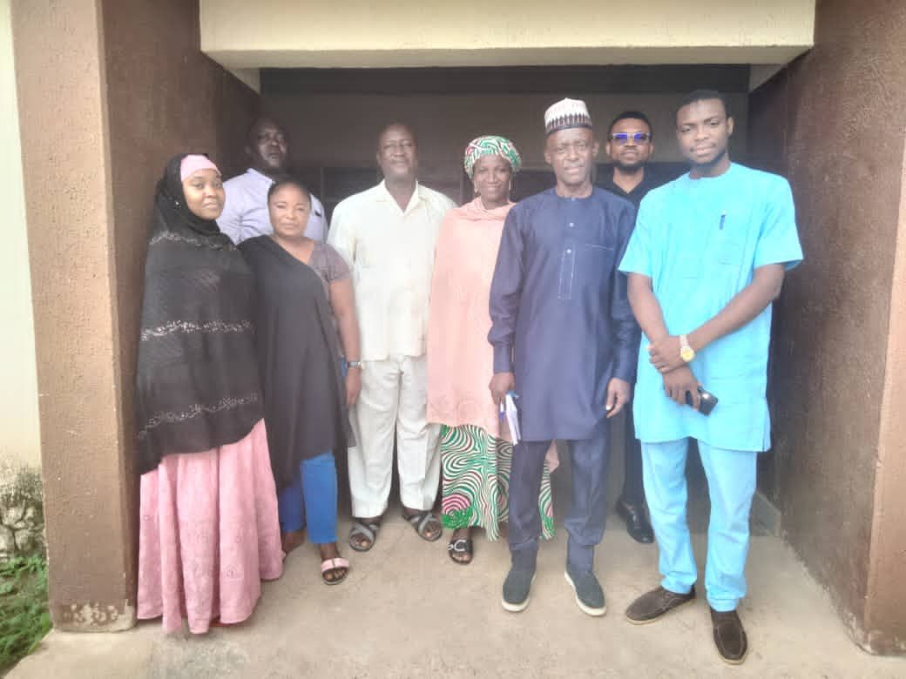  Consultant after consultation meeting with student leaders and medical department staff. | 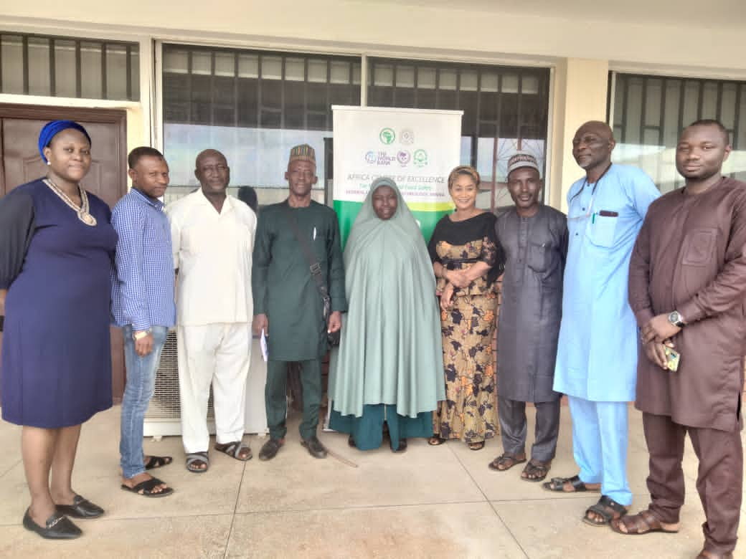  A cross section photo with Centre management after project planning meeting.
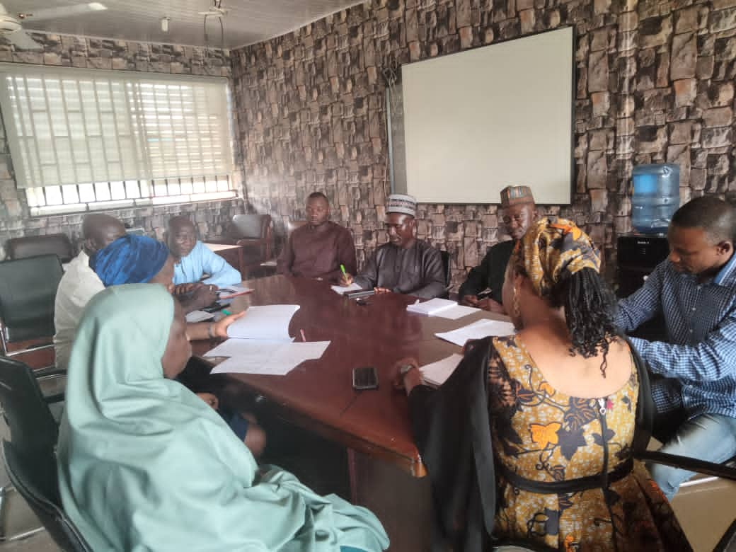  Consultant having meeting with proponent during project planning. | 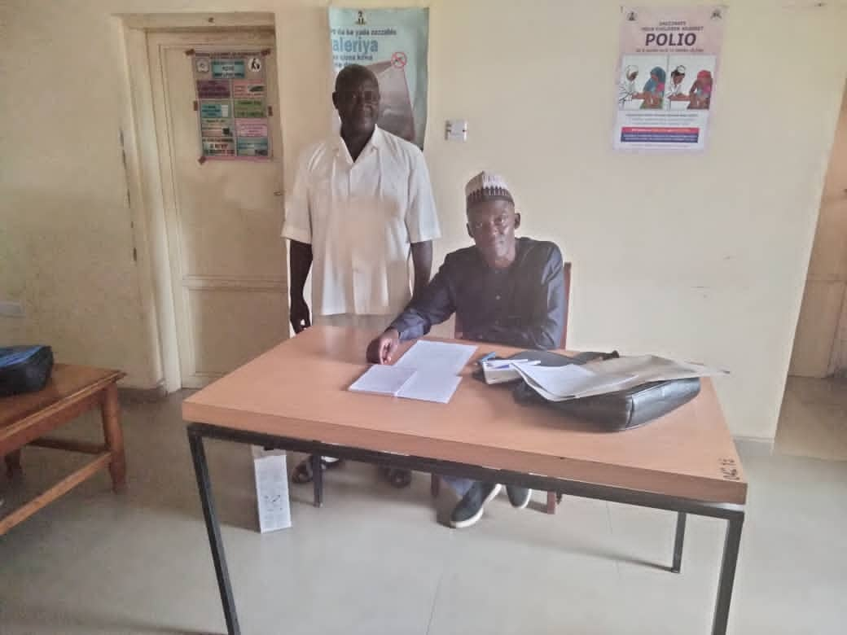  Consultant with the Environmental Safeguard officer during consultation.

7.3 Conclusion
The Environmental and Social Management Plan (ESMP) of the proposed construction of ACEMFS Centre has been carried out to satisfy government, financiers/Sponsor, regulators and stakeholders that proactive environmental actions have been incorporated into project design/ plan. The study was carried out in line with regulatory requirements for environmental management in Nigeria.
- The proposed development project explains the various economic and social benefits not only to the local communities within the project areas, but to the entire nation as a whole, particularly in supporting international research and bringing foreign exchange to the educational and economic sector respectively.
- The negative environmental impacts that have been identified and are associated with the implementation of this project are minimal and could be addressed by implementing the mitigation measures proposed to ensure that they pose no threat to the environment and to the community. These measures are part of the project’s component and will bring no added cost in the implementation process.

7.4 Recommendations
- It is important that during the implementation, relevant line authorities and other stakeholders are effectively involved to address some of the cross-cutting issues such as environmental, management and research procedures.
- The multi-disciplinary approach will ensure that emerging issues and challenges are not only adequately addressed but the addressing is done timely and appropriately.
- The contractors and the project proponents should take into consideration all the legislative measures put in place so as to ensure the due process is followed.
- The mitigation measures provided are based on the recommendations of this ESMP and they should be followed so as to address the environmental issues that may arise in the course of the implementation of this project.
Finally, it is hoped that all necessary information/ evidence contained in this report is sufficient in the development of an Environmental Auditing and acquisition of necessary permits for the operation of the proposed ACEMFS building project.
In view of the foregoing, the project is considered viable and therefore requested for approval by the authority as its benefits are considered greater than the associated normal and manageable adverse impacts

REFERENCES

- Addax, 2010: Environmental Impact Assessment of Shoreline Logistics Base Expansion Project, Calabar, Cross Rivers State.
- Beyond Africa Centre of Excellence for Neglected Tropical Disease and Forensic Biotechnology (ACEMFS)
- Covich, A.P., Palmer, M.A. and Crowl, T.A. (1999). The Role of Benthic Invertebrate Species in Freshwater Ecosystems, Zoobenthic species influence energy flows and nutrient cycling BioScienceVol. 49No. 2.
- Designing Buildings, the Construction Wiki (Sept. 2021) Risk in Building Essential Construction
- Hopkins, B. (1981) Forest and Savanna Heinemann Educational Books Ltd 123-154p.
- National Academic of Sciences (1989), National Research Council (US) Committee on Hazardous Biological Substances in the Laboratories. Biosafety in the laboratory: Prudent practices for handling and disposal of infectious materials, Washington DC Academic Press safe disposal of infectious laboratory waste.
- National Bureau of Statistics (2016) Annual Socio-Economic Report Access to Electricity, National Bureau of Statistic, Abuja
- Oyibo. H. A (2022), Propose Building Construction for Africa Centre of Excellence for Mycotoxin and Food Safety, FUT Minna.
- World bank Environment Department. (1991). Environmental Assessment Source Book. Technical Paper 154Vol3
- World bank Group (2007) Environmental Health and Safety (EHS) Guidelines-General EHS Guidelines; Waste Management
- World bank Group (2007) Environmental Health and Safety (EHS) Guidelines-General EHS Guidelines; Construction and Decommissioning
- World Health Organization WHO (2000). Environmental Health Criteria 171p

ANNEXES

Annex 1: Terms of Reference for the ESMP

- Introduction
The Africa Higher Education Centers of Excellence (ACE) Project is a World Bank initiative in collaboration with governments of participating countries to support Higher Education institutions in specializing in Science, Technology, Engineering and Mathematics (STEM), Environment, Agriculture, applied Social Science / Education and Health. It is the first World Bank project aimed at the capacity building of higher education institutions in Africa.
The first phase (ACE I) was launched in 2014 with 22 Centers of Excellence in nine (9) West and Central African countries; Benin, Burkina Faso, Cameroon, Côte d'Ivoire, Gambia, Ghana, Nigeria, Senegal and Togo. The Project aims to promote regional specialization among participating universities in areas that address specific common regional development challenges. It also aims to strengthen the capacities of these universities to deliver high quality training and applied research as well as meet the demand for skills required for Africa's development. The second phase (ACE II) was launched in East and Southern Africa with 24 centers across Ethiopia, Kenya, Malawi, Mozambique, Rwanda, Tanzania, Uganda and Zambia.
Based on the initial successes, the World Bank and in collaboration with the African governments, launched the ACE Impact Project in 2018 to strengthen post-graduate training and applied research in existing fields and support new fields that are essential for Africa's economic growth. There are 43 ACEs (25 new ones and 18 from ACE I); 5 Emerging Centers;1 “top up” center in Social Risk Management; and 5 Colleges and Schools of Engineering. The new areas include sustainable cities; sustainable power and energy; social sciences and education; transport; population health and policy; herbal medicine development and regulatory sciences; public health; applied informatics and communication; and pastoral production

The Africa Center of Excellence for Mycotoxin and Food Safety (ACEMFS) in Federal University of Technology, Minna – Nigeria, is one of the ten ACE Centres in Nigeria. There are presently 17 African Centers of Excellence in Nigeria. The ACEMFS primary focus areas of research is on three of the postgraduate programs (MTech. and PhD) in;
- Food safety,
- Toxicology,
- Molecular biology, and
- Bioinformatics
The main aim of the Centre is to train personnel in food safety, toxicology, molecular biology & bioinformatics that will impart better food and feed safety culture, and ensure safer foods for healthy living in Nigeria and across Africa.
As the proponent for the sub-projects, their central objectives are;
To acquire knowledge required to create an interdisciplinary and experience based educational model that will prepare graduates on the rapidly emerging need for innovations at the nexus of food security, food safety, agricultural productivity and economics from local to global scales.
To be able to foster impactful interdisciplinary research and implement solutions that will improve the quality of life of Africans through fit-for-purpose interventions fostering economic growth and access to sufficient safe food for all.
To be able to address Africa’s shortage of expertise and applicable solutions to ensure a safe, controlled and sufficient food supply that will support economic growth and public health.
1.2- CENTRE ACTIVITIES
The main activities of the Centre are therefore:
- To provide relevant human and material resources for the effective training of high-level independent minded, self-reliant and competent researchers that are capable of providing critical skills in effective food system.
- To provide the skills that will adequately address the research and training needs to conduct regional survey of food borne pathogens and toxic chemical residues, assess their health and economic impacts and consequently set appropriate national and regional standards for effective prevention and control
- In view of the above benefits to be accrued from the project, the centre is proposing to construct a befitting office accommodation for its staff to enable them perform effectively and efficiently. The proposed building construction has been assessed to have potential adverse impacts that are site specific, limited in number, reversible and triggered environmental assessment policies of the World Bank (WB) OP/BP 4.01, equivalent to Nigeria Environmental and Impact Assessment (EAI) policy requirement. The impact here will be small-scale and site-specific typical of category B projects. This could result in environmental and social impacts thus triggering the World Bank OP/BP 4.01 – Environmental Assessment.

The Africa Centre of Excellence for Mycotoxin and Food Safety in FUT Minna, is proposing to award a contract for the conduct of an Environmental and Social Management Plan (ESMP) to identify the environmental and social management impact and mitigation measures required to implement these sub-projects.
2.0 - ESMP
The proposed ESMP is to provide an overview of the environmental base line conditions of the proposed sub-projects, summarize the potential impacts associated with the construction works, and set out the management measures required to mitigate any potential impacts in a series of sector specific Environmental Management Plans (ESMPs).
These ESMPs are to be utilized by the contractors, to be commissioned by ACEMFS for the sub-projects, and will form the basis of site-specific management plans that will be prepared by the contractors as part of their construction methodology prior to works commencing.
As the proponent for the sub-projects, it is our objective to avoid, where practical, unacceptable adverse environmental, social and /or economic impacts. In the circumstance that an impact cannot be avoided, ACEMFS and Project Management (who will be responsible for the management of the project) are committed to the implementation of appropriate mitigation measures. For clarity in the management structure however, Project Management will consult ACEMFS on matters relating to environmental health and safety performance. Project Management will however have overall responsibility for planning, implementation, monitoring and enforcement of activities associated with this ESMP and environmental and health and safety performance
3.0 - Terms of Reference for the ESMP are to:
- To assess the impact of the sub-projects to environment, human health and safety, physical cultural issues. The ESMP shall identify the risk early before commencement of the sub- projects with the view of mitigating against such issues.
- The ESMP shall provide cultural guide lines to avoid any adverse impacts these sub-projects will have on the surrounding areas of the university.
- Describe the measures required to implement the activities of the sub-projects, related management and mitigation commitments;
- Describe specific additional measures required to implement contract related international best practices, and approval conditions stipulated by the World Bank’s environmental, health safety guidelines, Nigeria’s Federal Ministry of Environment and NESREA requirements;
- Identify the roles and responsibilities of the environmental and social management stakeholders of the project; and
- Communicate the environmental and social expectations and requirements throughout the project tenure.
While all contractors and sub-contractors shall comply with, and apply the ESMP requirements as applicable to the tasks they are employed to undertake, some of the measures and procedures outlined in this proposal are commitments made by Project Management of ACEMFS, and therefore remain responsible for their implementation. It should however be recognized that practical implementation of many of the measures may rest with contractors and sub-contractors and consequently, ACEMFS will require the implementation of a robust review/audit program, as may be described in the proposed ESMP, to measure and ensure that they are executed on their behalf appropriately.
4.0 - Scope of Work:

The core tasks for the ESMPs shall include:
- Assess the potential environmental and social impacts related to construction activities and recommend adequate mitigation measures, including costs estimation.
- Identify responsibilities and actors for the implementation of proposed mitigation measures
- Assess the capacity available to implement the proposed mitigation measures, and suggest recommendation in terms of training and capacity building, and estimate their costs.
- Develop an Environmental and Social Management Plan (ESMP) for the work. The ESMP should underline
- The potential environmental and social impacts resulting from construction activities
- The proposed mitigation measures;
- The institutional responsibilities for implementation;
- The monitoring indicators;
- The institutional responsibilities for monitoring and implementation of mitigation measures;
- The costs of activities; and
- The calendar of implementation.
- Consultations: The ESMP results and the proposed mitigation measures will be discussed with relevant stakeholders mainly involved by the construction activities. Recommendations from this consultation will be included in the final ESMP report.
- Preparing the ESMP according to the generic contents below:

The objective of the study is to prepare an environmental and social management plan (ESMP) for the proposed upgrade of research facilities (laboratories) and the construction and maintenance of an animal house.

The ESMP should consists of a well-documented set of mitigation, monitoring, and institutional actions to be taken before and during construction and rehabilitation of the required facilities towards minimizing and elimination of the adverse environmental and social impacts. It should also include the measures needed to implement these actions, addressing the adequacy of the monitoring and institutional.
5.0 - ESMP Structures
The ESMP Report shall be presented in a concise format and should contain all studies, processes, analyses, tests and recommendations for the proposed intervention. The report shall focus on the findings, conclusions and any recommended actions, supported by summaries of the data collected and citations for any references used.

The ESMP report will include the following Chapters and Sections:

Preliminary pages

- Cover page
- Table of contents
- List of acronyms and their definitions
- Executive Summary

Chapter 1: Introduction

- Introduction to the ACE Project and description of the proposed construction detailing what this subproject entails and its purpose
- Rationale for ESMP
Chapter 2: Project Description
- Project Activities and Schedules including expected duration of the construction works

Chapter 3: Baseline Description of Project Area
- Overview of the Project Area including relevant maps and engineering designs for proposed construction activities.
- Socioeconomic Environment of the Project Area
- Biophysical Environment of the Project Area
- Environmental and Social Sensitivities in the project areas (including map of the hubs showing the locations of all sensitivities)
- Gender and Gender Based Violence Statistic including state information as well as those related to the project

Chapter 4: Environmental and Social Management and Monitoring Plan
- Introduction
- Positive Impacts
- Negative Impacts
- Environmental and Social Management Table (ESMP table) highlighting Activities, identified adverse impacts, mitigation measures and corresponding Indicator(s), Mode of Measurement, corresponding Cost of Mitigation, monitoring indicators, Frequency, Monitoring Cost, as well as responsibilities for implementing these measures
- Roles and Responsibilities
- Capacity Building
- Monitoring and Reporting
- Implementation Schedule
- Contractual Measures
- Measures for Non-Compliance with the ESMP
- Cost Estimates for ESMP Implementation

Chapter 5: Grievance Redress Mechanism
- Introduction
- Expectation When Grievances Arise
- Structure and Protocols for Reporting and Managing Grievances
- Protocol for reporting and managing grievance for this sub project.

Chapter 6: Stakeholders’ Consultation
This chapter shall summarize the actions undertaken to consult relevant groups affected by the proposed construction. The detailed record of the consultation meetings shall be presented in annex to the ESMP.

Chapter 7: Summary and Recommendations
The Annexes below must consider COVID-19 requirement. See Annex K for WHO, World Bank and ILO guidance notes on construction, labour, waste management, etc. provisions.
Annex 1: Terms of Reference
Annex 2: Sample of Questionnaire for socioeconomics
Annex 3: List of participants in consultations and summaries of meetings
Annex 4: General Environmental and Social Management Conditions for Construction Contracts
Annex 5: Project Occupational Health and Safety (OHS) Plan
Annex 6: Company Code of Conduct on Preventing Gender Based Violence and Violence Against Children
Annex 7: Manager’s Code of Conduct on Preventing Gender Based Violence and Violence against Children
Annex 8: Individual Code of Conduct on Preventing Gender Based Violence and Violence against Children
Annex 9: Waste Management Plan
Annex 10: Traffic Management Plan
Annex 11: Workers Campsite Management Plan
Annex 12: Safeguard guidance on Covid-19 consideration in construction/civil works projects.

6.0 - PROCUREMENT METHOD
The request for the engagement of the consultant shall follow due process. Selective tendering method would be used. By this, four re-known environmental consultants would be invited.
The engagement of qualified consultant would be decided by considering their work profile and evidence of proficiency. The most acceptable consultant based on the assessment would be presented to the Centre for approval, this would also be a criterion for award of certificate of compliance in due course.
The consultant would be briefed on the pending assignment and given four weeks to carry out the assignment. After completion of the job, the consultant would be made to host a presentation to a group ACEMFS team.

The successful consultant would be paid in accordance with the agreed payment schedule, upon agreed negotiation terms and subject to satisfactory performance, timely receipt as well as approval of deliverables.

7.0 - RENUMERATION AND PAYMENT SCHEDULE
The Consultant will be paid based on negotiations with the ACEMFS but shall not exceed 1% of the entire project value.

8.0 - DELIVERABLES AND TIMING:
- Inception report: The inception report shall be submitted a week after submission of action plan/commencement of work.
- Draft report: A draft ESMP will be submitted for comments between the second and third week after commencement of work. It will identify all the areas, the mitigation measures, and the environmental and social issues associated with the rehabilitation, as well as the adequacy of the monitoring.
- Draft Final: A draft final will be submitted after making inputs to comments of the draft ESMP.
- Final report: The final ESMP Report will take into account all comments, and will be submitted four weeks after commencement of work.

9.0 - Planned Activities and Time lines
A schedule of activities for the preparation and completion of the ESMP report by the consultant following appointment is provided in the table below.
Activities | Week1 | Week2 | Week3 | Week4
Submission of Inception Report | X
Submission of Draft Report |  | X
Submission of Draft Final |  |  | X
Submission of Final Report |  |  |  | X

10.0 - Duration of Work and Reporting
- Duration
This assignment shall be completed within a period of 5 weeks commencing immediately after contract signing. The Consultant is expected to conduct a baseline survey within the project site and in consultations with all relevant stakeholders to gather all necessary primary information.
- Reporting
The Consultant shall report to the Centre Head of ACEMFS / Project Management Team.
- - Responsibilities of the Client
In addition to the project supervisory and other responsibilities contained in this assignment, the client shall provide the Consultant with the following project documents:
- Project Appraisal Document
- Relevant project documents
- Access to relevant stakeholders

- - Deliverables/Payment Plan
A comprehensive and fully referenced Report including detailed recommended actions for implementation must be submitted at the end of the assignment. The Report must contain an in-depth analysis of the issues described in the objectives and should propose clear, implementable measures towards achieving the set goals of the assignment.
13.0 - QUALIFICATION AND EXPERENCE OF THE CONSULTANT
The consultant shall have:
- Experience with a minimum of MSc. (PhD an added advantage) in environmental sciences / analytical sciences and a professional/technical background appropriate for understanding both the environmental and social management implications in construction, waste disposals, laboratory waste and vectors disposals, and infective/toxic materials, including their design, construction, operation and monitoring.
- At least five (10) years’ experience in practical safeguards, social and environmental management and HSE with demonstrated proficiency in the preparation, review, and approval of EAs/ESIAs/ESMPs to meet World Bank standards
- Excellent analytical, communication and writing skills.
- It is highly desirable that the consultant have experience with working with international development institutions like the World Bank, and on infrastructure related projects.

Annex 2: Sample of Questionnaire for socioeconomics
Assessment Instrument
Environmental and Social Management Plan for the proposed Building Construction of Africa Centre of Excellence for Mycotoxin and Food Safety (ACEMFS) Main Campus, Minna, Niger State, Nigeria.
ANY INFORMATION PROVIDED HERE IS STRICKLY FOR THE PURPOSE OF THIS STUDY AND HIGHLY CONFIDENTIAL.
PART A: General information
- Name of Household Head/Department…………………………………………………………………...
- Name of Respondent………………………………………………………………………………………
- Relationship of Respondent to Household Head/Department……………………………………………...
- House/Office Address……………………………………………………………………………………
- Sex Respondents a. Male( ) b. Female( )
- Age of Respondents……………………….
- Marital Status of Respondents a. Single( ) b. Married( ) c. Divorced( ) d. Widow/Widower( )
- How long have you lived/worked in this community………………………….?
- Specify any society, group or association which you belong to within your community…...…………
………………………………………………………………………………………………
- How many persons live in your Household (i.e., Eat from the same pot)…………
- Howmanypersons/staffinyourdepartmentfallsintothefollowingagecategories?
Categories | Male | Female | Total
0-4yrs
5-9yrs
10-14yrs
15-19yrs
20-24yrs
25-29yrs
30-34yrs
35-39yrs
40-44yrs
45-49yrs
50-54yrs
55-59yrs
60-64yrs
65-above
Total

- What is your highest educational qualification? a. WASC/SSCE ( ) b. TCII/OND ( ) c. HND/Degree ( ) d. M.Sc./PhD e. others (specify)……………………………
- Main Occupation/Job Description of house hold respondents…………………………………………
16. What is your Annual Income? i)N0–50,000…… (ii)N51,000-100,000……. iii)N100,101-500,000…… iv)N500,000 and above……
If Not Known, what is your Monthly income………………. OR Daily income…………….
17. Estimate the monthly/annual income of other members of your household. i)N0–50,000…… ii)N51,000-100,000…… iii)N100,101-500,000… iv)N500,000andabove…….

Part D: Availability of Amenities
18. How would you describe the condition of the following amenities in your community?
 | Excellent | Very Good | Good | Fair | Poor
Roads to the community
Roads within the community
Schools in the community
Public Health Institutions
Potable Water
Public Electricity
Communication facilities (Postal Service, Telephone)
Public recreation facilities

19. What is the major source of water available to your household? (Please Tick One)
i. River…………………… ii. Borehole (commercial)……………
iii. Pond……………………… iv. Borehole (private)………………
v Public pipe-borne water………… vi. Water Vendor……………….
vii Well water…………..(Please Tick One)
20. If a public pipe borne water, how regular does the tap flow in a week? a. Regularly ( ) b. Occasionally ( ) c. Rarely( )
21. How long does it take you in minutes/hours to get to your water source………………………………
22. How much do you spend/pay in a month for water bill?………………………………………….
23. Estimate the number of gallons (20litres) of water you use in your household daily?…………………….
24. What is the primary source of electricity/light to this community?(Please Tick One)
- Hurricane Lamp……… ii) Private Generators…………………………………
- Community Generators……… iv) State Government Utilities Board…………………
- Company Operating in your community……. vi) PHCN (National Grid)……………..
25. What is the main secondary source of electricity?(Please Tick One)
  - Hurricane Lamp……………ii) Private Generators…………
  - Community Generators………iv) Company Operating in your community………
26. What is the main fuel you use for cooking?(Please Tick One)
i) Firewood……………. ..ii) Charcoal…………..
- Kerosene/Oil………. iv) Gas……………
v) Electricity…………… .vi) Crop residue/Sawdust……………
- Animal Wastes……… .viii) Others
27. What type of toilet facility do you use?(Please Tick One)
i) Pit………………ii) Bush…………
- Prier Head………iv) Bucket…………
v) Water Closet……vi) Others (Specify)……
28. How do you dispose your household/office waste?
i) Burying………………ii) Bush…………
  - Burning……… iv) Open dump…………
v) Organized collection……vi) Others (Specify)……
29. Please, kindly tick the availability of the existing facilities in the community listed below;
Items | Tick
- Nursery school
- Primary
- Secondary
- Tertiary
- Worship Centres
- Shops/minimart
- Business Centre
- Others(Specify)

30. What is your proximity to the above mentioned facilities? ………………………………………
31. Comment on major environmental issues affecting the community………………………………………
32. What do you think are the likely environmental problems to be caused by this project? a. Noise pollution () b. Air pollution () c. Vegetal loss () d. Water pollution e. wildlife disturbance()Waste generation
33. Comment on any environmental issues recorded during the course of construction within the community in the past five(5) Years.……………………………………………………………..
34. Is the community faced with security challenges? a.Yes( )b.No()
35. If yes, are there any insecurity issues within the project area? aYes( )b.No()
36. If yes, what effort are they making in eradicating the insecurity problems?……………………………….
37. What are the social problems to be experience as a result of the project?a…a…….b ……c ……..d …..
38. What are the common diseases that are prevailing in your community? a Malaria Fever( ) b. Tphoid Fever( ) c. Cholera( ) d. Others specify………………
39. Have you had outbreak of any of the communicable diseases such as; a.Cholera( ) b.Covid-19( ) c.Ebola() d. Others specify………
40. Have you ever heard of any illness caused by bacteria or other toxins in food? If yes, mention any………………………e.g. Food Poisoning
41. Have you ever had contact/any person contacted such illnesses/diseases before? IfYes( )
42. Where has him/her been treated? a. Hospital ( ) b. Clinic() c. Herbal( ) d. Others specify…..

Annex 3: List of participants in consultations and summaries of meetings
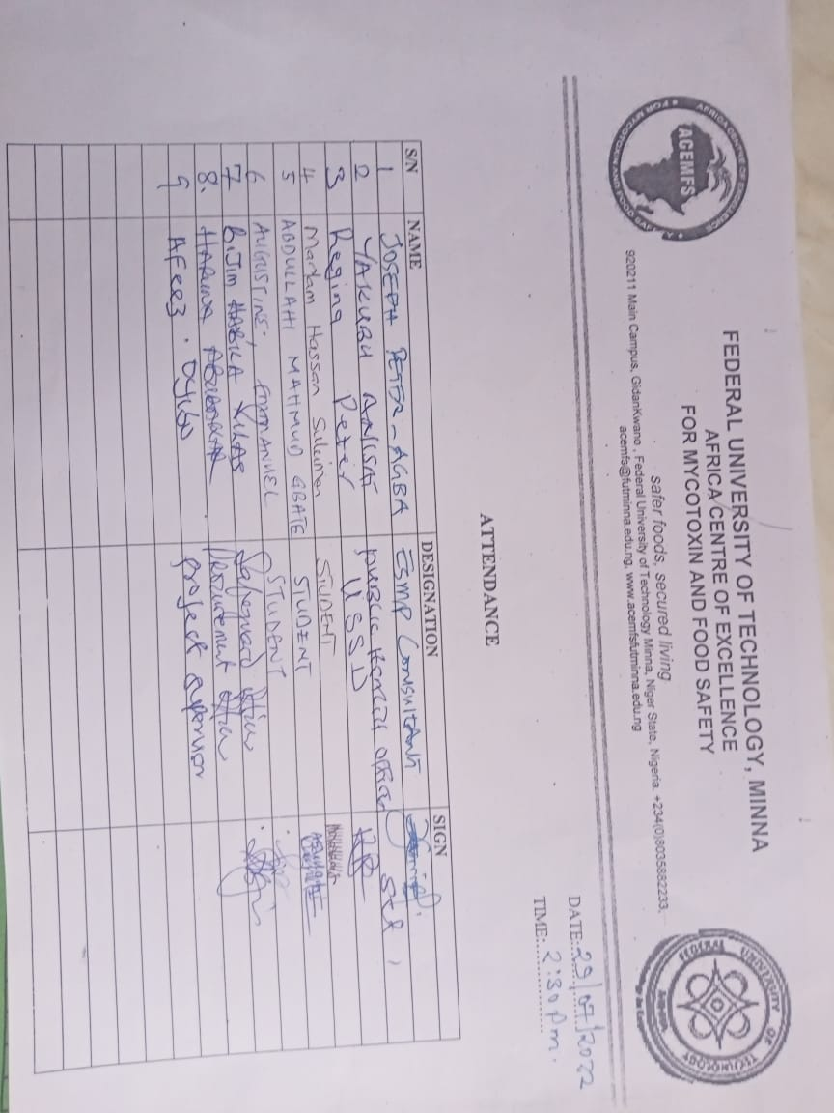

Annex 4: General Environmental Management Conditions for Construction Contracts
General
1. In addition to these general conditions, the Contractor shall comply with any specific Environmental Management Plan (EMP) or Environmental and Social Management Plan (ESMP) for the works he is responsible for. The Contractor shall inform himself about such an EMP, and prepare his work strategy and plan to fully take into account relevant provisions of that EMP. If the Contractor fails to implement the approved EMP after written instruction by the Supervising Engineer (SE) to fulfil his obligation within the requested time, the Owner reserves the right to arrange through the SE for execution of the missing action by a third party on account of the Contractor.

2. Notwithstanding the Contractor’s obligation under the above clause, the Contractor shall implement all measures necessary to avoid undesirable adverse environmental and social impacts wherever possible, restore work sites to acceptable standards, and abide by any environmental performance requirements specified in an EMP. In general these measures shall include but not be limited to:
(a) Minimize the effect of dust on the surrounding environment resulting from earth mixing sites, asphalt mixing sites, dispersing coal ashes, vibrating equipment, temporary access roads, etc. to ensure safety, health and the protection of workers and communities living in the vicinity dust producing activities.
(b) Ensure that noise levels emanating from machinery, vehicles and noisy construction activities (e.g. excavation, blasting) are kept at a minimum for the safety, health and protection of workers within the vicinity of high noise levels and nearby communities.
(c) Ensure that existing water flow regimes in rivers, streams and other natural or irrigation channels is maintained and/or re-established where they are disrupted due to works being carried out.
(d) Prevent bitumen, oils, lubricants and wastewater used or produced during the execution of works from entering into rivers, streams, irrigation channels and other natural water bodies/reservoirs, and also ensure that stagnant water in uncovered borrow pits is treated in the best way to avoid creating possible breeding grounds for mosquitoes.
(e) Prevent and minimize the impacts of quarrying, earth borrowing, piling and building of temporary staging area and access roads on the biophysical environment including protected areas and arable lands; local communities and their settlements. In as much as possible restore/rehabilitate all sites to acceptable standards.
(f) Upon discovery of ancient heritage, relics or anything that might or believed to be of archaeological or historical importance during the execution of works, immediately report such findings to the SE so that the appropriate authorities may be expeditiously contacted for fulfilment of the measures aimed at protecting such historical or archaeological resources.
(g) Discourage construction workers from engaging in the exploitation of natural resources such as hunting, fishing, collection of forest products or any other activity that might have a negative impact on the social and economic welfare of the local communities.
(h) Implement soil erosion control measures in order to avoid surface run off and prevents siltation, etc.(i) Ensure that garbage, sanitation and drinking water facilities are provided on site for construction workers.
(j) Ensure that, in as much as possible, local materials are used to avoid importation of foreign material and long-distance transportation.
(k) Ensure public safety and meet traffic safety requirements for the operation of work to avoid accidents.

3. The Contractor shall indicate the period within which he/she shall maintain status on site after completion of civil works to ensure that significant adverse impacts arising from such works have been appropriately addressed.
4. The Contractor shall adhere to the proposed activity implementation schedule and the monitoring plan / strategy to ensure effective feedback of monitoring information to project management so that impact management can be implemented properly, and if necessary, adapt to changing and unforeseen conditions.
5. Besides the regular inspection of the sites by the SE for adherence to the contract conditions and specifications, the Owner may appoint an Inspector to oversee the compliance with these environmental conditions and any proposed mitigation measures. AEPB may carry out similar inspection duties. In all cases, as directed by the SE, the Contractor shall comply with directives from such inspectors to implement measures required to ensure the adequacy rehabilitation measures carried out on the bio-physical environment and compensation for socio-economic disruption resulting from implementation of any works.

Material Excavation and Deposit
12. The Contractor shall obtain appropriate licenses/permits from relevant authorities to operate quarries or borrow areas.
13. The location of quarries and borrow areas shall be subject to approval by relevant local and national authorities, including traditional authorities if the land on which the quarry or borrow areas fall in traditional land.
14. New extraction sites:
a) Shall not be located in the vicinity of settlement areas, cultural sites, wetlands or any other valued ecosystem component, or on high or steep ground or in areas of high scenic value and shall not be located less than 1km from such areas.
b) Shall not be located adjacent to stream channels wherever possible to avoid siltation of river channels. Where they are located near water sources, borrow pits and perimeter drains shall surround quarry sites.
c) Shall not be located in archaeological areas. Excavations in the vicinity of such areas shall proceed with great care and shall be done in the presence of government authorities having a mandate for their protection.
d) Shall not be located in forest reserves. However, where there are no other alternatives, permission shall be obtained from the appropriate authorities and an environmental impact study shall be conducted.
e) Shall be easily rehabilitated. Areas with minimal vegetation cover such as flat and bare ground, or areas covered with grass only or covered with shrubs less than 1.5m in height, are preferred.
f) Shall have clearly demarcated and marked boundaries to minimize vegetation clearing.

15. Vegetation clearing shall be restricted to the area required for safe operation of construction work. Vegetation clearing shall not be done more than two months in advance of operations.
16. Stockpile areas shall be located in areas where trees can act as buffers to prevent dust pollution. Perimeter drains shall be built around stockpile areas. Sediment and other pollutant traps shall be located at drainage exits from workings.
17. The Contractor shall deposit any excess material in accordance with the principles of the general conditions, and any applicable EMP, in areas approved by local authorities and/or the SE.
18. Areas for depositing hazardous materials such as contaminated liquid and solid materials shall be approved by the SE and appropriate local and/or national authorities before the commencement of work. Use of existing, approved sites shall be preferred over the establishment of new sites.

Rehabilitation and Soil Erosion Prevention
19. To the extent practicable, the Contractor shall rehabilitate the site progressively so that the rate of rehabilitation is similar to the rate of construction.
20. Always remove and retain topsoil for subsequent rehabilitation. Soils shall not be stripped when they are wet as this can lead to soil compaction and loss of structure.
21. Topsoil shall not be stored in large heaps. Low mounds of no more than 1 to 2m high are recommended.
22. Re-vegetate stockpiles to protect the soil from erosion, discourage weeds and maintain an active population of beneficial soil microbes.
23. Locate stockpiles where they will not be disturbed by future construction activities.
24. To the extent practicable, reinstate natural drainage patterns where they have been altered or impaired.
25. Remove toxic materials and dispose of them in designated sites. Backfill excavated areas with soils or overburden that is free of foreign material that could pollute groundwater and soil.
26. Identify potentially toxic overburden and screen with suitable material to prevent mobilization of toxins.
27. Ensure reshaped land is formed so as to be inherently stable, adequately drained and suitable for the desired long-term land use, and allow natural regeneration of vegetation.
28. Minimize the long-term visual impact by creating landforms that are compatible with the adjacent landscape.
29. Minimize erosion by wind and water both during and after the process of reinstatement.
30. Compacted surfaces shall be deep ripped to relieve compaction unless subsurface conditions dictate otherwise.
31. Revegetate with plant species that will control erosion, provide vegetative diversity and, through succession, contribute to a resilient ecosystem. The choice of plant species for rehabilitation shall be done in consultation with local research institutions, forest department and the local people.

Water Resources Management
32. The Contractor shall at all costs avoid conflicting with water demands of local communities.
33. Abstraction of both surface and underground water shall only be done with the consultation of the local community and after obtaining a permit from the relevant Water Authority.
34. Abstraction of water from wetlands shall be avoided. Where necessary, authority has to be obtained from relevant authorities.
35. Temporary damming of streams and rivers shall be done in such a way avoids disrupting water supplies to communities downstream and maintains the ecological balance of the river system.
36. No construction water containing spoils or site effluent, especially cement and oil, shall be allowed to flow into natural water drainage courses.
37. Wash water from washing out of equipment shall not be discharged into water courses or road drains.
38. Site spoils and temporary stockpiles shall be located away from the drainage system, and surface run off shall be directed away from stockpiles to prevent erosion.

Traffic Management
39. Location of access roads/detours shall be done in consultation with the local community especially in important or sensitive environments. Access roads shall not traverse wetland areas.
40. Upon the completion of civil works, all access roads shall be ripped and rehabilitated.
41. Access roads shall be sprinkled with water at least five times a day in settled areas, and three times in unsettled areas, to suppress dust emissions.
Blasting
42. Blasting activities shall not take place less than 2km from settlement areas, cultural sites, or wetlands without the permission of the SE.
43. Blasting activities shall be done during working hours, and local communities shall be consulted on the proposed blasting times.
44. Noise levels reaching the communities from blasting activities shall not exceed 90 decibels.
Disposal of Unusable Elements
45. Unusable materials and construction elements such as electro-mechanical equipment, pipes, accessories and demolished structures will be disposed of in a manner approved by the SE. The Contractor has to agree with the SE which elements are to be surrendered to the Client’s premises, which will be recycled or reused, and which will be disposed of at approved landfill sites.
46. As far as possible, abandoned pipelines shall remain in place. Where for any reason no alternative alignment for the new pipeline is possible, the old pipes shall be safely removed and stored at a safe place to be agreed upon with the SE and the local authorities concerned.
47. AC-pipes as well as broken parts thereof have to be treated as hazardous material and disposed of as specified above.
48. Unsuitable and demolished elements shall be dismantled to a size fitting on ordinary trucks for transport.

Health and Safety
49. In advance of the construction work, the Contractor shall mount an awareness and hygiene campaign. Workers and local residents shall be sensitized on health risks particularly of AIDS.
50. Adequate Road signs to warn pedestrians and motorists of construction activities, diversions, etc. shall be provided at appropriate points.
51. Construction vehicles shall not exceed maximum speed limit of 40km per hour.

Repair of Private Property
52. Should the Contractor, deliberately or accidentally, damage private property, he shall repair the property to the owner’s satisfaction and at his own cost. For each repair, the Contractor shall obtain from the owner a certificate that the damage has been made good satisfactorily in order to indemnify the Client from subsequent claims.
53. In cases where compensation for inconveniences, damage of crops etc. are claimed by the owner, the Client has to be informed by the Contractor through the SE. This compensation is in general settled under the responsibility of the Client before signing the Contract. In unforeseeable cases, the respective administrative entities of the Client will take care of compensation.

Contractor’s Environment, Health and Safety Management Plan (EHS-MP)
54. Within 6 weeks of signing the Contract, the Contractor shall prepare an EHS-MP to ensure the adequate management of the health, safety, environmental and social aspects of the works, including implementation of the requirements of these general conditions and any specific requirements of an EMP for the works. The Contractor’s EHS-MP will serve two main purposes:
- For the Contractor, for internal purposes, to ensure that all measures are in place for adequate EHS management, and as an operational manual for his staff.
- For the Client, supported where necessary by a SE, to ensure that the Contractor is fully prepared for the adequate management of the EHS aspects of the project, and as a basis for monitoring of the Contractor’s EHS performance.

55. The Contractor’s EHS-MP shall provide at least:
- a description of procedures and methods for complying with these general environmental management conditions, and any specific conditions specified in an EMP;
- a description of specific mitigation measures that will be implemented in order to minimize adverse impacts;
- a description of all planned monitoring activities (e.g., sediment discharges from borrow areas) and the reporting thereof; and
- the internal organizational, management and reporting mechanisms put in place for such.

56. The Contractor’s EHS-MP will be reviewed and approved by the Client before start of the works. This review should demonstrate if the Contractor’s EHS-MP covers all of the identified impacts and has defined appropriate measures to counteract any potential impacts.

EHS Reporting
57. The Contractor shall prepare bi-weekly progress reports to the SE on compliance with these general conditions, the project EMP if any, and his own EHS-MP. An example format for a Contractor EHS report is portrayed below. It is expected that the Contractor’s reports will include information on:
- EHS management actions/measures taken, including approvals sought from local or national authorities;
- Problems encountered in relation to EHS aspects (incidents, including delays, cost consequences, etc. as a result thereof);
- Lack of compliance with contract requirements on the part of the Contractor;
- Changes of assumptions, conditions, measures, designs and actual works in relation to EHS aspects; and
- Observations, concerns raised and/or decisions taken with regard to EHS management during site meetings.

58. It is advisable that reporting of significant EHS incidents be done “as soon as practicable”. Such incident reporting shall therefore be done individually. Also, it is advisable that the Contractor keep his own records on health, safety and welfare of persons, and damage to property. It is advisable to include such records, as well as copies of incident reports, as appendixes to the bi-weekly reports. A sample format for an incident notification is shown below. Details of EHS performance will be reported to the Client through the SE’s reports to the Client.

Training of Contractor’s Personnel
59. The Contractor shall provide sufficient training to his own personnel to ensure that they are all aware of the relevant aspects of these general conditions, any project EMP, and his own EHS-MP, and are able to fulfil their expected roles and functions. Specific training should be provided to those employees that have particular responsibilities associated with the implementation of the EHS-MP. General topics should be:
- EHS in general (working procedures);
- emergency procedures; and
- social and cultural aspects (awareness raising on social issues).

Cost of Compliance
60. It is expected that compliance with these conditions is already part of standard good workmanship and state of art as generally required under this Contract. The item “Compliance with Environmental Management Conditions” in the Bill of Quantities covers this cost. No other payments will be made to the Contractor for compliance with any request to avoid and/or mitigate an avoidable EHS impact.

Annex 5: Project Occupational Health and Safety (OHSP)
This plan is developed to meet up with OHS standards and to achieve the objectives set for the project. The project team shall undertake to ensure high performance standards and conformity with contract requirements by managing the works in a systematic and thorough manner.
- Competency
All personnel required to operate or work with any equipment or machine must be competent, be tested for each equipment that he/she shall be operating. All personnel who as part of their profession require licensing or certification must obtain the necessary certification before he/she shall be allowed to work on the site.
- Fitness
All personnel working on site shall be required to be certified medically fit to do so by an approved medical facility or Medical Doctor (pre-employment medical examination)
- HSE TRAINING
  - Induction/Orientation
Every new or rehired employee and Subcontractors employees must undergo mandatory OHS orientation / induction. The purpose of the Induction is to educate workers and make them aware of the major potential hazards he or she shall come into contact with while working on the site; also, it is one more opportunity to stress the importance of HSE being the first priority in the operations.
The content of the HSE orientation / induction shall cover the following subjects:
- Site safety rules.
- Personnel protective equipment requirements (PPE).
- Environmental sensitivity and protection.
- Preparation and planning of the job (Daily Pre-task talk).
- Emergency plan and muster points.
- SEA/SH and GBV prevention strategies
- COVID-19 prevention strategies
  - Project Specific HSE Training
In addition to the HSE orientation /induction, there shall be specific site HSE trainings which shall cover the following topics:
- Manual handling.
- Electrical Safety
- Emergency Prevention, Preparedness and Response
- Work at height training
- First Aid training ( for site First Aiders)
- Lifting and Rigging
- Safe Driving techniques (for drivers)

  - Emergency Preparedness and Response
Emergency procedures and evacuation plan shall be developed by the HSE Department and displayed on the notice board. These procedures shall be communicated to all staff. Also, there shall be at least a trained first aider at all times.

- HSE IMPLEMENTATION AND PERFORMANCE MONITORING
  - HSE Meetings
HSE management meetings shall be held once a month. The meeting is to help identify safety problems, develop solutions, review incident reports, provide training and evaluate the effectiveness of our safety program. Some of the meetings shall be:
- Project/Site Management HSE Meeting for management and supervision (Monthly).
- Tool box talk meetings for all workforce (Weekly).
- Pre-task briefing for all workforces (Daily).
- Special situation meeting (As required).
  - HSE Reporting
All incidents and illnesses must be reported to site supervisor after which investigation shall commence and recorded so that appropriate corrective actions shall be implemented to prevent any re-occurrence and report findings shall be forwarded to management for review. Reporting requirements shall include notification of incident, investigation report, and monthly report. Notification of Incident form shall be developed which shall be filled and submitted to HSE department for investigation.

- HSE Inspection and Audits
For continual improvement of HSE management system, HSE inspection and audit shall be conducted. An inspection checklist shall be developed. This is to ensure that the HSE management system is being adhered to. The inspection shall be conducted by the HSE department together with site management.
Corrective and Preventive Actions and Non-Conformities
During the cause of inspections, concerns raised shall be addressed and closed out. It is expected that in a period of two weeks, a close out inspection shall take place to verify that the corrective actions have been closed.
Project HSE Rules
The project HSE rules shall be developed and supervision shall develop specific rules and procedures when necessary.
The following site rules shall be implemented at all times. The Site Manager shall draw these rules to the attention of their own workmen or staff. All sub-contractors must ensure that these rules are drawn to the attention of their workmen and staff.
The Principal Contractor may implement additional site rules during the contract programmed. Any such additional rules shall be notified to all personnel engaged on the project prior to their implementation. The HSE rules shall include but not limited to:
- Personal Protective Equipment must be worn at all times.
- All instructions issued by the Site Manager regarding the storage, handling or cleaning of materials, plant and equipment must be followed.
- All vehicles must be parked in the designated areas.
- Any workman suffering from a medical condition that might affect his work and/or that could require specific medical treatment must inform the supervisor before commencing work.
- All site tools shall either be battery operated or 110 volts.
- No one shall be permitted on site if it is believed that they are under the influence of alcohol or drugs.
- Vehicles must not reverse without a banksman in attendance.
- All visitors to site must undergo a site-specific induction and operative Identity badges must be worn at all times.
- All excavations must be secured.
- Smoking and eating shall only be permitted in the designated area. This area shall be identified during induction.
- No hot works operations are permitted without a hot work permit in place.
- There shall be no radios or other music playing devices on site.
- Good housekeeping practices to be adopted.
- Compliance with all Ethical Power Permit to Work systems
- The site keyed access procedure must be strictly adhered to.
- All Contractors must comply with Site Health & Safety Guidelines / Site Safety Method Statement
- No untrained worker shall be permitted to operate heavy machineries.
- COVID-19 protocols to be adhered to including frequent handwashing, use of nose masks when in crowded spaces, timely reporting of any symptoms to HSE officer and immediate isolation
- Safe Work Practices/Personal Protective Equipment (PPE)
- The basic PPE required for the project shall be Safety Glasses, Safety Boots, Hand Gloves, Hard Hat, ear plugs and Coverall. Any other PPE shall be used as applicable. Management is responsible for the provision of PPE and usage shall be enforced at all time.
- PPE shall be provided in circumstances where exposure to hazards cannot be avoided by other means or to supplement existing control measures identified by a risk assessment. An assessment shall be made to ensure that the PPE is suitable for purpose and is appropriate to the risk involved.
- Information, instruction & training shall be given to all employees on safe use, maintenance and storage of PPE. Employees shall, in accordance with instructions given, make full use of all PPE provided and maintain it in a serviceable condition and report its loss or defect immediately to the maintenance department where it shall be replaced.
- PPE shall be replaced when it is no longer serviceable and returned on a new for old basis. Employees shall sign to state that they have received PPE when issued.
- Welfare Facilities
The provision of welfare facilities on the site shall be communicated to all operatives at site induction.
A cleaning regime shall be implemented and maintained for the duration of the construction phase to ensure the site welfare facilities remain in a clean and tidy condition.

Annex 6: Company Code of Conduct
- The company is obliged to create and maintain an environment which prevents Gender Based Violence (GBV) and Sexual Exploitation & Abuse (SEA) issues. The company is also required to maintain an environment where the unacceptability of GBV and actions against children are clearly communicated to all those involved in the project. In order to prevent GBV and SEA, the following core principles and minimum standards of behaviour will apply to all employees without exception:
- GBV/SEA constitutes acts of gross misconduct and are therefore grounds for sanctions, penalties and/or termination of employment. All forms of GBV/SEA including grooming are unacceptable, be it on the work site, the work site surroundings, project neighborhoods or on site. Prosecution of those who commit GBV or SEA will be followed.
- Treat women, children (persons under the age of 18), and men with respect regardless of race, colour, language, religion, political or other opinion, national, ethnic or social origin, property, disability, birth or other status.
- Do not use inappropriate language or behaviour towards women, children and men. This includes harassing, abusive, sexually provocative, derogatory, demeaning or culturally inappropriate words, gestures or actions.
- Sexual activity with children under 18—including through digital media—is prohibited. Mistaken belief regarding the age of a child and consent from the child is not a defense.
- Sexual favours or other forms of humiliating, degrading or exploitative behaviour are prohibited.
- Sexual interactions between contractor’s and consultant’s employees at any level and member of the communities surrounding the work place that are not agreed to with full consent by all parties involved in the sexual act are prohibited. This includes relationships involving the withholding/promise of actual provision of benefit (monetary or non-monetary) to community members in exchange for sex – such sexual activity is considered “non-consensual” within the scope of this Code.
- All employees are required to attend an induction training course prior to commencing work on site to ensure they are familiar with the GBV/SEA Code of Conduct.
- All employees must attend a mandatory training course once a month for the duration of the contract starting from the first induction training prior to commencement of work to reinforce the understanding of the institutional GBV and SEA Code of Conduct.
- All employees will be required to sign an individual Code of Conduct confirming their agreement to support GBV and SEA activities.
I do hereby acknowledge that I have read the foregoing Code of Conduct, do agree to comply with the standards contained therein and understand my roles and responsibilities to prevent and respond to GBV and SEA. I understand that any action inconsistent with this Code of Conduct or failure to take action mandated by this Code of Conduct may result in disciplinary action.
FOR THE COMPANY
Signed by ____________________
Title: _________________________
Date: _________________________

Annex 7: Manager’s Code of Conduct
Managers at all levels have particular responsibilities to create and maintain an environment that prevents GBV and SEA. They need to support and promote the implementation of the Company Codes of Conduct. To that end, Project Managers are required to sign up to Codes of Conduct applicable to their managerial duties within the context and also sign the Individual Codes of Conduct. This commits them to support and develop systems that facilitate the implementation of this action plan and maintain a GBV-free, child-safe and conflict-free work environment. These responsibilities include but are not limited to:

Mobilization
- Establish a GBV/SEA Compliance Team from the contractor’s and consultant’s staff to write an Action Plan that will implement the GBV and SEA Codes of Conduct.
- The Action Plan shall, as a minimum, include the
- Standard Reporting Procedure to report GBV and SEA issues through the project Grievance Redress Mechanism (GRM);
- Accountability Measures to protect confidentiality of all involved; and,
- Response Protocol applicable to GBV survivors/survivors (including access to support coping and post-trauma management strategies) and perpetrators.
- Engagement of the services of social service providers (NGOs) with requisite skill in the prevention and management of GBV and SEA.
- Coordinate and monitor the development of the Action Plan and submit for review to the RAMP-PIU safeguards teams, as well as the World Bank prior to mobilization.
- Update the Action Plan to reflect feedback and ensure the Action Plan is carried out in its entirety.
- Provide appropriate resources and training opportunities for capacity building so members of the compliance team will feel confident in performing their duties. Participation in the Compliance tame will be recognized in employee’s scope of work and performance evaluations.
- Ensure that contractor, consultant and client staff are familiar with the RAMP GRM and that they can use it to anonymously report concerns over GBV and SEA.
- Hold quarterly update meetings with the compliance team to discuss ways to strengthen resources and GBV/SEA support for employees and community members.
- In compliance with applicable laws and to the best of your abilities, prevent perpetrators of sexual exploitation and abuse from being hired, re-hired or deployed. Use background and criminal reference checks for all employees.
- Ensure that when engaging in partnership, sub-grant or sub-recipient agreements, these agreements
a) incorporate this Code of Conduct as an attachment;
b) include the appropriate language requiring such contracting entities and individuals, and their employees and volunteers to comply with this Code of Conduct; and
c) expressly state that the failure of those entities or individuals, as appropriate, to take preventive measures against GBV and SEA, to investigate allegations thereof, or to take corrective actions when GBV/SEA has occurred, shall constitute grounds for sanctions and penalties.

Training
- All managers are required to attend an induction manager training course prior to commencing work on site to ensure that they are familiar with their roles and responsibilities in upholding the GBV/SEA Codes of Conduct.
- Provide time during work hours to ensure that direct recruits attend the mandatory induction training which covers GBV/SEA training required of all employees prior to commencing work on site.
- Managers are required to attend and assist with the NGO-facilitated monthly training courses for all employees. Managers will be required to introduce the trainings and an FUT Minna results of consequential evaluations.
- Collect satisfaction surveys to evaluate training experiences and provide advice on improving the effectiveness of training.
- Prevention
- All managers and employees shall receive a clear written statement of the company’s requirements with regards to preventing GBV/SEA in addition to the training.
- Managers must verbally and in writing explain the company and individual codes of conduct to all direct recruits.
- All managers and employees must sign the individual ‘Code of Conduct for GBV and SEA, including acknowledgment that they have read and agree with the code of conduct.
- To ensure maximum effectiveness of the Codes of Conduct, managers are required to prominently display the Company and Individual Codes of Conduct in clear view in public areas of the workspace. Examples of areas include waiting, rest and lobby areas of sites, canteen areas, health clinics.
- Managers will explain the GRM process to all employees and encourage them to report suspected or actual GBV/SEA
- Mangers should also promote internal sensitization initiatives (e.g. workshops, campaigns, on-site demonstrations etc.) throughout the entire duration of their appointment in collaboration with the compliance team, service providers and in accordance to the Action Plan.
- Managers must provide support and resources to the compliance tea and service provider NGOs to create and disseminate the internal sensitization initiatives through the Awareness-raising strategy under the Action Plan.

Response
- Managers will be required to provide input, final decisions and sign off on the Standard Reporting Procedures and Response Protocol developed by the compliance team as part of the Action Plan.
- Once signed off, managers will uphold the Accountability Measures set forth in the Action Plan to maintain the confidentiality of all employees who report or (allegedly) perpetrate incidences of GBV/SEA (unless a breach of confidentiality is required to protect persons or property from serious harm or where required by law).
- Once a sanction has been determined, the relevant manager(s) is/are expected to be personally responsible for ensuring that the measure is effectively enforced, within a maximum timeframe of 14 days from the date on which the decision was made.
- Managers failing to comply with such provision can be in turn subject to disciplinary measures, to be determined and enacted by the company’s CEO, Managing Director or equivalent highest-ranking manager. Those measures may include:
i. Informal warning
ii. Formal warning
iii. Additional Training
iv. Loss of up to one week’s salary.
v. Suspension of employment (without payment of salary), for a minimum period of 1 month up to a maximum of 6 months.
vi. Termination of employment.

I do hereby acknowledge that I have read the foregoing Code of Conduct, do agree to comply with the standards contained therein and understand my roles and responsibilities to prevent and respond to GBV and SEA. I understand that any action inconsistent with this Code of Conduct or failure to take action mandated by this Code of Conduct may result in disciplinary action.
FOR THE EMPLOYER
Signed by ____________________
Title: _________________________
Date: _________________________

Annex 8: Individual Code of Conduct
I, ______________________________, acknowledge that preventing gender-based violence (GBV) and violence against children (VAC) is important. The company considers that GBV or VAC activities constitute acts of gross misconduct and are therefore grounds for sanctions, penalties or potential termination of employment. All forms of GBV or VAC are unacceptable be it on the work site, the work site surroundings. Prosecution of those who commit GBV or VAC may be pursued if appropriate.
I agree that while working on the project I will:
- Consent to police background check.
- Treat women, children (persons under the age of 18), and men with respect regardless of race, colour, language, religion, political or other opinion, national, ethnic or social origin, property, disability, birth or other status.
- Not use language or behaviour towards women, children or men that is inappropriate, harassing, abusive, sexually provocative, demeaning or culturally inappropriate.
- Not participate in sexual contact or activity with children—including grooming or contact through digital media. Mistaken belief regarding the age of a child is not a defense. Consent from the child is also not a defense or excuse.
- Not engage in sexual favours—for instance, making promises or favorable treatment dependent on sexual acts—or other forms of humiliating, degrading or exploitative behaviour.
- Unless there is the full consent by all parties involved, I will not have sexual interactions with members of the surrounding communities. This includes relationships involving the withholding or promise of actual provision of benefit (monetary or non-monetary) to community members in exchange for sex—such sexual activity is considered “non-consensual” within the scope of this Code.
- Attend and actively partake in training courses related to HIV/AIDS, GBV and VAC as requested by my employer.
- Consider reporting through the GRM or to my manager any suspected or actual GBV or VAC by a fellow worker, whether employed by my company or not, or any breaches of this Code of Conduct.
With regard to children under the age of 18:
- Wherever possible, ensure that another adult is present when working in the proximity of children.
- Not invite unaccompanied children unrelated to my family into my home unless they are at immediate risk of injury or in physical danger.
- Not sleep close to unsupervised children unless absolutely necessary, in which case I must obtain my supervisor's permission, and ensure that another adult is present if possible.
- Use any computers, mobile phones, or video and digital cameras appropriately, and never to exploit or harass children or to access child pornography through any medium (see also “Use of children's images for work related purposes” below).
- Refrain from physical punishment or discipline of children.
- Refrain from hiring children for domestic or other labour which is inappropriate given their age or developmental stage, which interferes with their time available for education and recreational activities, or which places them at significant risk of injury.
- Comply with all relevant local legislation, including labour laws in relation to child labour.
Use of children's images for work related purposes
When photographing or filming a child for work related purposes, I must:
- Before photographing or filming a child, assess and endeavor to comply with local traditions or restrictions for reproducing personal images.
- Before photographing or filming a child, obtain informed consent from the child and a parent or guardian of the child. As part of this I must explain how the photograph or film will be used.
- Ensure photographs, films, videos and DVDs present children in a dignified and respectful manner and not in a vulnerable or submissive manner. Children should be adequately clothed and not in poses that could be seen as sexually suggestive.
- Ensure images are honest representations of the context and the facts.
- Ensure file labels do not reveal identifying information about a child when sending images electronically.
Sanctions
I understand that if I breach this Individual Code of Conduct, my employer will take disciplinary action which could include:
- Informal warning.
- Formal warning.
- Additional Training.
- Loss of up to one week’s salary.
- Suspension of employment (without payment of salary), for a minimum period of 1 month up to a maximum of 6 months.
- Termination of employment.
- Report to the police if warranted.

I understand that it is my responsibility to avoid actions or behaviors that could be construed as GBV or VAC or breach this Individual Code of Conduct. I do hereby acknowledge that I have read the foregoing Individual Code of Conduct, do agree to comply with the standards contained therein and understand my roles and responsibilities to prevent and respond to GBV and VAC. I understand that any action inconsistent with this Individual Code of Conduct or failure to take action mandated by this Individual Code of Conduct may result in disciplinary action and may affect my ongoing employment.
Signature: _________________________
Printed Name: _________________________
Title: _________________________
Date: _________________________

Annex 9: Waste Management Plan (WMP)
A Waste Management Plan (WMP) plays a key role in achieving sustainable waste management. The purpose of this plan is to ensure that effective procedures are implemented for the handling, storage, transportation and disposal of waste that is generated from the activities on site. The plan prescribes measures for the collection, temporary storage and safe disposal of the waste streams associated with the project and includes provisions for the recovery, re-use and recycling of waste.
This WMP has been compiled as part of the project Environmental Management Programme (EMP) and includes waste stream information available at the time of compilation. Construction practices and operations must be measured and analyzed in order to determine the efficacy of the plan and whether further revision of the plan is required. This plan should be further updated should further detail regarding waste quantities and categorization become available, during the construction and/or operational stages.
Waste generated on site, originates from various sources including:
- Concrete waste generated from foundations.
- Contaminated water, soil and vegetation due to accidental hydrocarbon spills.
- Hydrocarbon waste from vehicle, equipment and machinery parts (oil cans, filters, rags etc.), and servicing.
- Recyclable waste in the form of paper, nylon, electronic materials, cardboard, glass, metal offcuts, wood/ wood pallets and plastic.
- Organic waste from food waste and alien vegetation removal. Sewage from portable toilets.
- Inert waste from excess rock and soil from site clearance and trenching works.
- The integrated waste management approach
- Reducing volumes of waste is a priority.
- If reduction is not feasible, the maximum amount of waste is to be recycled; and
- Waste that cannot be recycled is to be disposed of in the most environmentally responsible manner as possible.
Construction phase
A plan for the management of waste during construction is detailed below. As previously stated, construction practices must be measured and analysed in order to determine the efficacy of the plan and whether further revision of the plan is required. A Method Statement detailing specific waste management practices during construction should be prepared by the Contractor prior to the commencement of construction.
Waste Assessment / Inventory
- The Environmental Officer must develop, implement and maintain a waste inventory reflecting all waste generated during construction for both general and hazardous waste streams.
- Construction method and materials should be carefully considered in view of waste reduction, re-use, and recycling opportunities.
- Once a waste inventory has been established, targets for recovery of waste (minimization, re-use, recycling) should be set.
Waste collection, handling and storage
- Each subcontractor must implement their own waste recycling system, i.e. separate bins for food waste, plastics, paper, wood, glass cardboard, metals, etc. Portable toilets must be monitored and maintained daily.
- Below ground storage of septic tanks, if installed, must withstand the external forces of the surrounding environment. The area above the tank must be demarcated to prevent any vehicles or heavy machinery from driving around the area.
- Waste collection bins and hazardous waste containers must be provided by the principal contractor and placed at various areas around site for the storage of organic, recyclable and hazardous waste.
- A dedicated waste area must be established on site for the storage of all waste streams, before removal from site.
- Signage/colour coding must be used to differentiate disposal areas for the various waste streams (i.e. paper, cardboard, metals, food waste, glass etc.).
- Hazardous waste must be stored within a bonded area constructed according to Nigeria Federal Ministry of Environment requirements. The volume of waste stored in the bunds must not exceed 110% of the bund capacity.
- The location of all temporary waste storage areas must aim to minimize the potential for impact on the surrounding environment, including prevention of contaminated runoff, seepage, and vermin control.
- Waste storage shall be in accordance with all Regulations and best-practice guidelines and under no circumstances may waste be burnt on site.
- Vegetation removed from the site must be chipped, removed from the site and disposed of at an appropriate waste disposal facility or used as mulch on site.
- A dedicated waste management team must be appointed by the principal contractors’ EO, whom will be responsible for ensuring the continuous sorting of waste and maintenance of the area. The waste management team must be trained in all areas of waste management and monitored by the EO.
- All waste removed from site must be done so by a registered/ licensed subcontractor, whom must supply information regarding how waste recycling/ disposal will be achieved. The registered subcontractor must provide waste manifests for all removals at least once a month.
Management of waste storage areas
- The position of all waste storage areas must be located away from water courses and ensure minimal degradation to the environment. The main waste storage area must have a suitable storm water system separating clean and dirty storm water.
- Waste storage areas must be under roof or the waste storage containers must be covered with tarpaulins (or similar material) to prevent the ingress of water. Collection bins placed around site and at subcontractors’ camps must be maintained and emptied on a regular basis by the principal contractor.
- Waste must be stored in designated containers and not on the ground.
- Inspections and maintenance of bunds must be undertaken daily. Bunds must be inspected for leaks or cracks in the foundation and walls.
- It is assumed that any rainwater collected inside the bund is contaminated and must be removed and stored as hazardous waste, and not released into the environment. If any leaks occur in the bund, these must be removed immediately.
Disposal
- Waste generated on site must be removed on a regular basis, as determined by the EO. This frequency may change during construction depending on waste volumes generated at different stages of the construction process.
- Waste must be removed by a suitably qualified contractor and disposed at an appropriately licensed landfill site. Proof of appropriate disposal must be provided by the contractor.
Record keeping
The success of the waste management plan is determined by measuring criteria such as waste volumes, cost recovery from recycling, cost of disposal. Recorded data can indicate the effect of training and education, or the need for education.
It will provide trends and benchmarks for setting goals and standards. It will provide clear evidence of the success or otherwise of the plan.
- Documentation (waste manifest, certificate of issue or safe disposal) must be kept detailing the quantity, nature, and fate of any regulated waste for audit purposes.
- Waste management must form part of the monthly reporting requirements in terms of volumes generated, types, storage and final disposal.
Training
Training and awareness regarding waste management shall be provided to all employees and contractors as part of the toolbox talks or on-site awareness sessions.

Operational Phase
It is expected that the operational phase will result in the production of general waste consisting mostly of cardboard, paper, plastic, tins, metals and a variety of synthetic compounds. Limited hazardous wastes (grease, oils) may also be generated during maintenance activities. All waste generated will be required to be temporarily stored at the facility in appropriate sealed containers prior to disposal at a permitted landfill site.
The following waste management principles apply during the operational phase:
- The Environmental safeguard officer and Site Manager must develop, implement and maintain a waste inventory reflecting all waste generated during operation for both general and hazardous waste streams.
- Adequate waste collection bins at site must be supplied. Separate bins should be provided for general and hazardous waste.
- Recyclable waste must be removed from the waste stream and stored separately.
- All waste must be stored in appropriate temporary storage containers (separated between different operational wastes, and contaminated or wet waste) at each operational area prior to being taken to the waste storage area for final sorting (if required). Waste storage shall be in accordance with all best-practice guidelines and under no circumstances may waste be burnt on site.
- Vegetation removed from the site must be chipped, removed from the site and disposed of at an appropriate waste disposal facility or used as mulch on site.
- Waste generated on site must be removed on a regular basis throughout the operational phase.
- Waste must be removed by a suitably qualified contractor and disposed at an appropriately licensed landfill site. Proof of appropriate disposal must be provided by the contractor.
Monitoring of Waste Activities
Records must be kept of the volumes/ mass of the different waste streams that are collected from the site throughout the life of the project. The appointed waste contractor is to provide monthly reports to the operator containing the following information:
- Monthly volumes/ mass of the different waste streams collected.
- Monthly volumes/ mass of the waste that is disposed of at a landfill site; Monthly volumes/ mass of the waste that is recycled; and
- Data illustrating progress compared to previous months.
This report will aid in monitoring the progress and relevance of the waste management procedures that are in place.
Laboratory Waste Management differs in nature and procedure, because all anatomical waste requires special handling and packaging. Cold storage is necessary for non-preserved anatomical waste to minimize odours and leakage problems. Biomedical laboratory and veterinary research operations also generated anatomical waste such as pathological specimens and animal carcasses. Studies of animal and human infections may generate infectious anatomical waste.
The most important precautions for all personnel handling infectious waste are the wearing of protective gloves and frequent hand washing. Gloves and a laboratory coat are recommended for all activities involving manipulations of contaminated items. Gloves and clothing should be changed when soiled or damaged. Thorough hand washing is recommended after working with infectious materials. Scavenging through waste, as well as eating, drinking and smoking while working with waste, must be prohibited.
NB: Laboratory Waste Management Plan need to be developed during commissioning
Security Plan
The project team led by the Site Project Manager shall ensure that adequate security arrangements are made to handle security-related issues effectively. The project team will identify, evaluate and manage the risks to personnel and property arising from routine operations, malicious practices, crime, civil disorder or armed conflict.
In addition, each contractor will be required to prepare a Project Site Security Plan and submit it to ACEMFS for review and approval before mobilization to site. The project team will also organize a security workshop to identify, evaluate and recommend contingency plans for all security risks. A Site Security Officer would be engaged at the site.
Inspection and Maintenance Plan (IMP)
In order to maintain technical integrity of the facility upon completion, a well-defined inspection and maintenance management system shall be activated to ensure compliance. ACEMFS’s maintenance programme shall deal with establishing processes to develop and sustain necessary maintenance procedures. The system shall identify what procedures are required, classifying procedures to their impact on operating integrity, controlling deviations from procedures, and updating of procedures to capture lessons learned. It will also address training and verifying competency for facility-specific procedures.
Workers to be involved in the construction and operational phases of the project will be employed by the contractor; therefore, PIU will pay particular attention to applying appropriate control measures, mitigation and monitoring activities for contractors. The PIU will expect contractors to have HSE systems in place and consistently apply the PPDU guidelines. Personnel working in the area shall work in accordance with job specifications developed by ESMP. They will have the direct responsibility for executing the work using sound engineering, fabrication, installation, and commercial practices, while maintaining adequate controls.

Annex 10: Traffic Management Plan
The objective of this TMP is to provide safe passage for community members, pedestrians, motorcyclist, cyclists and vehicular traffic in the project areas during the construction.
The Contractor should designate a TMP Supervisor who will oversee traffic management along major roads within the project corridors.
The following are the minimum requirements for traffic management on the project:

- Design and layout of Road Systems
The contractor in conjunction with the community, ACEMFS Project and FRSC must: -
a) Plan traffic routes to give the safest route between places within the project route
b) Make traffic routes wide enough for safe movement of the largest vehicle using them.
c) Ensure all drops and falls are adequately protected.
d) Avoid traffic routes passing close to vulnerable areas such as fuel tanks.
e) Ensure there are designated safe areas for loading, unloading and plant maintenance.
f) Avoid sharp corners or blind bends, if these cannot be avoided install mirrors.
g) Road crossings and junctions, should be clearly signed and marked.
h) Make entrances and gates wide enough.
i) Set speed limits and clearly mark on traffic routes; (5mph).
j) Give prominent warning of limited headroom and overhead cables.

- Liaisons with Government Traffic Agencies
The TMP will ensure liaisons with the FRSC at the MINNA level. In situations where heavy traffic impacts are envisaged, the Contractor will liaise with the FRSC to ensure traffic coordination and mitigate adverse traffic impacts.

- Pedestrians
a) Provide separate routes for pedestrians and where needed provide suitable barriers.
b) If traffic routes are used by both pedestrians and vehicles they should be wide enough.
c) Provide suitable well marked crossing points.

S/N | Aspects | Descriptions | Responsible Party
1 | Traffic/Safety Signage | - Safety signage should be put at strategic locations (in such a manner not to become a possible hazard to workers, community members or vehicles) to warn road users of the ongoing construction activities, especially at main entrance gate and the right-hand Junction into the site. | Contractor
2 | Movement of Vehicles and Equipment | - Limit movement to off-peak hours (peak hours are: 7:30AM – 10:00AM; and 4:00PM – 5:30PM; Mondays – Fridays).  - Enforce speed limit.  - Ensure vehicles and equipment are parked at designated areas ONLY.  - The contractor must ensure that trucks carrying sand/soil to and from the sites are well covered in order not to cause injury to the public. | Contractor
3 | Training | - Hire drivers with appropriate driver’s license.  - Liaise with FRSC to train drivers  - As part of refresher course for construction workers, train drivers on defensive driving and enforce speed limits | Contractor
4 | Communication | - All Traffic and Safety signages should be boldly written in English & local languages.  - Any incident/ accidents should be reported immediately to the ACEMFS Project within 24hrs. The Project will also report to the WB within 48hrs including immediate action taken | Contractor  ACEMFS  Contractor
 | Cost | All actions and costs have been embedded in the ESMP Matrix Table

Annex 11: Chance Find Procedure

In the event of a chance find of cultural/traditional/religious artefact, grave site etc. the following procedure should be adopted:
- Work should be suspended immediately, and the area protected and untouched. However, works can go on in other locations on site
- immediately inform the ESO-ACEMFS
- the ESO to call the attention of the Director, Faculty of Arts
- the Director should in turn call the attention of the Ministry of Tourism, Arts & Culture (Monument Department), through the office of the Vice Chancellor
- Proper evaluation should be conducted by the Ministry to ascertain the best procedure to adopt to secure the artefact
- Upon conclusion, work can resume at that particular site
The whole process should be well documented and stored in the project office for future reference

Annex 12: Land Allocation Paper
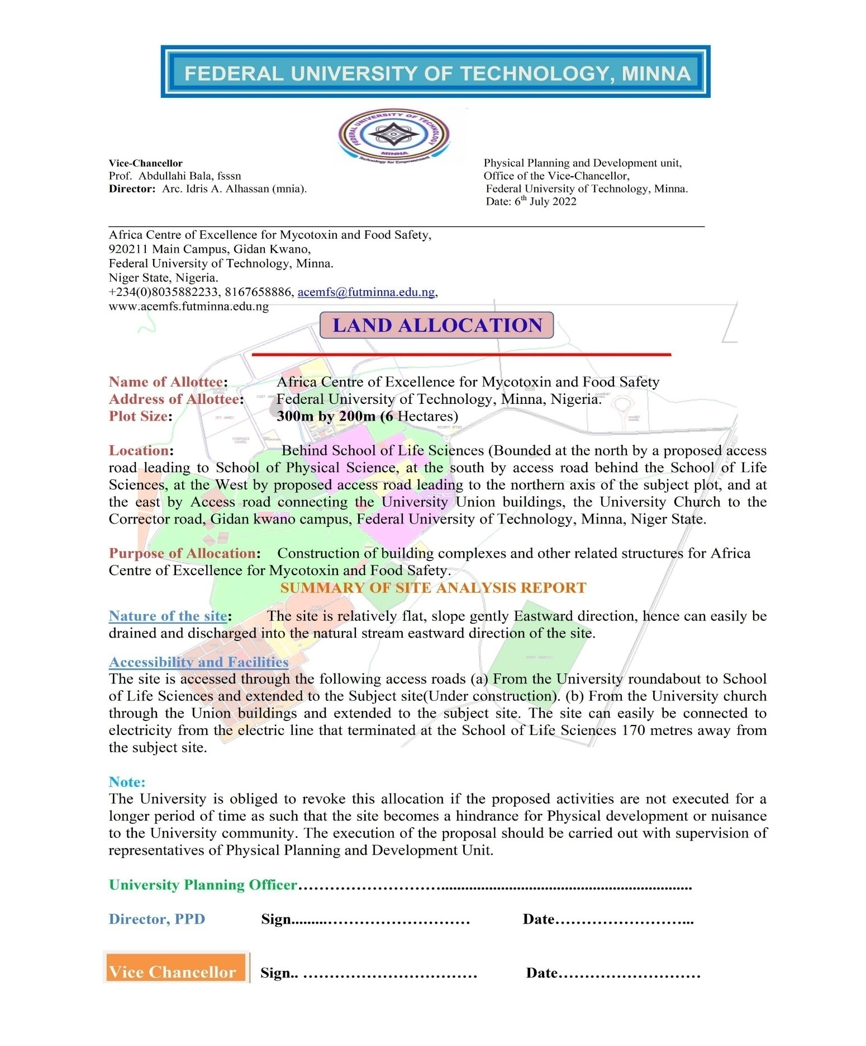

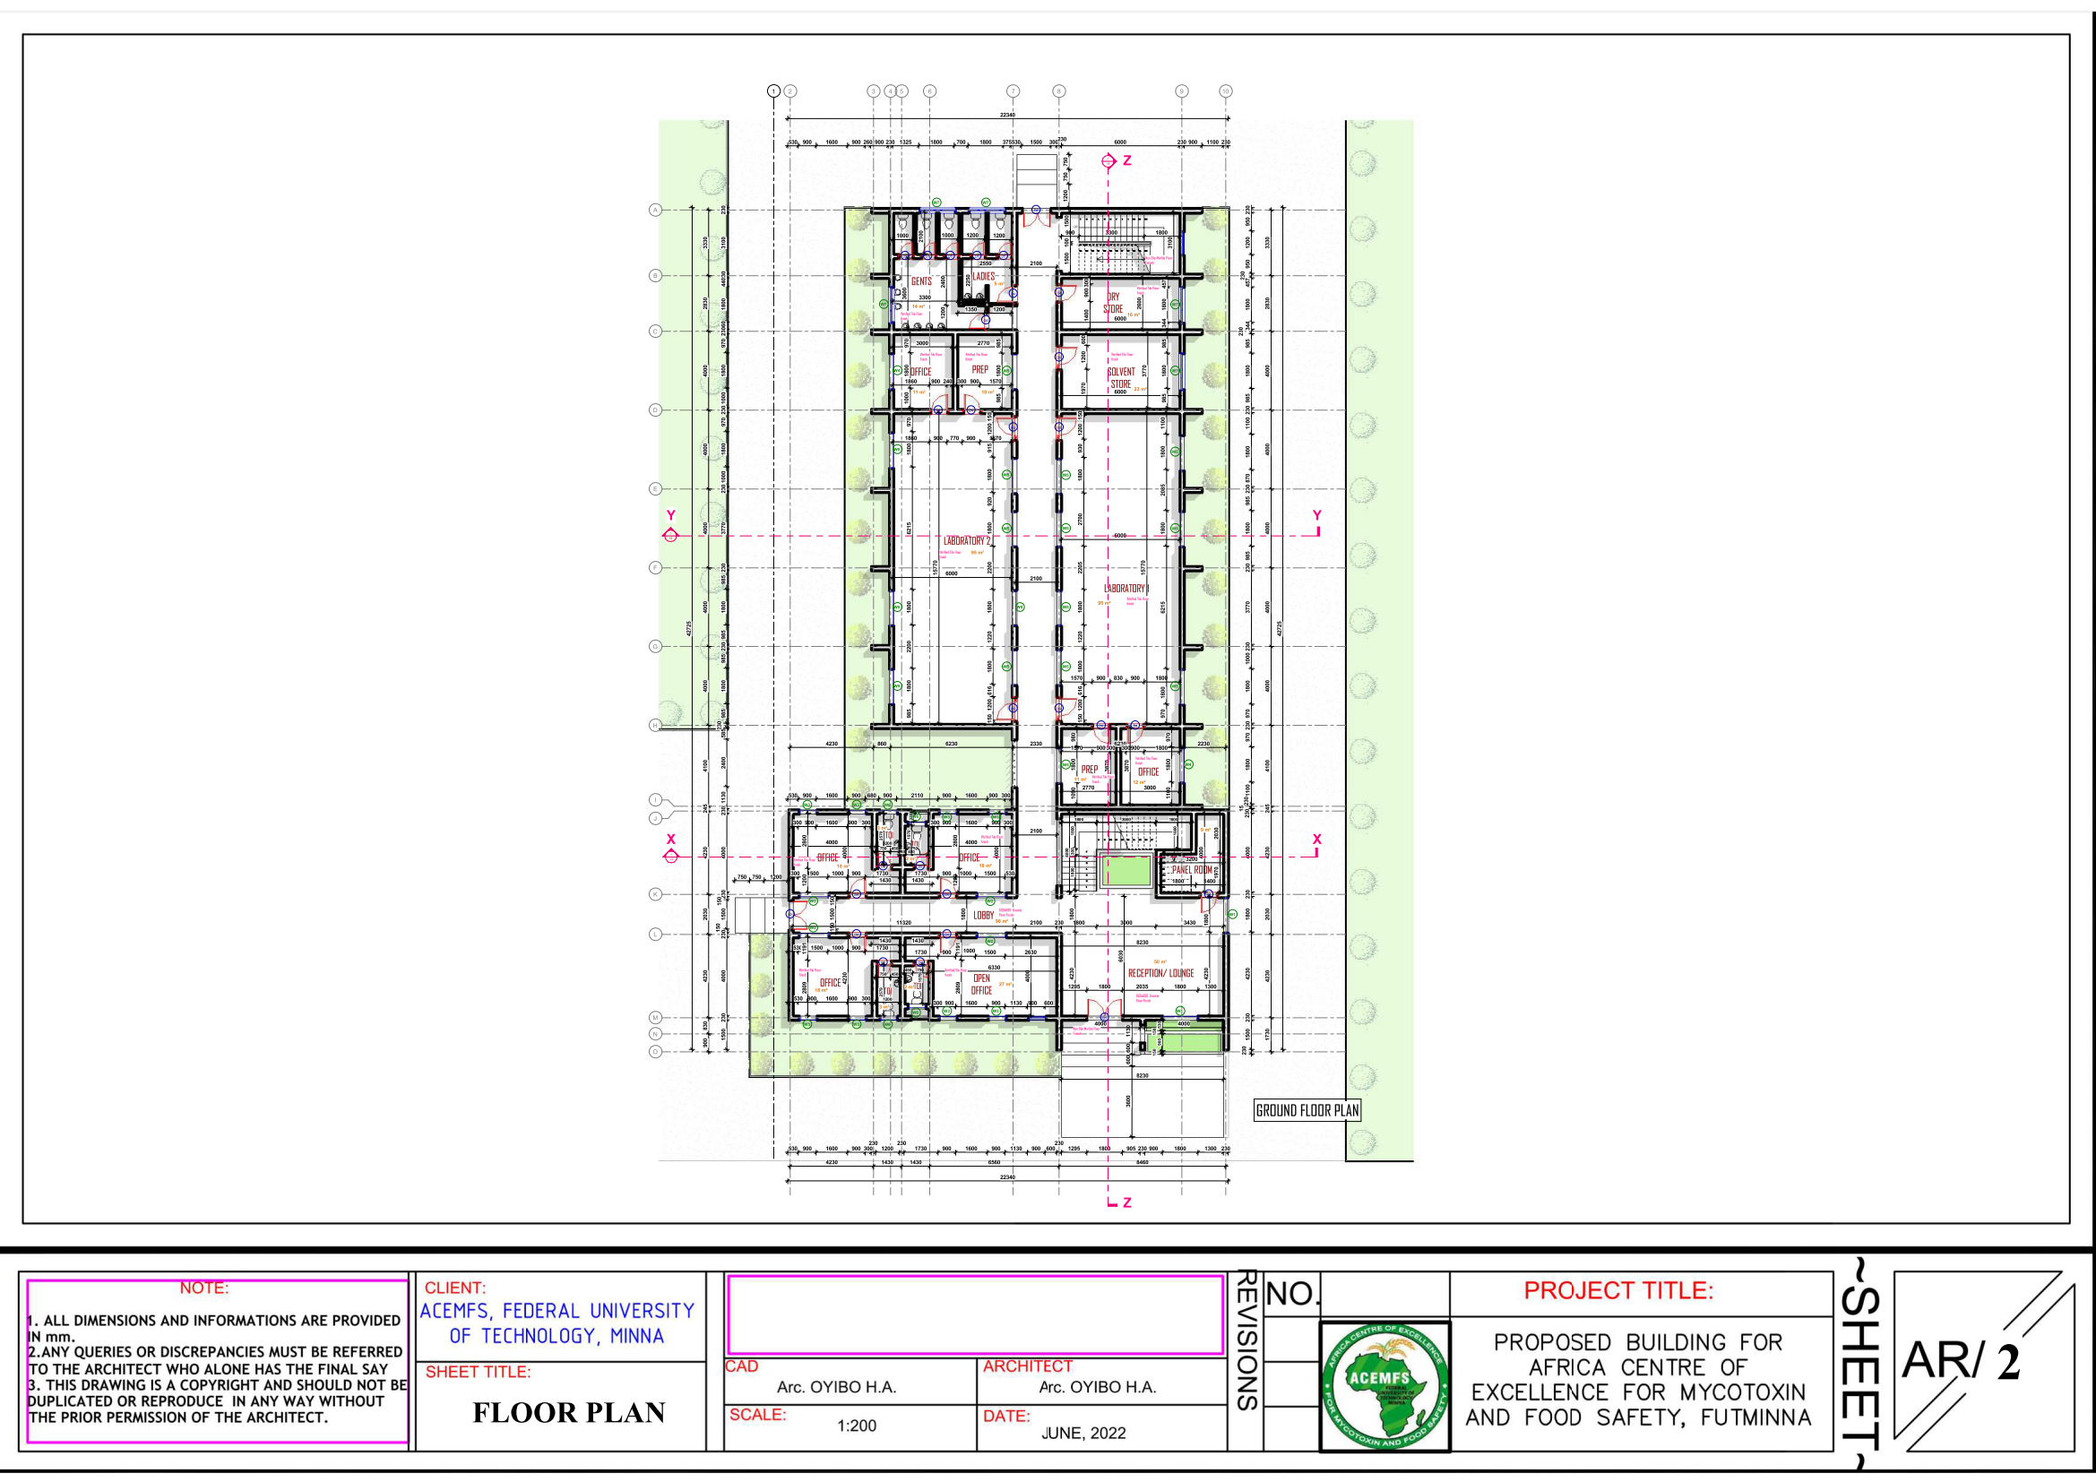
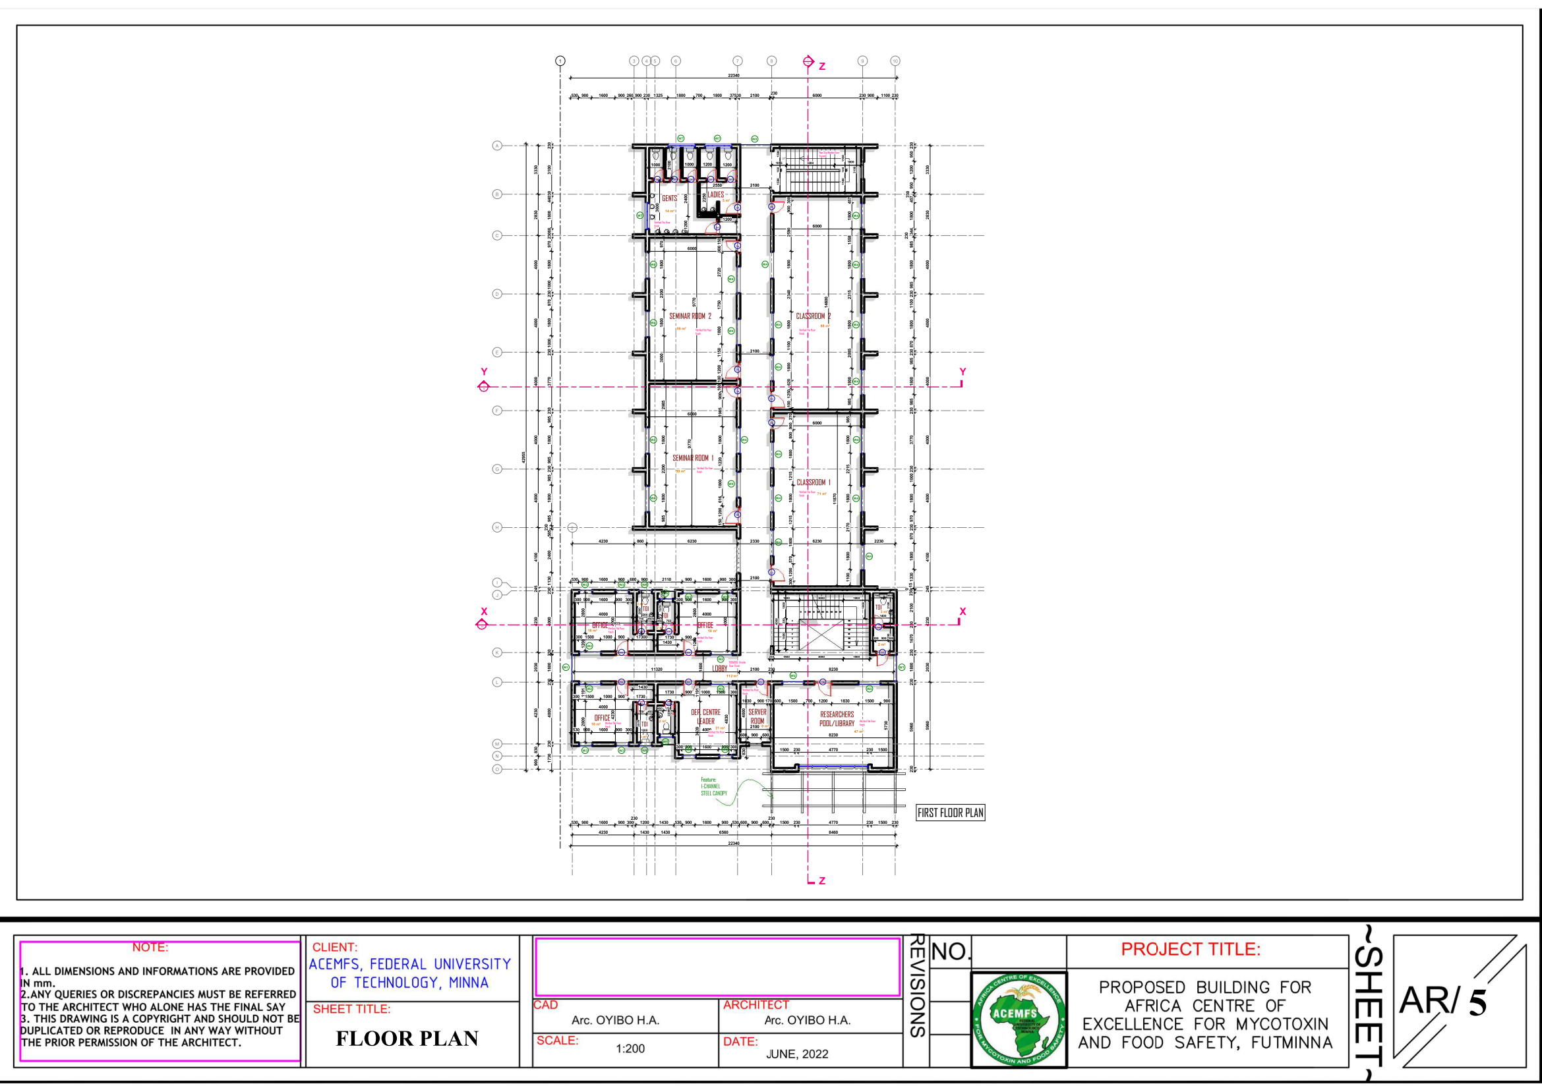
Annex 13: Building Plans

First Floor Plan

Ground Floor Plan

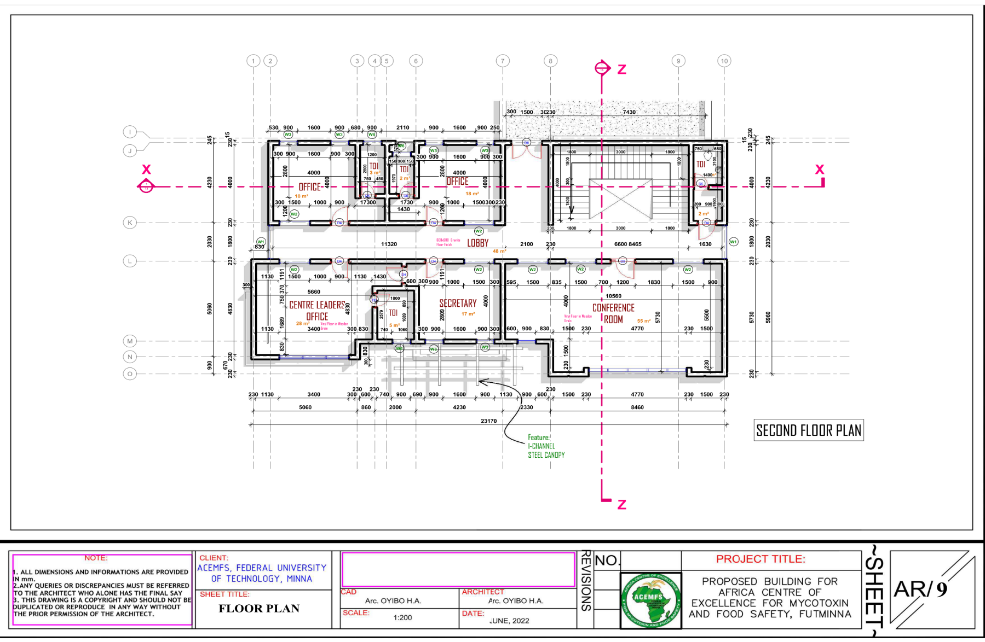
Second Floor Plan
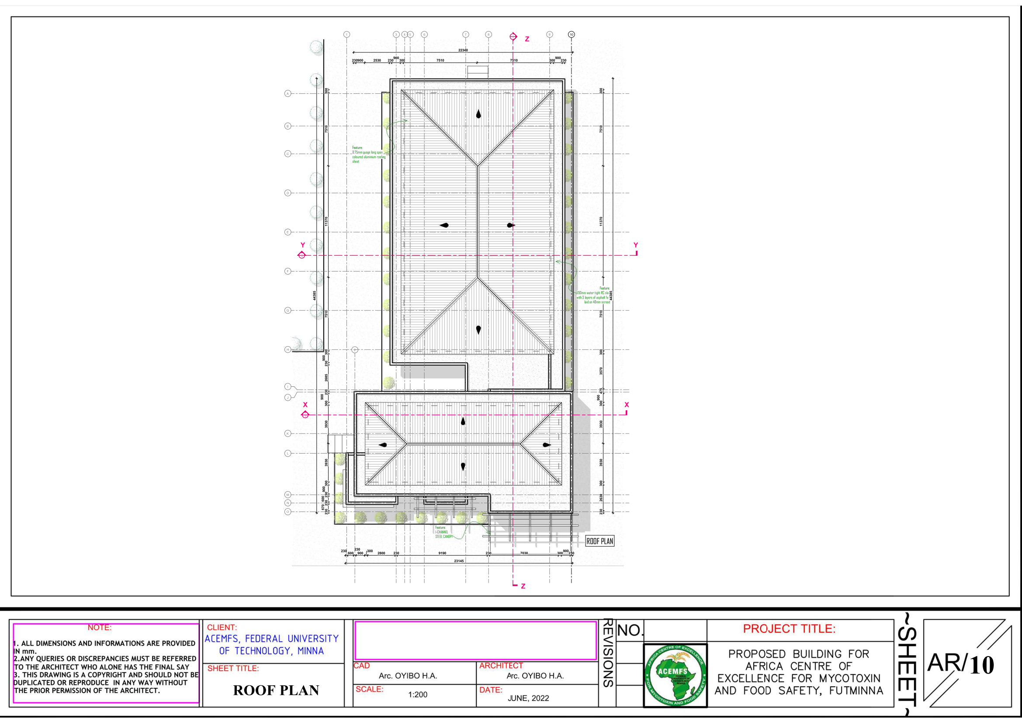
Roof Plan

Annex 14: Soil and Water Sample Result
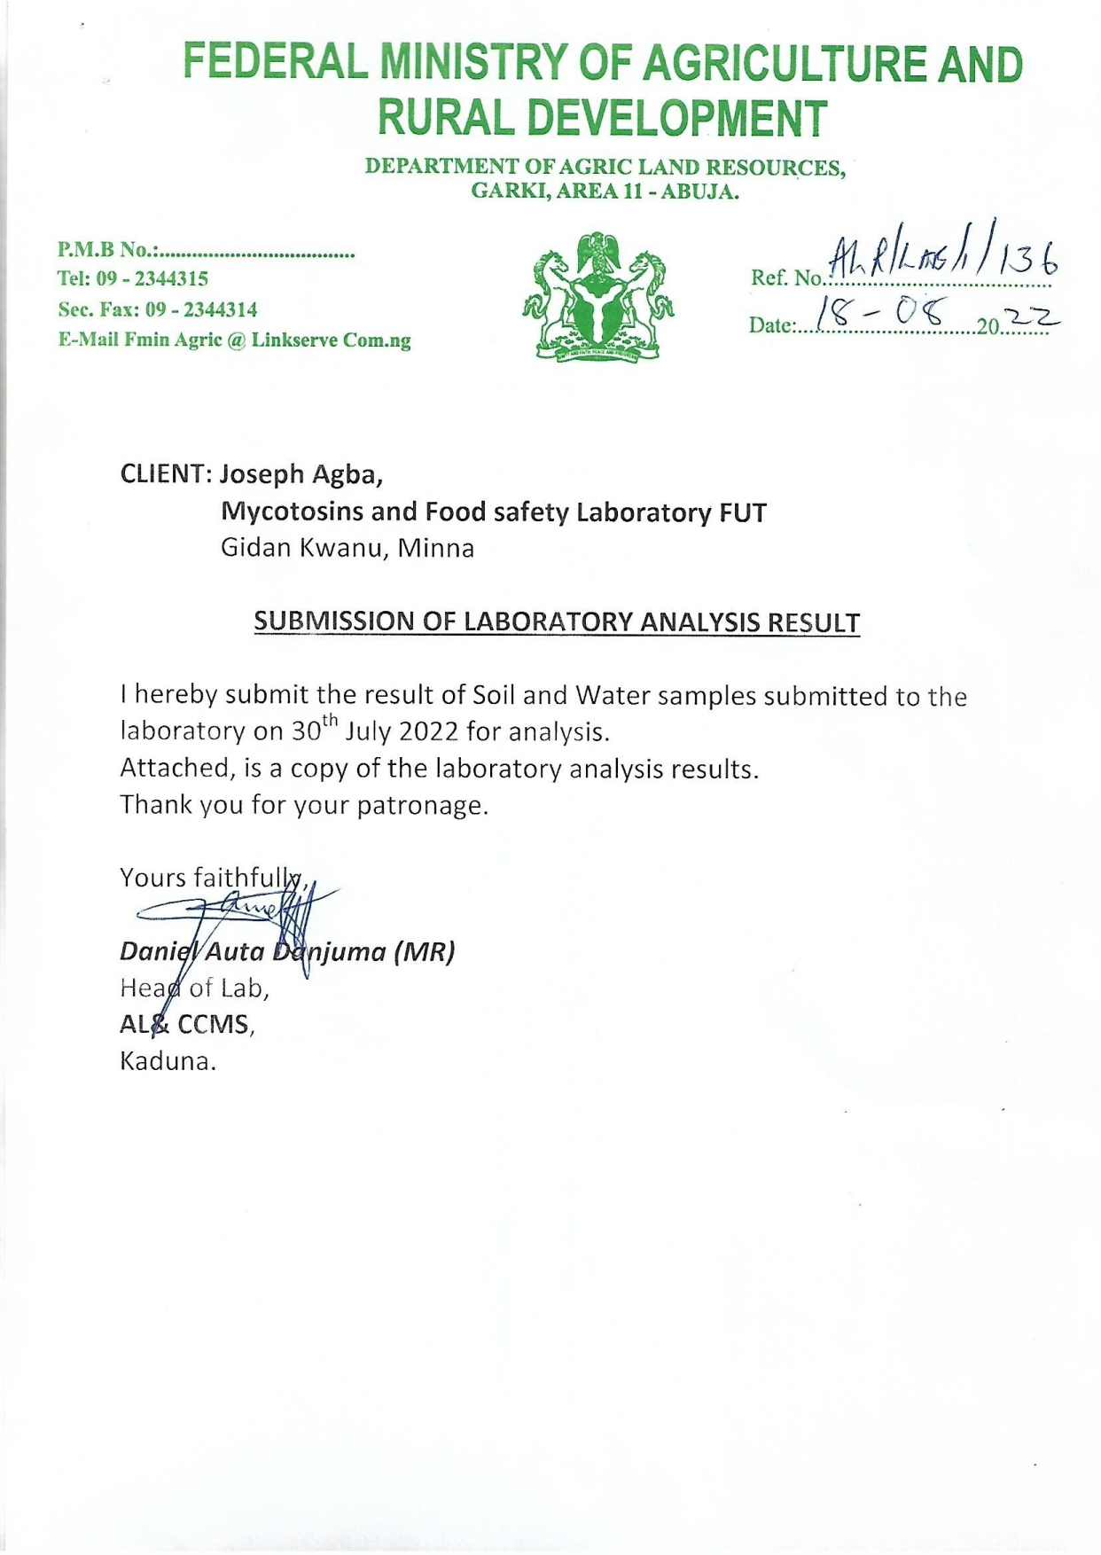

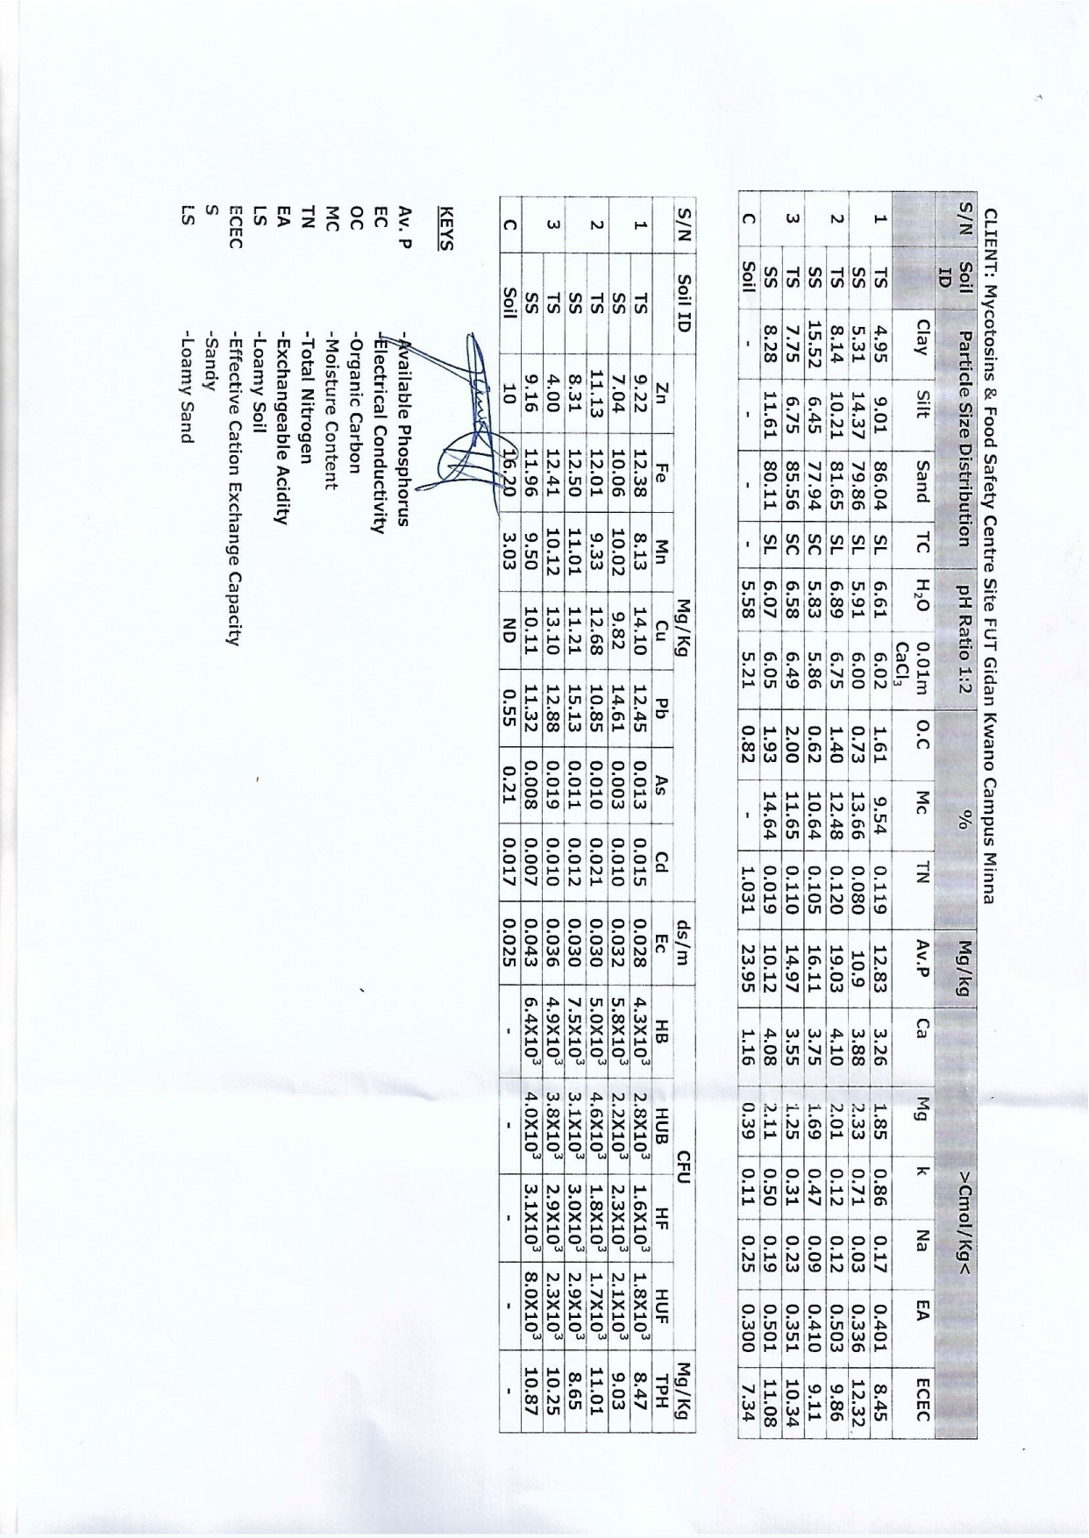

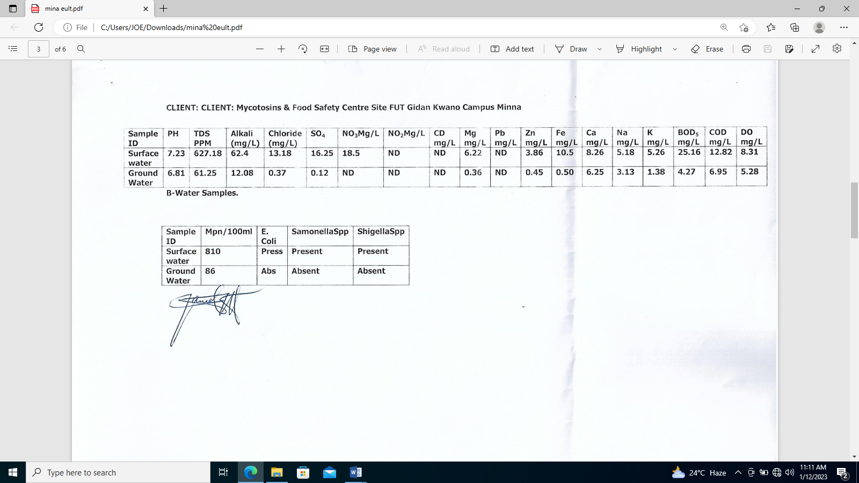

Annex 15: Safeguard Guidelines on Covid-19 in Construction/Civil Works Projects

Introduction
The Federal Ministry of Environment and the Federal Government of Nigeria through the NCDC, has made it mandatory for any organization or corporate body to have a Covid – 19 Plan, to guide against the Spread of the pandemic diseases. Already the ACEMFS is in compliance with the directives and has been a stakeholder in the control of the diseases in the community and Nigeria at large.
ACEMFS as a responsible employer and corporate body will stay abreast of guidelines and recommendations from the Federal and State Governments, regarding changes in national directives because of evolving knowledge of COVID-19 locally and nationally. This centre is one of the leading Centre for research and development in Nigeria with sound laboratory equipment should not be left out in the fight against the deadly diseases. The Centre is in compliance with all giving protocols for the prevention and eradication of Covid-19 diseases.
ACEMFS Covid -19 Hygiene Requirement
All employees and visitors should observe the general personal hygiene requirements while in the premises of ACEMFS and the site.

- Wash hands or use an alcohol-based sanitizer as soon as they enter office premises. Ensure hands are washed hands after using the washroom, before eating and regularly throughout the work day, ensuring colleagues follow this advice too.
- Cover their nose and mouth with tissue when coughing or sneezing, followed by washing of hands. Alternatively, sneezing or coughing into their bent elbow if no tissue is available. Used tissues should immediately be disposed of in a covered bin, and not left lying around on any public surfaces
- Ensure provision of covered bins in offices and business premises
- Office and business premises should be cleaned and disinfected daily, especially frequently touched surfaces like tables, door handles, countertops, computers, light and air conditioner switches which should be cleaned frequently during the day
- Keep all offices and site well ventilated, opening windows regularly to enable fresh air

There are several forms of GBV, including i) intimate partner violence; ii) non-partner sexual abuse; iii) harmful practices; iv) human trafficking and v) child sexual abuse. It is expected that the country profile will highlight the most prevalent forms of GBV within each country. http://www.worldbank.org/content/dam/Worldbank/document/Gender/Arango%20et%20al%202014.%20Interventions%20to%20Prevent%20or%20Reduce%20VAWG%20-%20A%20Systematic%20Review%20of%20Reviews.pdf
National Environmental (Air Quality Control) Regulations, 2014
Consent is defined as the informed choice underlying an individual’s free and voluntary intention, acceptance or agreement to do something. No consent can be found when such acceptance or agreement is obtained through the use of threats, force or other forms of coercion, abduction, fraud, deception, or misrepresentation. In accordance with the United Nations Convention on the Rights of the Child, the World Bank considers that consent cannot be given by children under the age of 18, even in the event that national legislation of the country into which the Code of Conduct is introduced has a lower age. Mistaken belief regarding the age of the child and consent from the child is not a defense.

